CIS 627 Radio Button Exercise
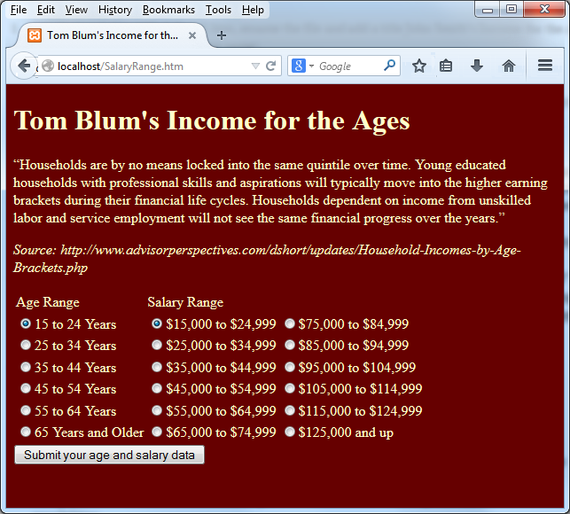
- Use the head start HTMLPage1.htm, rename the file and add a title John Smith’s Income for the Ages (with John Smith replaced by your name).
- Add an HTML comment with your name.
- Make the page’s background color and (font) color anything other than the default values.
- Put a header with John Smith’s Income for the Ages (with John Smith replaced by your name) at the top of the page.
- Above the table enter the text

“Households are by no means locked into the same quintile over time. Young educated households with professional skills and aspirations will typically move into the higher earning brackets during their financial life cycles. Households dependent on income from unskilled labor and service employment will not see the same financial progress over the years.” Source: http://www.advisorperspectives.com/dshort/updates/Household-Incomes-by-Age-Brackets.php

- Add a form that includes the radio buttons and a submit button that says “See Where You Stand”.
- Change the names and values as you see fit. The user should be able to choose only one Age Range and only one Income Range. The very first Age and Income should be pre-selected when the page starts.
- Make a PHP page that handles the form’s post action.
- The PHP handler should determine the user’s age range and income range.
- Next determine the median salary for the user’s age range. The median salaries are

(34311, 52702, 64973, 67141, 57538, 35611)

where $34,311 is the median salary for the 15-to-24-Years age range, etc. (These values and other arrays you might want to use can be found in AgeGroupSalaryRange.txt.)
- Compare the user’s selected Income Range to the median for his/her age. There are three possibilities:

- The median lies below the user’s income range. (User makes above average.)
- The median lies within the user’s income range. (User makes average.)
- The median lies above the user’s income range. (User makes below average.)

(Note the income ranges span $10,000.)
- Display on the responding page the results including the following

The user’s age range
The user’s salary range
The median salary for the user’s age range
A statement about how the user compares to the median for his/her age.

The dollar amounts should include a dollar sign and two decimal places. I used code like

number_format($amount, 2)

- ZIP up your files and post them.

Source: http://www.advisorperspectives.com/dshort/updates/Household-Incomes-by-Age-Brackets.php

