Conservation of Energy
It is believed that if all of the various energy terms are accounted for then a “closed” system will conserve energy, meaning that the amount of energy in the system will not change in time. A closed system is one in which there is no external agent that is introducing energy into the system or allowing it to escape. (This may be somewhat tautological in that we define a “closed” system as one that conserves energy.)
We will have a set up similar to the one used for the lab on Newton’s Second law – a cart on a flat track pulled by a string that passes over a pulley and is attached to a hanger.
- Set the track on two of the larger blocks so that it is level.
- At one end use a Universal Clamp to secure a Pulley at track level. At the other end place a Motion Sensor. Plug the yellow plug on the Motion Sensor into Digital Channel 1 of the Pasco Signal Interface and the black plug into Digital Channel 2. Open Data Studio, click on the image of Digital Channel 1, and choose Motion Sensor. On the middle right choose 20 Hz and the sampling frequency.
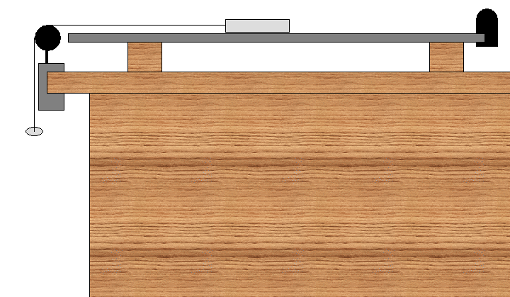
- Tie one end of a string to a cart, pass it over a pulley and tie the other end to a hanger. (The string coming from the cart should be horizontal.)
- Decide whether you want to use just the cart or place blocks in it. Record the mass below (approximately .500 kg for the cart and each block)
Mass of cart with blocks if included ( )

- Place the cart so that the string is taut and the hanger hangs just below the pulley.
- Measure the height of the hanger (distance from the bottom of the hanger to the floor).
Hanger Height ( )
- Begin recording data and release the cart. Stop recording data as soon as possible after the hanger hits the floor. Check off that we want to view the Position and Velocity Data.
- Click on a Table in the lower left hand side and make a table of the Position data. Use the menu’s Edit/Copy and then paste the data into an Excel SpreadSheet.
- Similarly copy and paste the Velocity data into Excel.
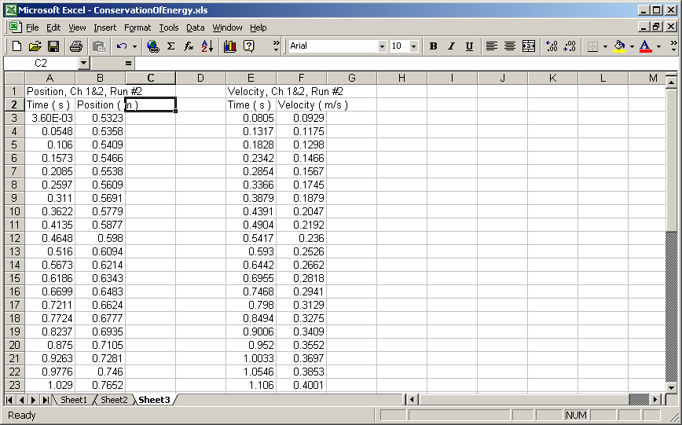
- Recall that displacement is the difference between one’s position at a given instant and one’s position at the start. We can calculate displacement in the above example by entering in cell C3 the formula =B3-0.5323 or =B3-$B$3 and copying down.
- We can then calculate the height of the hanger by taking the initial height and subtracting the displacement, for example, by entering in cell D3 the formula =0.667-C3.
- We should eliminate any data in which the height reaches zero. We would rather not have to consider the floor as part of our system. Note the time at which this occurs. (You may also have to remove a few initial rows if you started recording before releasing the cart.)
- Make a graph of velocity versus time for data in the falling time range. It should be a straight line. Fit it to a line and display the equation.
F
- In the absence of friction and air resistance, theory predicts that the acceleration is given by
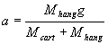
Enter below the experimental acceleration form the graph and the ideal acceleration from the calculation.

Experimental acceleration ( )
Ideal acceleration ( )

- Note that the times in the Position data and the times in the Velocity data are not the same. To compensate somewhat for this problem, we can average two consecutive velocities and assume that the resulting value is a value for an intermediate time and match that intermediate time as much as possible with a position time. In the example shown below, I have placed a formula averaging the first and second velocities =AVERAGE(F3,F4) into cell G5. This was done because averaging the times corresponding to those velocities 0.0805 and 0.1317 yields 0.1061 which is closest to the Position time in Row 5. This formula was then copied down the column being sure to stop at the time previously determined to be when the hanger hit the floor.

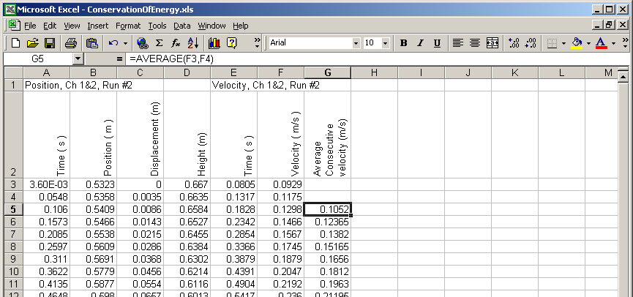

- Next we can calculate the gravitational potential energy using the formula mgh, where m here is the mass of the hanger (it’s the only thing changing height), g is the acceleration due to gravity 9.8 and the height is the value given in column D above. In the example this was achieved by entering in cell H5 the formula =0.05*9.8*D5. And then copying the formula down.

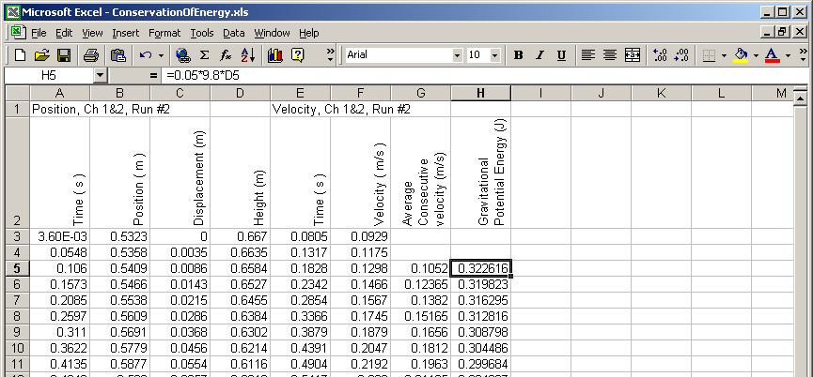

- Next we can calculate the kinetic energy using the formula mv²/2, where this time m is the mass of the hanger and the cart and any blocks in the cart (since they are all moving with the same velocity) and we use the average consecutive velocity (column G) for v. In this example (which had two blocks in the cart), we entered in cell I5 the formula = 1.55*G5^2/2.

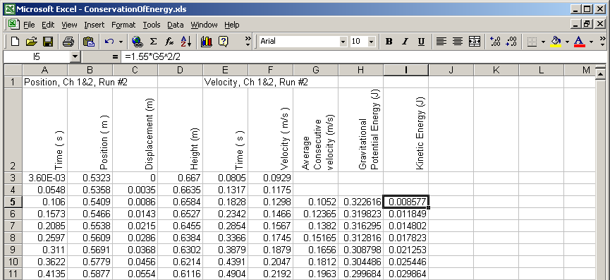

- Now we can determine the total mechanical energy by adding the gravitational potential and kinetic energies (cell J5, place the formula =H5+I5). Then we can highlight this most recent column and the corresponding columns in the first column (hold down the Ctrl button to highlight non-adjacent columns). And make a graph of mechanical energy versus time. Excel sometimes adjusts the vertical range to accentuate the variation, but one can right click on the y-axis numbers, choose format axis, and on the Scale tab, force the Minimum value to be 0.

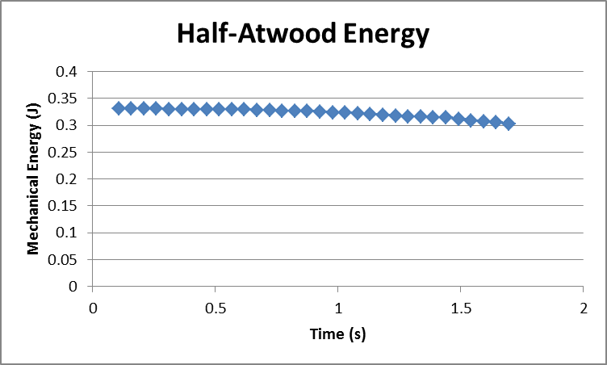

- Some mechanical energy appears to be lost in the above graph. (A simple conservation law of energy result would have been a straight, flat, horizontal line.)
- Let us assume that any difference between the ideal and experimental accelerations above is accounted for by friction. We can use F=ma and some algebra to arrive at the conclusion

F_{friction} = (M_{hang} + M_{cart})(a_{ideal} – a_{experimental})
- Calculate the frictional force for your results.

Frictional Force ( )

- We say that the cart must do work to overcome friction. This work is found by multiplying the friction force by the displacement. Below we placed in cell K5 the formula = 0.046345*C5 where 0.046345 was the frictional force for the example shown here.

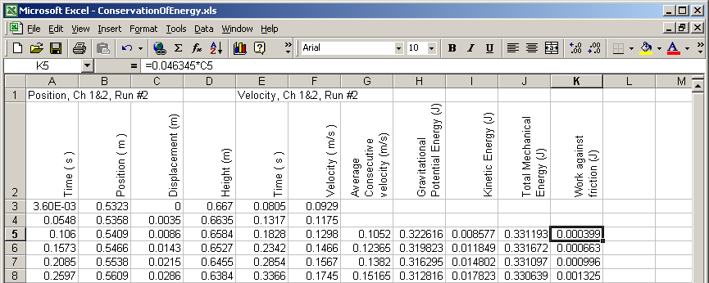

- The work against friction is converted to heat. To truly test that we would need a thermometer to see if the cart, track or surrounding air got hotter. All we will do here is add this work to mechanical energy to see if the graph is flatter. This is done by putting in cell L5 the formula =J5+K5.

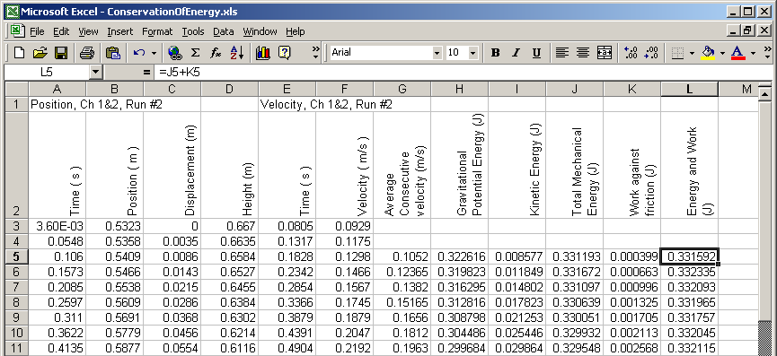

- Highlight columns A, J and L. and make a graph.

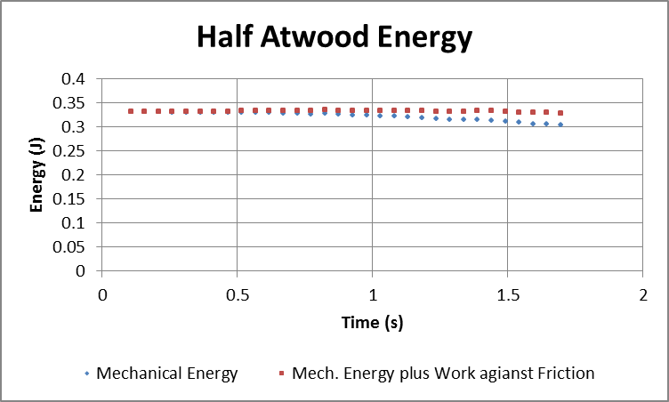

- Right click on the data and choose Select Data…. Select one of the Series on the left and click the Edit button above it. Use the dialog box to give the series a name.

