Constant Acceleration

Galileo studied a cart rolling down an incline. It has similarities to a falling body; in fact, if the slope of the incline becomes steep enough, the cart on the incline approaches the free falling ituation. The advantage of the incline (for small angles between the incline and the horizontal) is that it slows the action down enough to make it observable.

We will use a device called a Motion Sensor that will measure the position as time goes by (we say it measures position as a function of time or that it takes position versus time data).

- The PASCO Signal Interface should be on before the computer is turned on (so the computer can detect the interface as it boots up).
- Plug the yellow plug of the Motion Sensor into Digital Channel 1 and plug the black plug into Digital Channel 2.
- Go to Start/All Programs/Physics/Data Studio/Data Studio.

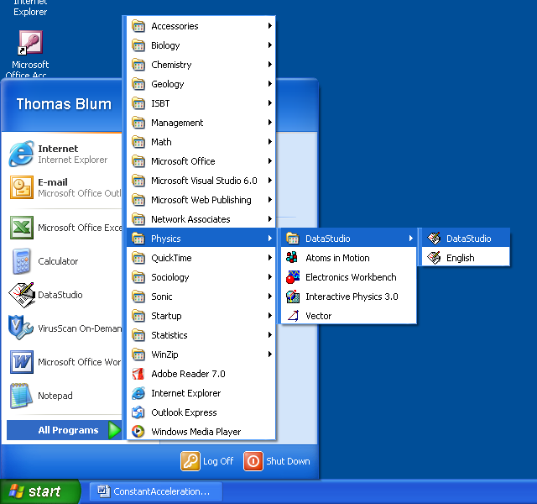

- Click on Create Experiment.

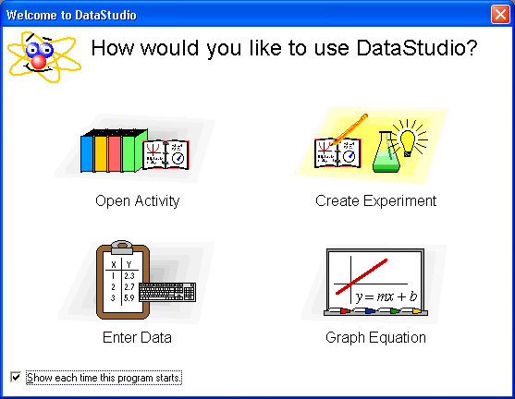

- Click on the image of Digital Channel 1 and choose Motion Sensor from the dialog box that arises. After that change the Sample Rate (on the right, toward the middle) to 20 Hz.

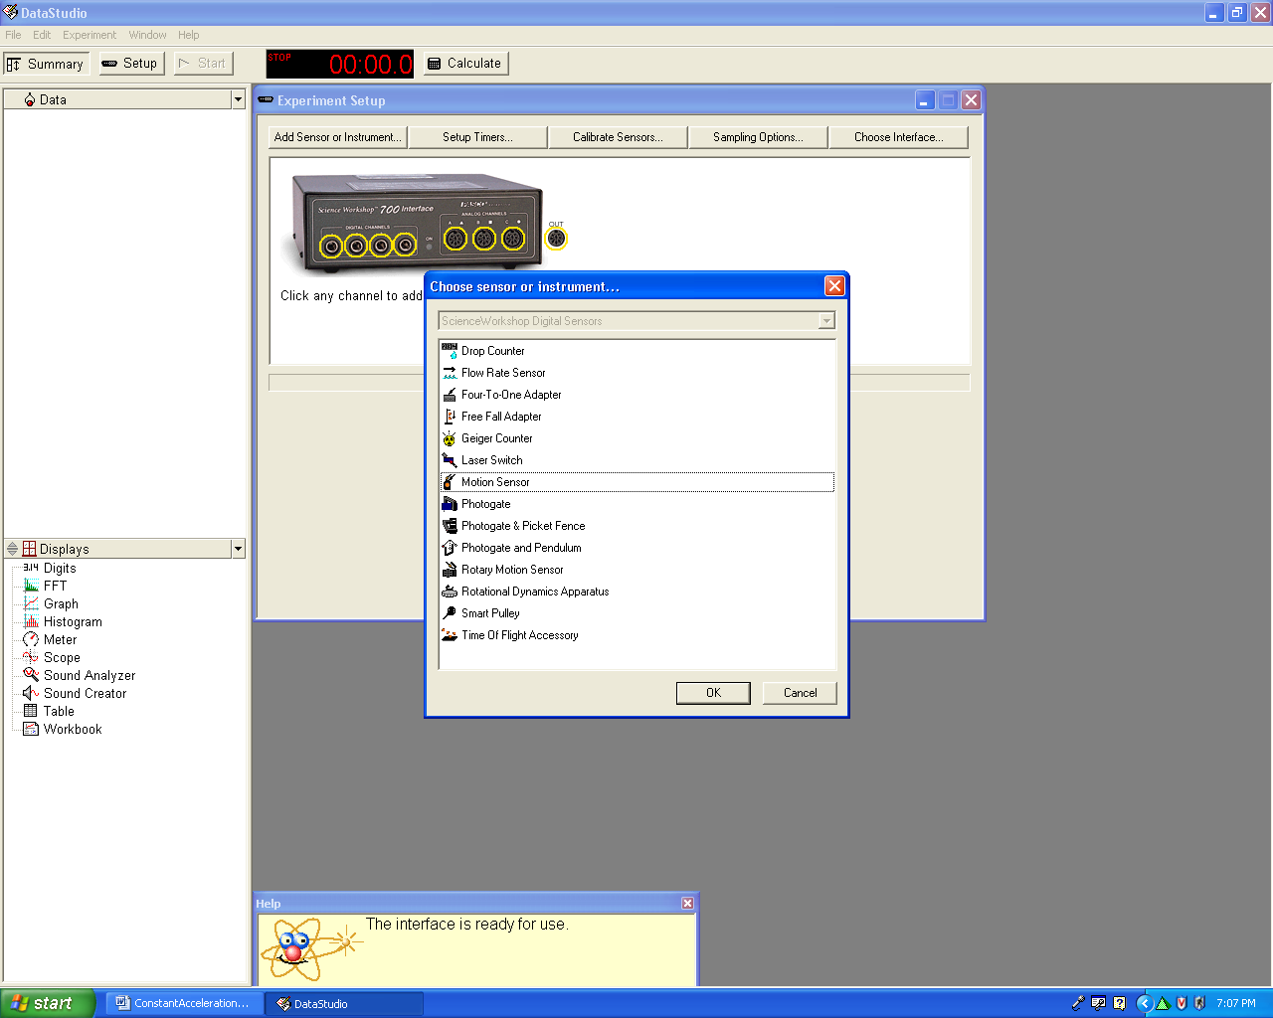

- Place one end of the track on a block so that it is inclined. Connect the Motion Sensor to the upper end of a track

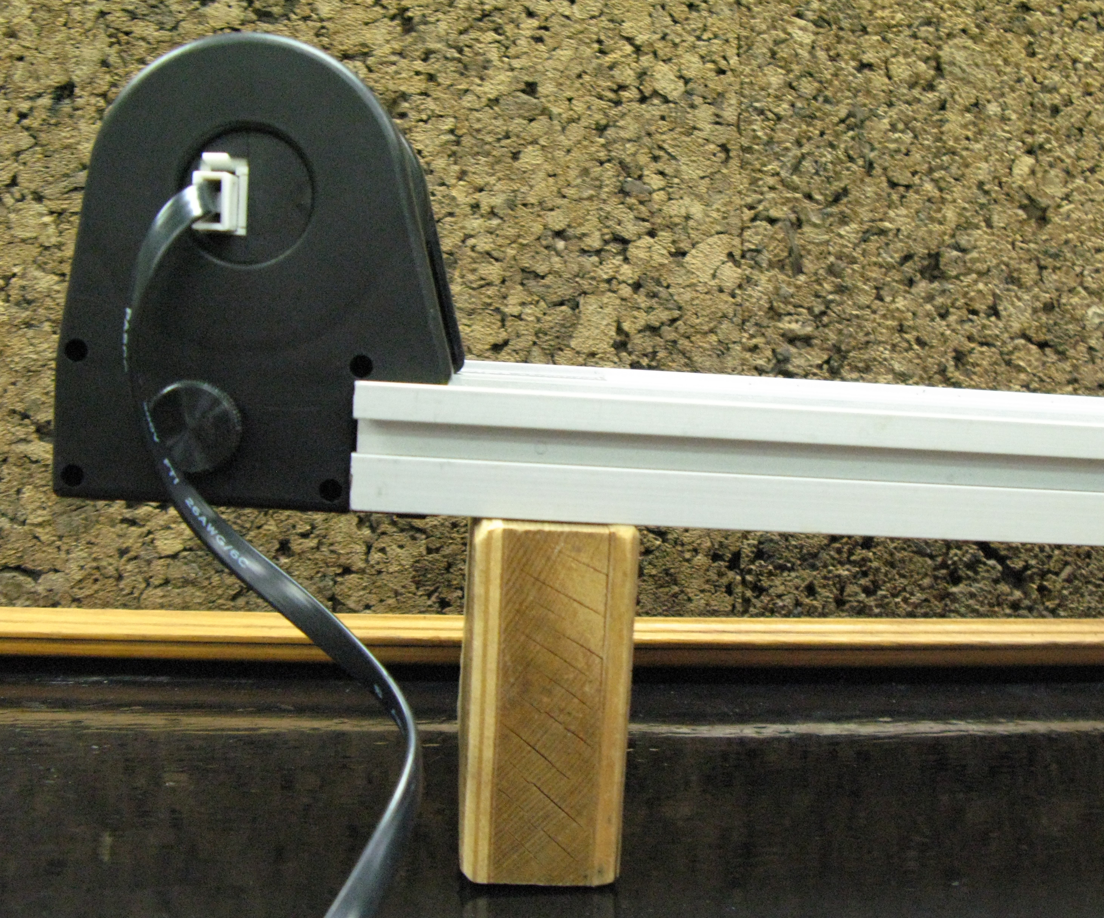

- Record the length of the track and the height of the raised end.

Length of track (cm)
Height of incline (cm)

- Place a cart approximately 50 cm down the track from the Motion Sensor (these sensors need some distance between themselves and what they detect for accurate measurements).
- To start recording data, click on the Start button (upper left) and release the cart. Stop the cart and the recording when the cart reaches the end of the incline.
- Double click on Table (lower left), and choose Position Run #1, and click OK.
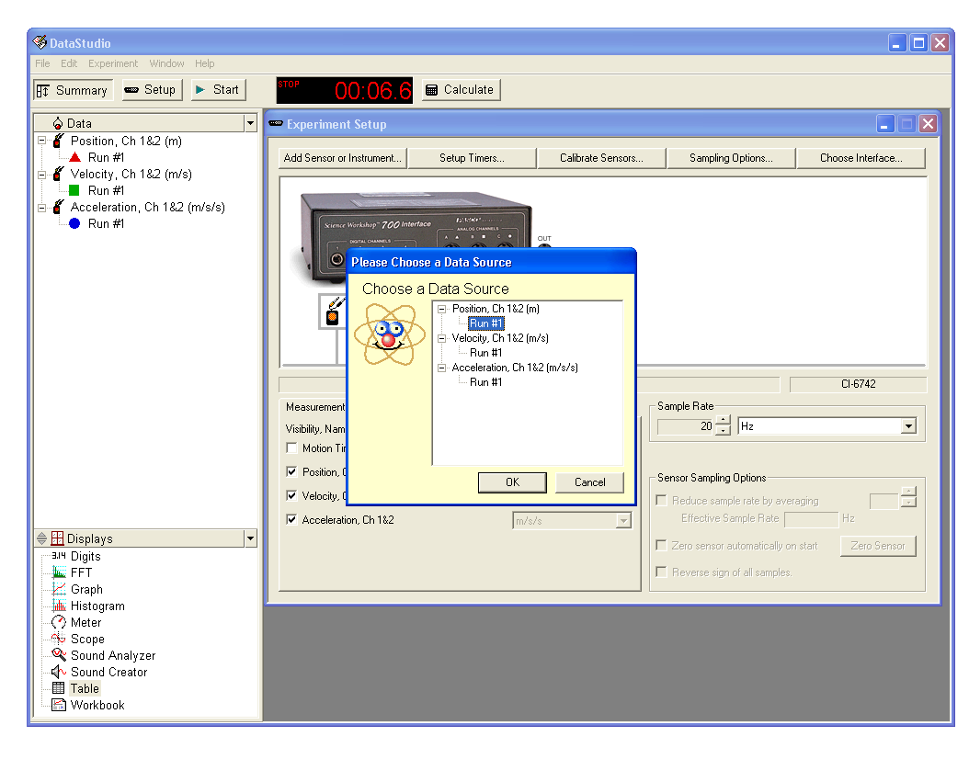

- If the Time data does not appear in the first column, click on the clock icon (upper left of Table dialog box).

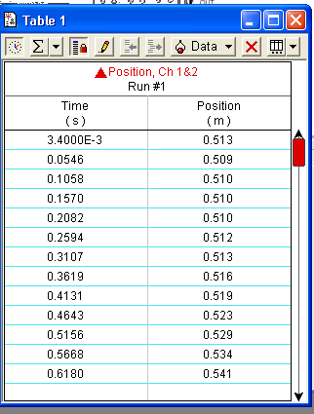
- Go to Data Studio’s main menu and click Edit/Copy. Open Excel and paste the data into Excel. If the start of Motion Sensor recording and the release of the cart did not coincide, you may need to eliminate some data at the beginning. If the cart reached the end of the track before the Motion sensor stopped recording, some data may need to be eliminated.
- Collect data for two more trials with the above scenario.
- Place a metal block on the cart and take data for three trials. Place a second metal block on the cart and take data for three trials.
- We wish to compare our data to the formula displacement = (acceleration)(time)² / 2. To facilitate this comparison we will square the times recorded by the Motion Sensor. Insert a row above the data using Insert/Row. In the third column enter the formula =A4^2 to square the time data.

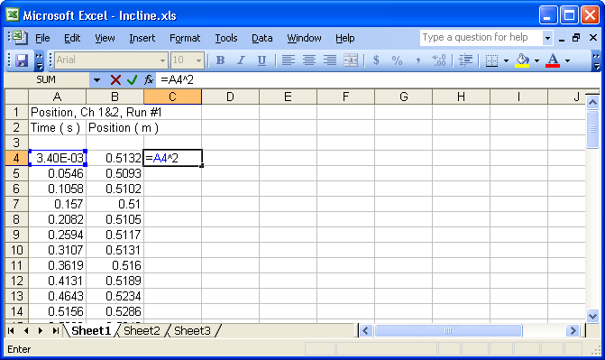

- After entering the formula copy it down into the cells below it by placing the cursor in the lower right hand corner of the cell with the formula until the cursor turns into a thin cross. Then drag down the column. This copies the formula but A4 becomes A5 in row 5 and becomes A6 in row 6, etc.
- Because of the way the Motion Sensor works, our displacement data does not start at zero. We can adjust for this by entering a formula in column D that subtracts from each of our positions that starting position’s value. In the example below one enters the formula =B4-0.5132. (A fancier version would be to enter =B4-B$4.)

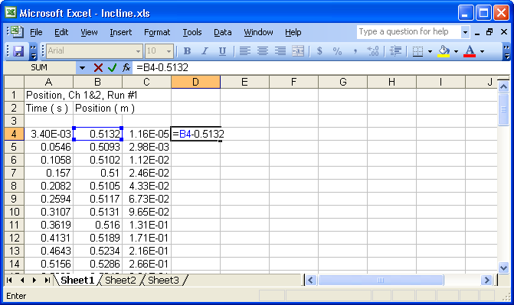

- After entering the formula copy it down into the cells below. (In the fancy version of the formula B$4 will not change as it is copied down so that it will always correspond to the initial position.)

- Highlight the last two columns and make a chart like that shown below.

- As you can see my version ended up with the x axis in Scientific Notation, which one can change by right clicking on the axis numbers and choosing Format Axis …. Then choose the Number tab, choose General under category and click OK. One can make the s2 look like s² in the x-axis label by highlighting the 2, right clicking, choosing Format Axis Title…, and on the Font tab, checking the superscript box.

- A straight line for the above data suggests that the displacement of the cart does vary like the square of time under these circumstances. Next, fit the data to a straight line. (Right click on a data point, choose Add a Trendline, choose Linear as the Type, and under the Options tab, check Set intercept = 0 and also check display equation.

- Plotted along our y-axis is displacement and along our x-axis is time squared. Thus the fit equation y=0.1253x corresponds to displacement = 0.1253 (time)². Comparing this result to displacement = (acceleration)(time)² / 2, we can identify 0.1253 as acceleration divided by 2. Thus we conclude that our experimental acceleration is 0.2506 m/s².
- Extract accelerations for all of your trials.

 | Trial 1 | Trial 2 | Trail 3 | Average

No block
One block
Two blocks

- Include in your report commentary about whether your data when plotted in this way was “well fit” by a straight line.
- Like the free fall case, the basic theory suggests that the acceleration of the cart on the incline does not depend on mass. Discuss whether your data supports this conjecture.

