Constant Acceleration

Galileo studied a cart rolling down an incline. It has similarities to a falling body; in fact, if the slope of the incline becomes steep enough, the cart on the incline approaches the free falling situation. The advantage of the incline (for small angles between the incline and the horizontal) is that it slows the action down enough to make it observable.

We will use a device called a Motion Sensor that will measure the position as time goes by (we say it measures position as a function of time or that it takes position versus time data).

- The PASCO Signal Interface should be on.
- Plug the yellow plug of the Motion Sensor into Digital Channel 1 and plug the black plug into Digital Channel 2.
- Go to Start/All Programs/Data Studio/Data Studio.

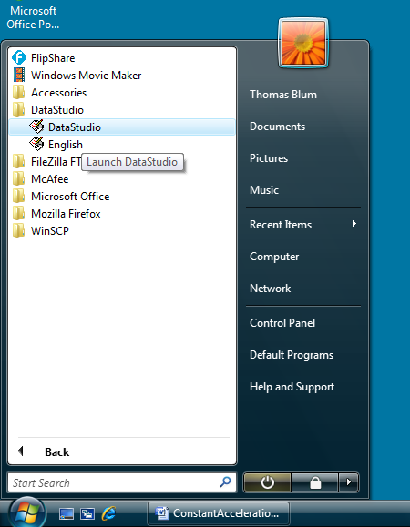

- Click on Create Experiment.

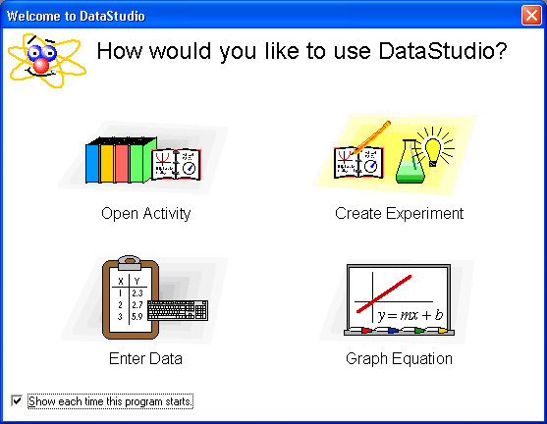

- Click on the image of Digital Channel 1 and choose Motion Sensor from the dialog box that arises. After that change the Sample Rate (on the right, toward the middle) to 20 Hz.

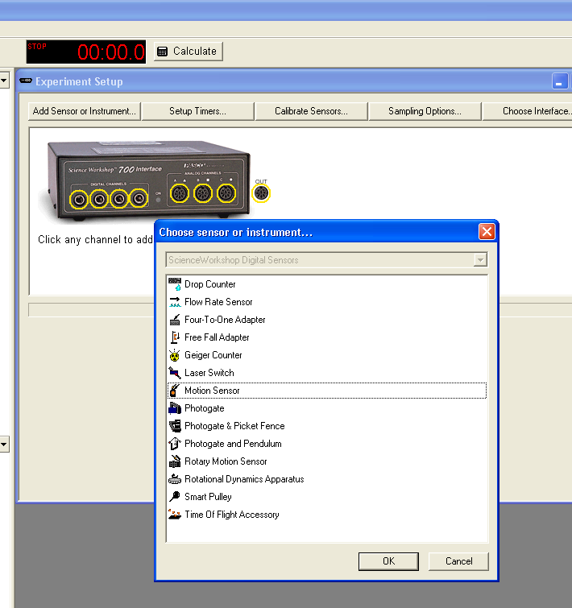

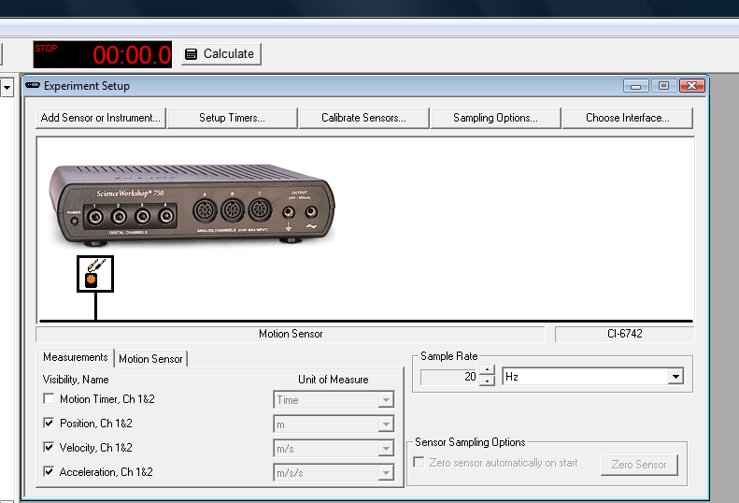

- Place one end of the track on a block so that it is inclined. Connect the Motion Sensor to the upper end of a track

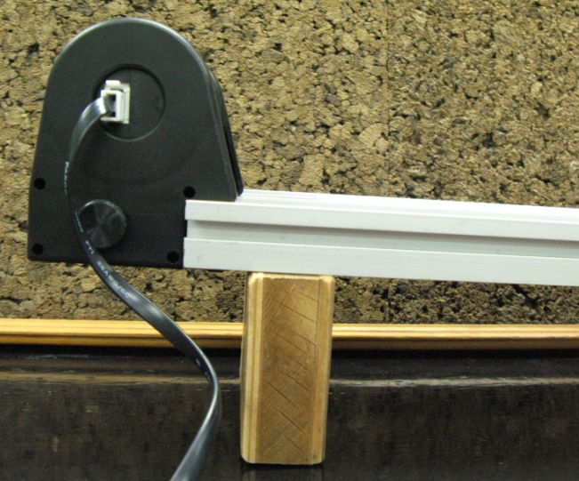

- Record the length of the track and the height of the raised end.

Length of track (cm)
Height of incline (cm)
Angle between incline and horizontal
(degrees or radians?)
Sine of Angle

hypotenuse
opposite
θ
adjacent

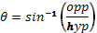

- Place a cart approximately 50 cm down the track from the Motion Sensor (these sensors need some distance between themselves and what they detect for accurate measurements).
- To start recording data, click on the Start button (upper left) and release the cart. Stop the cart and the recording when the cart reaches the end of the incline.
- Double click on Table (lower left), and choose Position Run #1 (or some other number if you have more data), and click OK.
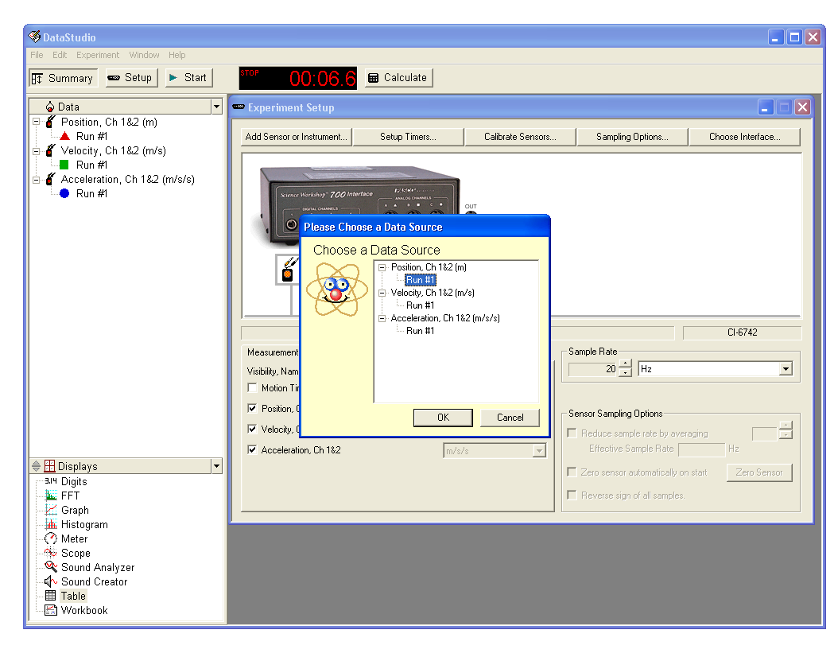

- If the Time data does not appear in the first column, click on the clock icon (upper left of Table dialog box).

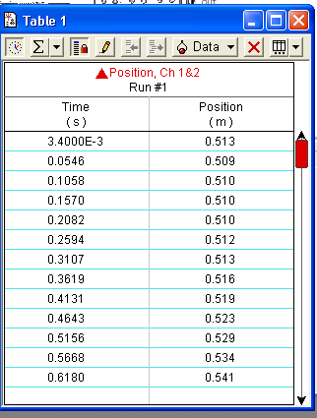

- Go to Data Studio’s main menu and click Edit/Copy. Open Excel and paste the data into Excel. If the start of Motion Sensor recording and the release of the cart did not coincide, you may need to eliminate some data at the beginning. If the cart reached the end of the track before the Motion sensor stopped recording, some data may need to be eliminated.
- Collect data for two more trials with the above scenario.
- Place a metal block on the cart and take data for three trials. Place a second metal block on the cart and take data for three trials.
- We wish to compare our data to the formula

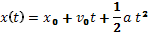

where x₀ is the initial position, v₀ the initial velocity and a the acceleration. In order to extract the acceleration we will fit (add a TrendLine) with its type set to Polynomial of order 2 (i.e. a quadratic).

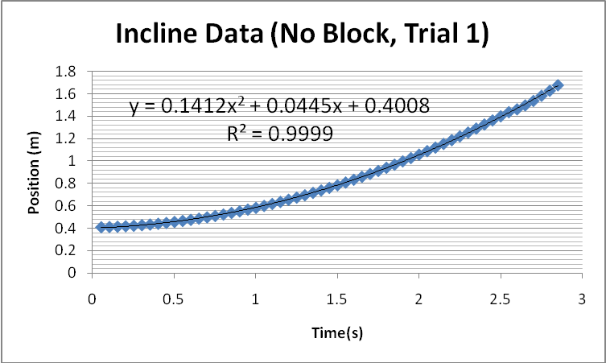

- Extract accelerations for all of your trials.

 | Trial 1 | Trial 2 | Trail 3 | Average | Standard  Deviation | Theory  g sin(θ) | Percent Error

No block
One block
Two blocks

- Calculate the average and standard deviation, using =stdev(RangeOfCells), The theory and the percent error.
- Include in your report commentary about whether your data when plotted in this way was “well fit” by a straight line.
- Like the free fall case, the basic theory suggests that the acceleration of the cart on the incline does not depend on mass. Discuss whether your data supports this conjecture.
- Next rotate the block or add blocks to change the height of one side of the track and collect acceleration data for different angles of incline. (One entry below can come from your data above. Also keep the mass fixed with varying angle.)

Height | Angle | Acceleration | Theory  g sin(θ) | Percent Error

- Comment on why your experiment may vary from the theoretical predictions.
- Remember to include units when reporting data, e.g. not 5.42 but 5.42 cm. The convention when reporting data in tables is to place the units in the table headers, for example the first/header row in each column.

