Constant Acceleration

Galileo studied an object rolling down an incline. It has similarities to a falling body; in fact, if the slope of the incline becomes steep enough, the cart on the incline approaches the free falling situation. The advantage of the incline (for small angles between the incline and the horizontal) is that it slows the action down enough to make it observable.

We will use a device called a Motion Sensor that will measure the position as time goes by (we say it measures position as a function of time or that it takes position versus time data).

- The PASCO Signal Interface should be on.
- Plug the PasPort Motion Sensor into the PasPort slot of the capstone Interface.
- Go to Start/All Programs/Pasco Scientific/Pasco Capstone.

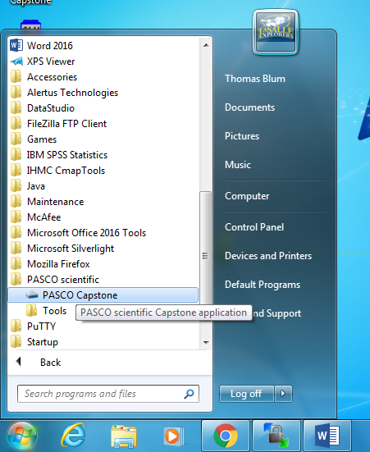

- Click on Hardware Setup on the left.

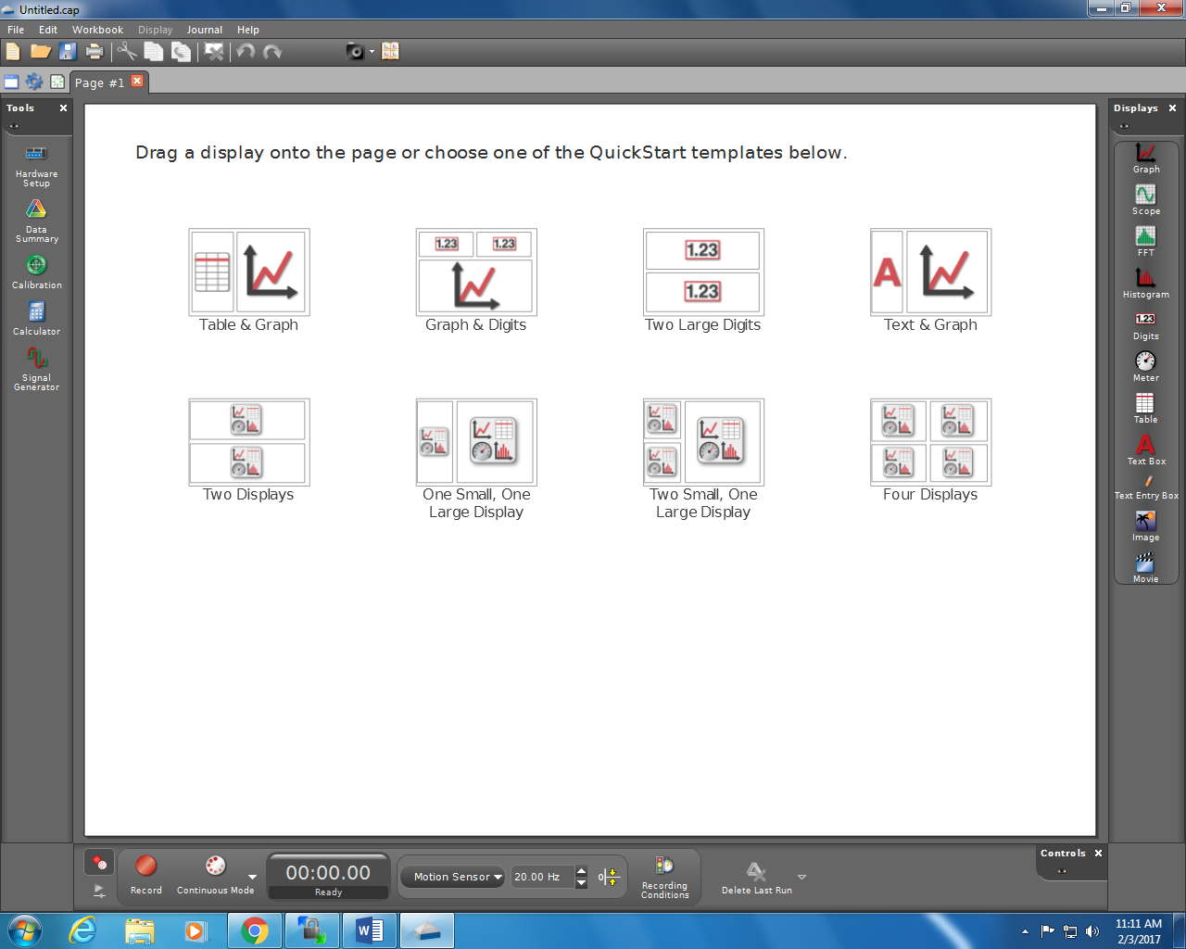

- Click on the Properties (Settings Gear icon) check that the default Sample Rate is 20 Hz and click OK.
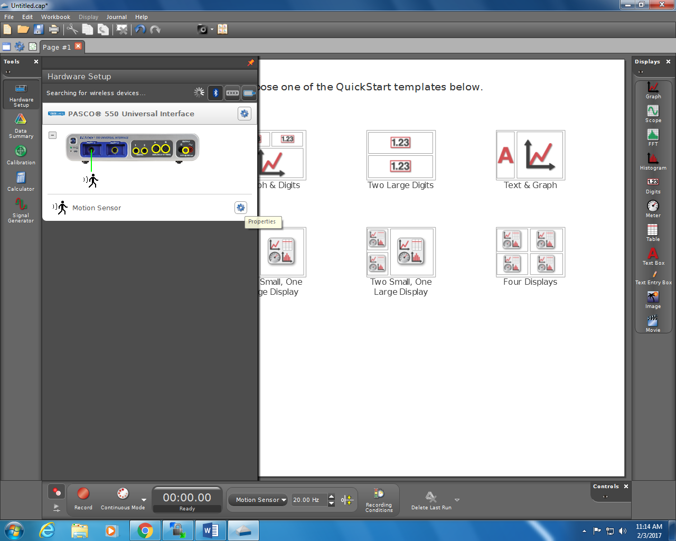

- Place one end of the track on a block so that it is inclined. Connect the Motion Sensor to the upper end of a track

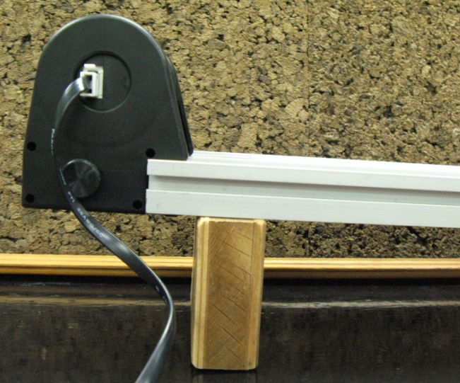

- Record the length of the track and the height of the raised end.

Length of track (cm)
Height of incline (cm)
Angle between incline and horizontal
(degrees or radians?)
Sine of Angle

hypotenuse
opposite
θ
adjacent

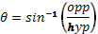

- Place a cart approximately 50 cm down the track from the Motion Sensor (these sensors need some distance between themselves and what they detect for accurate measurements).
- To start recording data, click on the Record button at the bottom and release the cart. Stop the cart and the recording when the cart reaches the end of the incline.

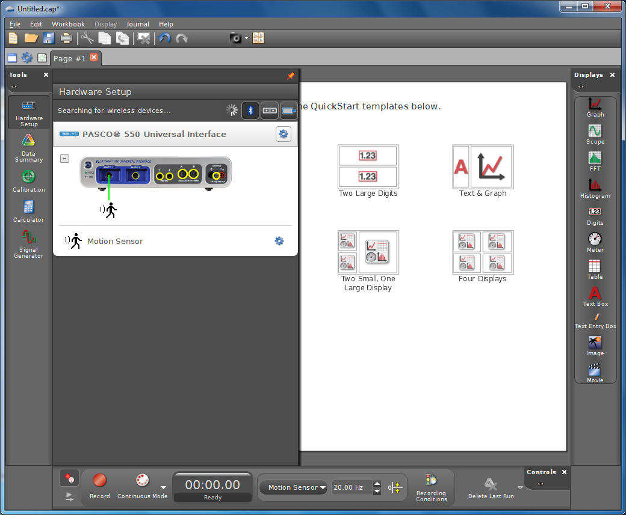

- Click on Data Summary on the left. And double click on the Table icon on the right.
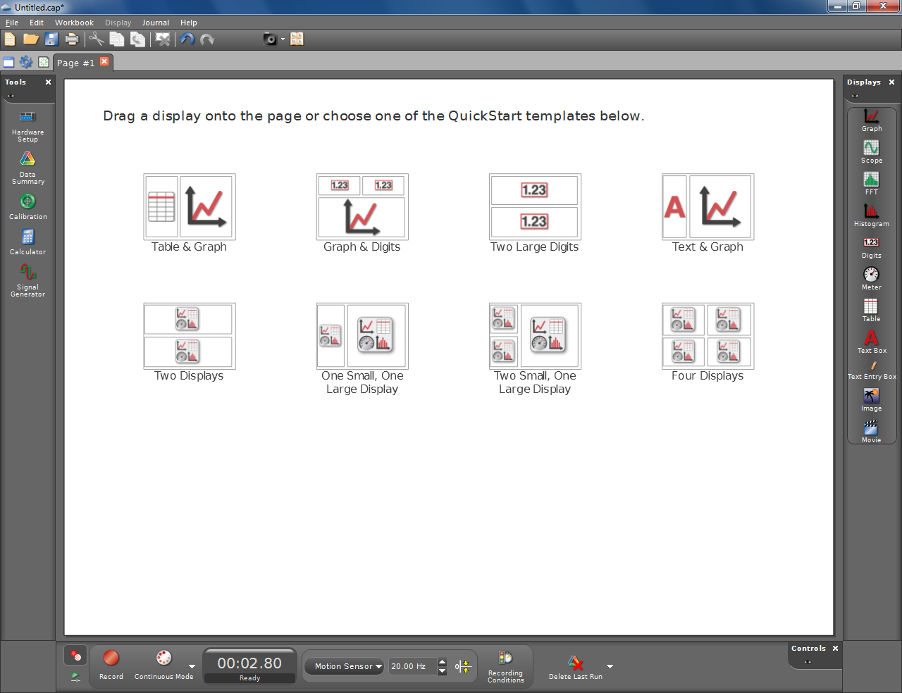

- Click on Select measurement and choose Time for the first column and position for the second. The time won’t show up until you choose Position as well.
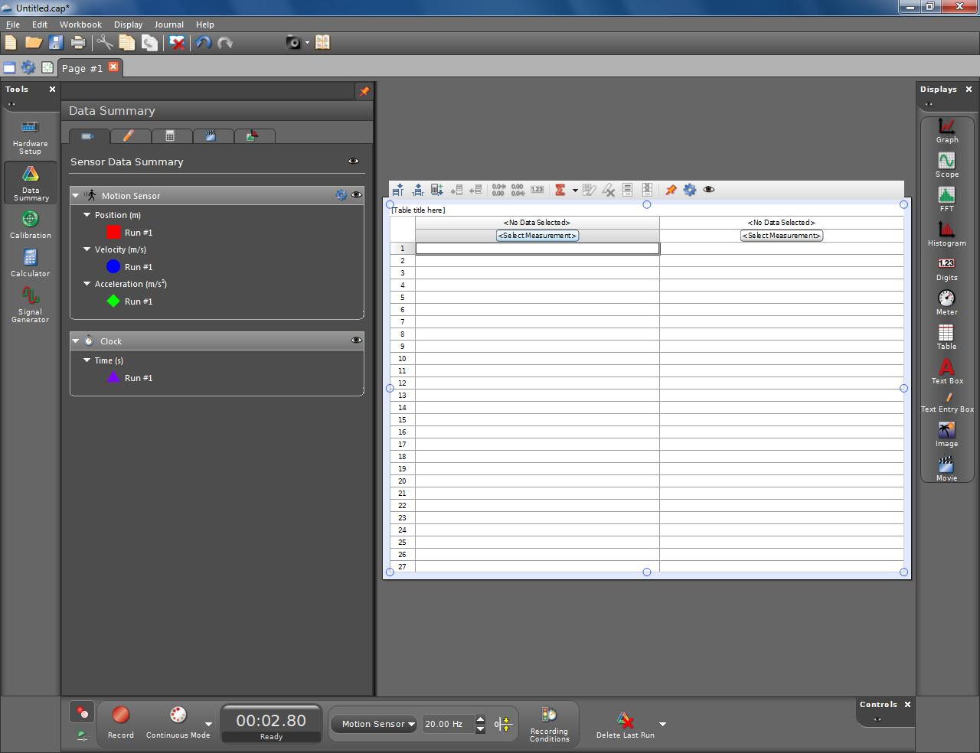

- Highlight the data in the table and click the main menu Edit/Copy. Open Excel and paste the data into Excel. If the start of Motion Sensor recording and the release of the cart did not coincide, you may need to eliminate some data at the beginning. If the cart reached the end of the track before the Motion sensor stopped recording, some data may need to be eliminated.
- Collect data for two more trials with the above scenario.
- Place a metal block on the cart and take data for three trials. Place a second metal block on the cart and take data for three trials.
- We wish to compare our data to the formula

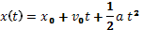

where x₀ is the initial position, v₀ the initial velocity and a the acceleration. In order to extract the acceleration we will fit (add a TrendLine) with its type set to Polynomial of order 2 (i.e. a quadratic).

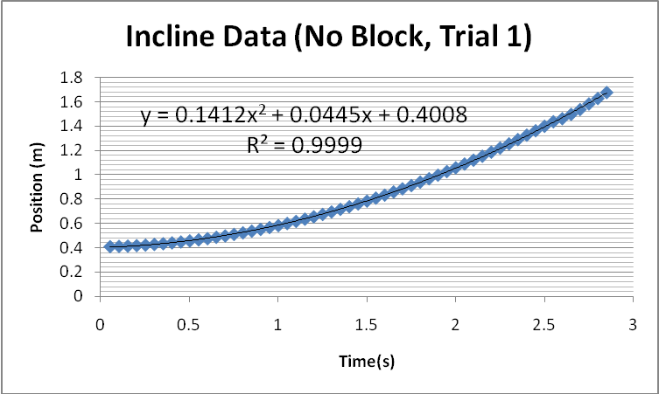

- Extract accelerations for all of your trials.

 | Acc.  ( )  Trial 1 | Acc.  ( )  Trial 2 | Acc.  ( )  Trail 3 | Average  Acc.  ( ) | Standard  Deviation  ( ) | Theory  g sin(θ)  ( ) | Percent Error

No block
One block
Two blocks

- Calculate the average, using =average(RangeOfCells).
- Calculate the standard deviation, using =stdev(RangeOfCells).
- Calculate the theory, using g*sin(θ).
- Calculate the percent error. The percent error is given by:
percent error = ((experimental value - theoretical value)/theoretical value) * 100%

- Include in your report commentary about whether your data when plotted in this way was “well fit” by the polynomial.
- Like the free fall case, the basic theory suggests that the acceleration of the cart on the incline does not depend on mass. Discuss whether your data supports this conjecture.

