Information Entropy

We are going to count the frequency of letter occurrence in English. Start by making a conjecture about what you expect the six most frequent and six least frequent letters to be.

Conjecture of most frequent:

Conjecture of least frequent:

Claude Shannon introduced the notion of entropy to the field of Information Science (also known as Communication Theory). Information entropy measures the rate at which information is transmitted. Using an alphabet of 26 letters suggests at first that one conveys log₂(26)= 4.7 bits per letter (ignoring spaces and punctuation). However, the calculation of entropy suggests that the alphabet’s capacity to convey information is not actually met because some letters are used frequently and some quite infrequently. In this lab you will calculate the entropy of two texts and compare their so-called frequency analyses and entropy calculations. (It might be interesting to compare two languages or text from two different centuries, etc.)

Open a new Word document and paste in some text (at least a long paragraph). The longer it is, the better the statistics. Open an Excel spreadsheet and in the first column place the header “Letters” followed by each letter as shown below.

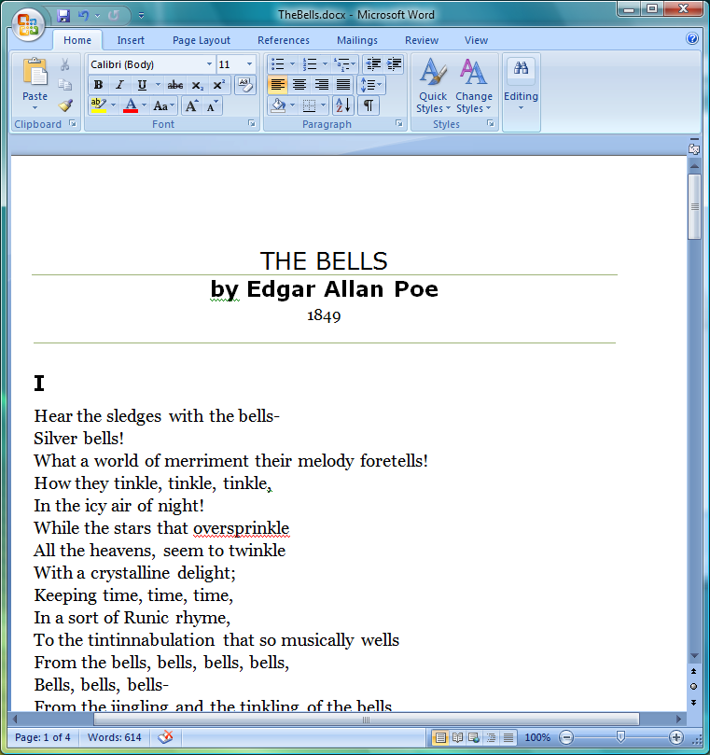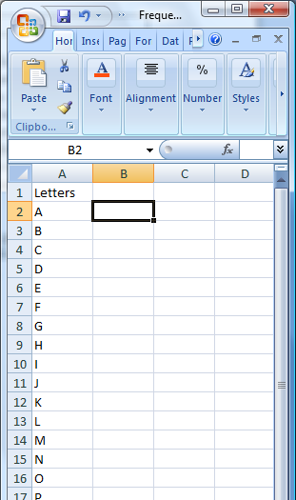

Use Word’s Find and Replace dialog box found under Edit/Replace. Enter an “a” in the Find What textbox and enter nothing in the Replace with textbox. Click on the Replace All button and enter the number of replacement reported into your Excel spreadsheet next to the letter a (Cell B2).

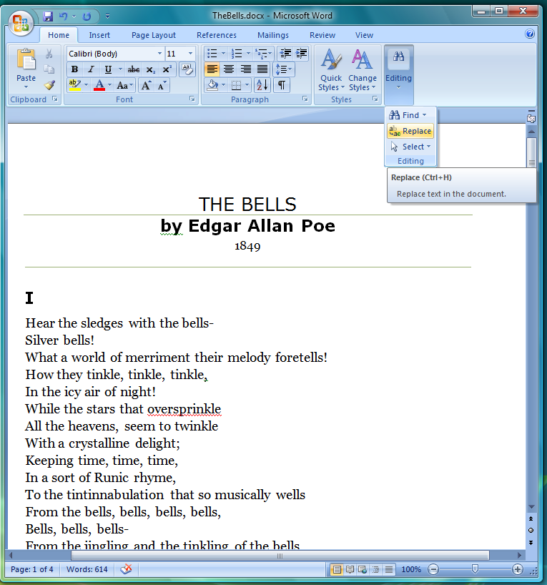

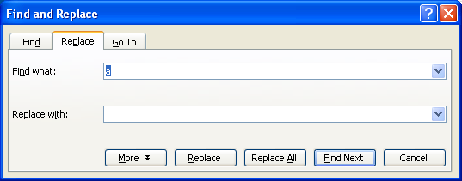

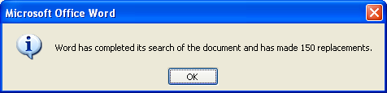

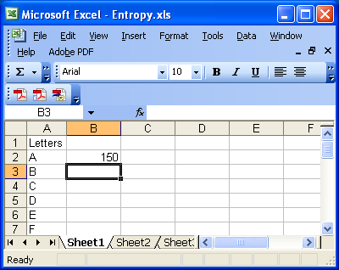

Continue with the other letters.

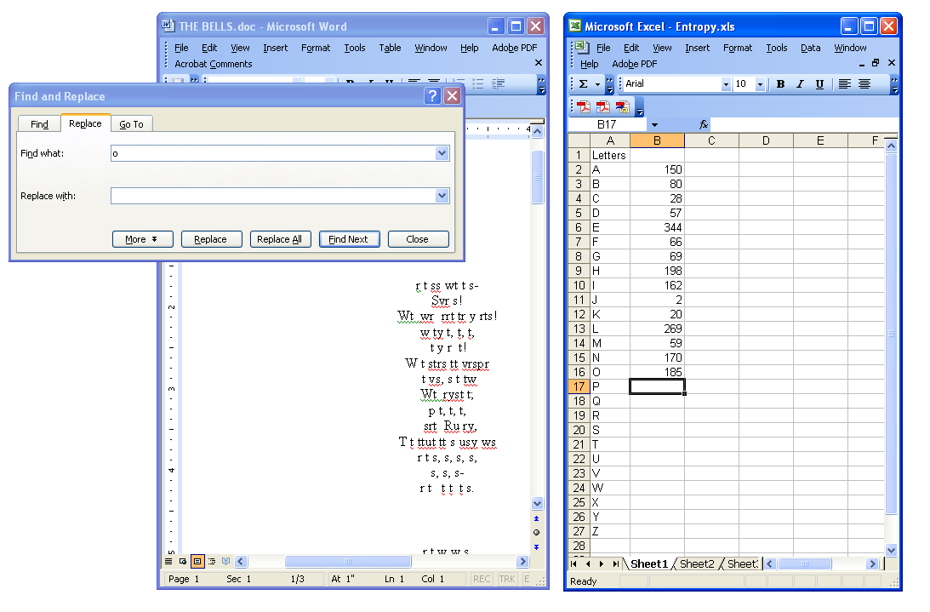

Strictly speaking we should count the spaces and various punctuation marks as well, but we will stop with the letters. Place a header “Frequencies” at the top of this column and then take the sum of the frequencies (highlight the cell at the bottom, B28 and either double click the Σ button or enter the formula =SUM(B2:B27).)

Place a header “Probabilities” in the third column. Calculate the probabilities by dividing the frequency by the sum. For example, enter in C2 the formula =B2/B$28. (You can check your calculations by summing this column; you should get 1.)

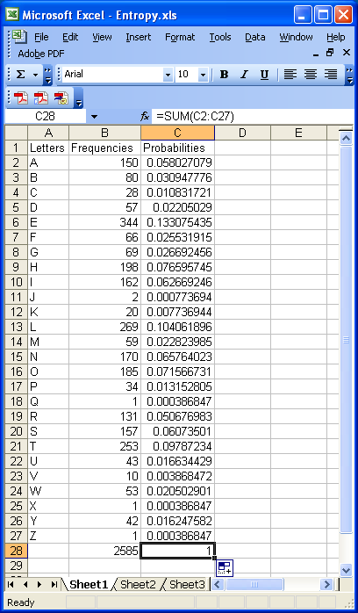

Make a histogram (column chart) of the letters and their probabilities. Right click on a column; choose Format Data Series; then on the Options tab, set the Gap Width to 0.

Because the frequency distribution shown above is based on the poem The Bells, the letters “b” and “l” have larger than usual probabilities. Frequency analysis is used to decrypt the messages hidden in cryptograms, such as that shown below.

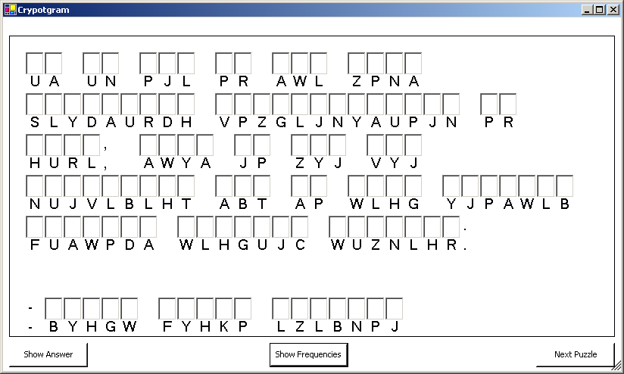

The 9th Century mathematician Al-Kindi did some of the early work on such techniques. It may seem odd that the uneven use of letters that allows one to discover the cryptogram’s hidden message also implies that it conveys less information than it could.

Frequency analysis is also used in file compression. It allows one to better match the size of a file with the actual amount of information contained therein. Next, we will calculate the entropy from the frequency distribution. In a column labeled “Entropy”, enter the formula = - C2*LOG(C2,2). If you have any frequencies that are zero, you may want to enter the more complicated formula =IF(C2=0, 0, -C2*LOG(C2,2)). Finally sum the entropy column to determine the entropy per letter as shown below.

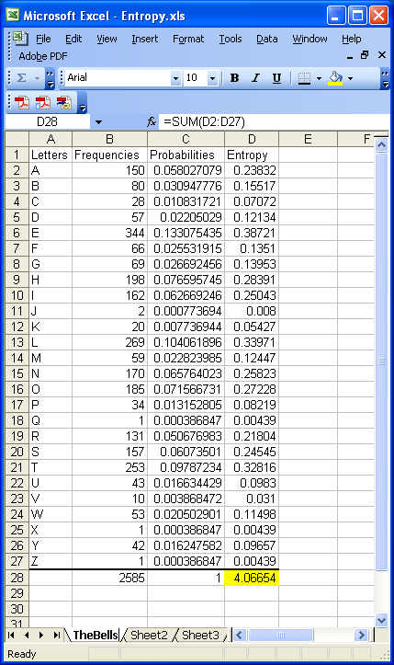

This calculation suggests that the poem The Bells by Edgar Allen Poe contains a little over 4 bits of information per letter. A standard encoding scheme for letters known as ASCII uses 8 bits per character. Thus one can see that such an encoding would not be efficient using almost twice as many bits as there is actual information in the text. Unlike ASCII which uses 8 bits for each character, efficient encoding methods use short codes for frequently occurring letters and long codes for infrequently occurring letters making for a shorter encoded message (on average). Morse code is an example of such a system – using a dot to represent the most common letter E and dash-dash-dot-dash to represent the infrequent Q.

Perform the frequency analysis and entropy calculation for your two texts. Compare these to a third distribution in which you make all of the frequencies the same. Having all of the frequencies the same should maximize the entropy and provide what we call the information capacity.

Make a comment on how your hypothesis compared to the experimental results.

Reference: http://en.wikipedia.org/wiki/ETAOIN_SHRDLU (from Jim Butler)

Microstates and Macrostates

Much of our understanding of heat and related phenomena involves the notion of what are called macrostates and microstates. A state is a description or specification of a system based on identifying the values of a number of properties or parameters. For example we could identify the state of a falling body by giving its height and its velocity at a given instant. A microstate is then a very detailed description of all of the system’s properties on a small-scale or microscopic scale. For example, a microstate of a gas would be to list the positions and velocities of all the molecules. On the other hand, a macrostate is a less detailed description of a few of the system’s gross, large-scale properties. For instance, a macrostate of a gas would be to list its density, volume, temperature and pressure. The ideas of statistical mechanics are tied up with the association between microstates and macrostates. Roughly the second law of thermodynamics will be that systems tend toward the macrostates which have the most microstates associated with them.

In this lab we will consider a simplified scenario of rolling three dice (a red one, a green one, and a white one). The microstate will be the specific value of each colored die. For example,

Microstate: Red: 3 Green: 1 White: 4

The macrostate will be the sum of the dice. For example,

Macrostate: Sum: 8

- In an Excel SpreadSheet, make a column for Red, Green and White values. Roll and record the three individual die values. Repeat for a total of 150 times. If I cannot get access to the real dice then we can simulate a die roll in Excel using the formula

=int(rand()*6+1)

- Sum the three die values for each roll (a formula like =A2+B2+C2 might help).
- In a nearby column make a list of possible sums, which are the numbers between 3 (all 1’s) and 18 (all 6’s) as shown below.

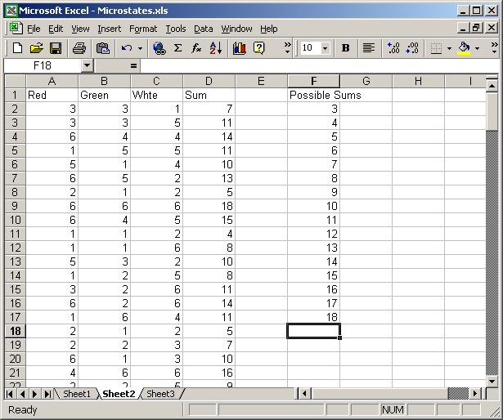

- Highlight the empty column to the right of the Possible Sums column. Include one more row than there are Possible Sums values. See below.

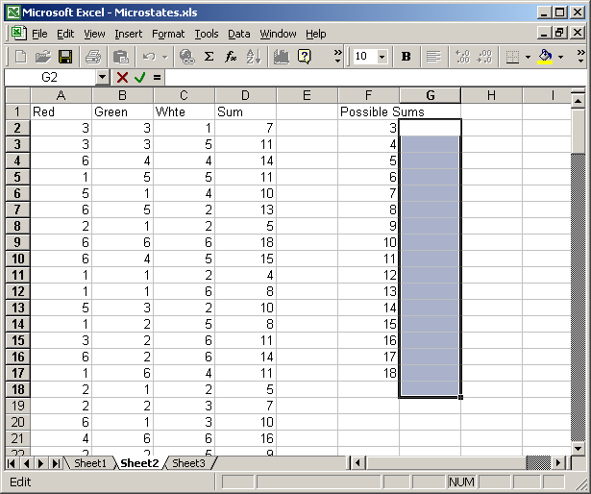

- Enter the following formula: =FREQUENCY (D2:D152,F2:F17), then hit simultaneously Ctrl+Shift+Enter. See below.

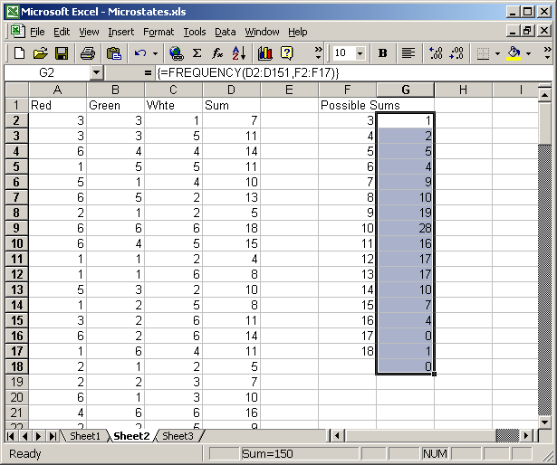

- The result should be that next each Possible Sum is its frequency – the number of times it occurred in the experiment. You can verify this by highlighting the Sum column and go to Edit/Find and search for a number such as 14, and count the number of times you find it.
- To determine the fraction of times a given macrostate occurred, divide the frequencies by the total numbers of rolls (e.g. =G2/150). See below.

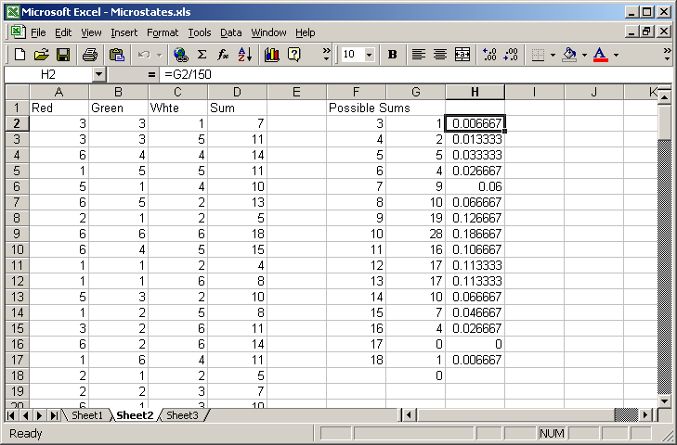

- Enter your fractions (decimals) in the table below and compare them to the ideal fractions.

Macrostate | Your fraction | Ideal fraction | As decimal
3 |  | 1/216 | 0.00463
4 |  | 3/216 | 0.013889
5 |  | 6/216 | 0.027778
6 |  | 10/216 | 0.046296
7 |  | 15/216 | 0.069444
8 |  | 21/216 | 0.097222
9 |  | 25/216 | 0.115741
10 |  | 27/216 | 0.125
11 |  | 27/216 | 0.125
12 |  | 25/216 | 0.115741
13 |  | 21/216 | 0.097222
14 |  | 15/216 | 0.069444
15 |  | 10/216 | 0.046296
16 |  | 6/216 | 0.027778
17 |  | 3/216 | 0.013889
18 |  | 1/216 | 0.00463

- In the Ideal fraction above the numerator is the number of microstates corresponding to the macrostate. For example, the macrostate 5 corresponds to the microstates {(1,1,3), (1,3,1), (3,1,1), (1,2,2), (2,1,2), (2,2,1)}. The denominator is the total number of microstates (which happens to be 6³=216.
- Note that even with only three dice, the “central” macrostates are more likely that those on either extreme – in this case 27 times more likely. Ultimately we say that a statement like “heat flows from a body with a higher temperature to one with a lower temperature is” is like saying “one is more likely to roll a 10 or 11 with three dice than to roll a 3 or an 18”.

