Microstates and Macrostates

Much of our understanding of heat and related phenomena involves the notion of what are called macrostates and microstates. A state is a description or specification of a system based on identifying the values of a number of properties or parameters. For example we could identify the state of a falling body by giving its height and its velocity at a given instant. A microstate is then a very detailed description of all of the system’s properties on a small-scale or microscopic scale. For example, a microstate of a gas would be to list the positions and velocities of all the molecules. On the other hand, a macrostate is a less detailed description of a few of the system’s gross, large-scale properties. For instance, a macrostate of a gas would be to list its density, volume, temperature and pressure. The ideas of statistical mechanics are tied up with the association between microstates and macrostates. Roughly the second law of thermodynamics will be that systems tend toward the macrostates which have the most microstates associated with them.

In this lab we will consider a simplified scenario of rolling three dice (a red one, a green one, and a white one). The microstate will be the specific value of each colored die. For example,

Microstate: Red: 3 Green: 1 White: 4

The macrostate will be the sum of the dice. For example,

Macrostate: Sum: 8

- In an Excel SpreadSheet, make a column for Red, Green and White values. Roll and record the three individual die values. Repeat for a total of 150 times.
- Sum the three die values for each roll (a formula like =A2+B2+C2 might help).
- In a nearby column make a list of possible sums, which are the numbers between 3 (all 1’s) and 18 (all 6’s) as shown below.

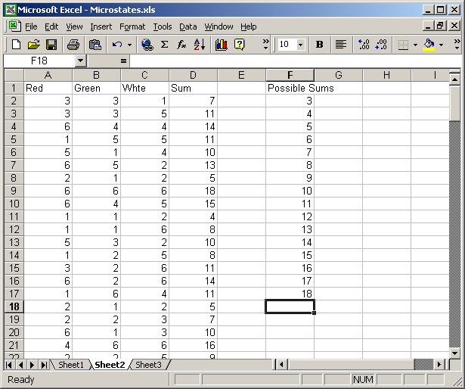

- Highlight the empty column to the right of the Possible Sums column. Include one more row than there are Possible Sums values. See below.

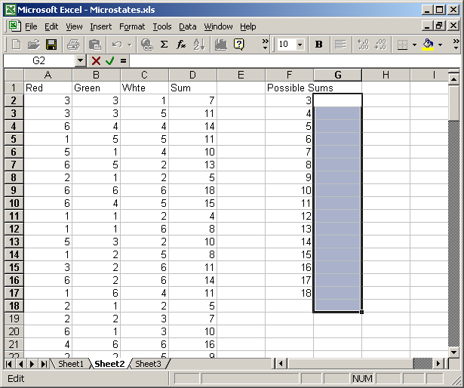

- Enter the following formula: =FREQUENCY (D2:D152,F2:F17), then hit simultaneously Ctrl+Shift+Enter. See below.

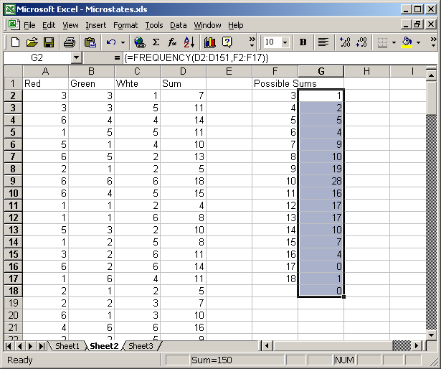

- The result should be that next each Possible Sum is its frequency – the number of times it occurred in the experiment. You can verify this by highlighting the Sum column and go to Edit/Find and search for a number such as 14, and count the number of times you find it.
- To determine the fraction of times a given macrostate occurred, divide the frequencies by the total numbers of rolls (e.g. =G2/150). See below.

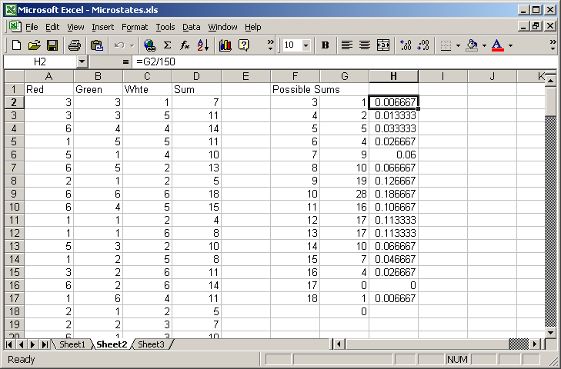

- Enter your fractions (decimals) in the table below and compare them to the ideal fractions.

Macrostate | Your fraction | Ideal fraction | As decimal
3 |  | 1/216 | 0.00463
4 |  | 3/216 | 0.013889
5 |  | 6/216 | 0.027778
6 |  | 10/216 | 0.046296
7 |  | 15/216 | 0.069444
8 |  | 21/216 | 0.097222
9 |  | 25/216 | 0.115741
10 |  | 27/216 | 0.125
11 |  | 27/216 | 0.125
12 |  | 25/216 | 0.115741
13 |  | 21/216 | 0.097222
14 |  | 15/216 | 0.069444
15 |  | 10/216 | 0.046296
16 |  | 6/216 | 0.027778
17 |  | 3/216 | 0.013889
18 |  | 1/216 | 0.00463

- In the Ideal fraction above the numerator is the number of microstates corresponding to the macrostate. For example, the macrostate 5 corresponds to the microstates {(1,1,3), (1,3,1), (3,1,1), (1,2,2), (2,1,2), (2,2,1)}. The denominator is the total number of microstates (which happens to be 6³=216.
- Note that even with only three dice, the “central” macrostates are more likely that those on either extreme – in this case 27 times more likely. Ultimately we say that a statement like “heat flows from a body with a higher temperature to one with a lower temperature is” is like saying “one is more likely to roll a 10 or 11 with three dice than to roll a 3 or an 18”.

