Newton’s Second Law
Newton’s Second Law is often seen written as an equation F=ma. It says that is there is unbalanced force acting on an object, then that object will experience acceleration (where acceleration is the rate of change of velocity).
In the case of the cart on the incline (studied in a previous lab), the cart (in particular, its mass) plays a dual role. It is the thing being accelerated, and it is the cause of the acceleration (the gravitational attraction between the mass and that of the earth). Now we will consider a situation in which the cause of the object's acceleration is not its weight.
- Set the track on two of the larger blocks so that it is level.
- At one end use a universal clamp to secure a Smart Pulley at track level. Plug the Smart Pulley into Digital Channel 1 of the Pasco Signal Interface. Open Data Studio, click on the image of Digital Channel 1, and choose Smart Pulley. (If you are having trouble with the Smart Pulley, the lab can be performed with a Motion Sensor, just ask for help.)
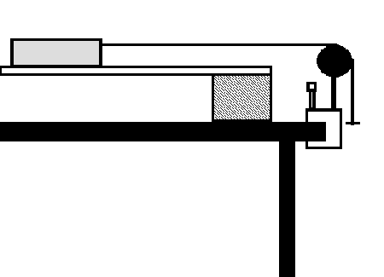
- Tie one end of a string to an empty cart, pass it over a pulley and tie the other end to a hanger. (The string coming from the cart should be horizontal.)
- Place the cart so that the string is taut and the hanger hangs just below the pulley.
- Begin recording data and release the cart.
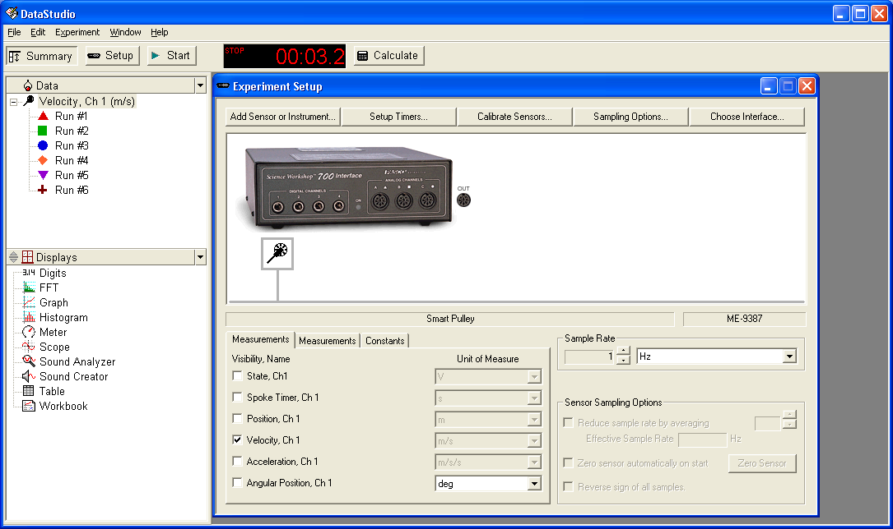
- Make sure Velocity is checked and no other quantities are checked. Drag a graph into the Run of interest. Plot velocity versus time and extract the acceleration. Please note that if the hanger hits the floor or if someone grabs the cart, then the "physics" changes. Drag across the relevant part of the data. Choose the Linear Fit option under the Fit drop-down list.
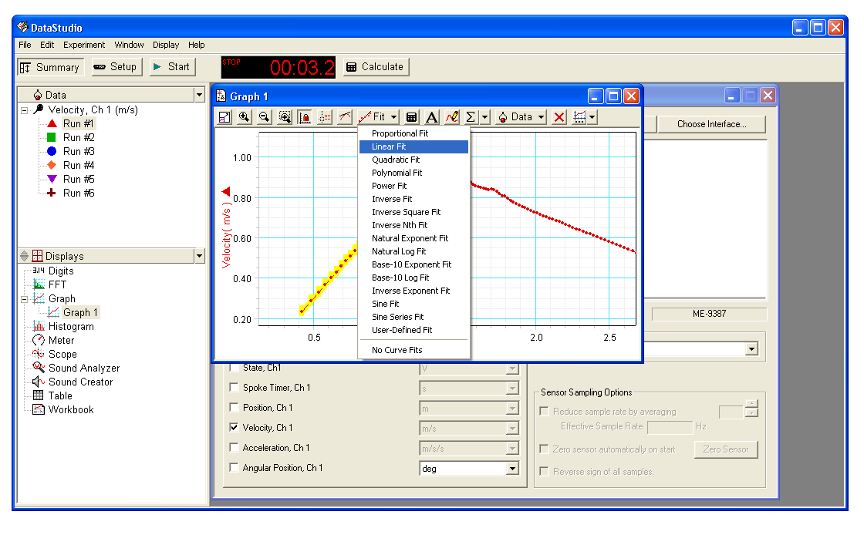
- Make note of the slope. The slope of curve in a velocity versus time graph is the acceleration.
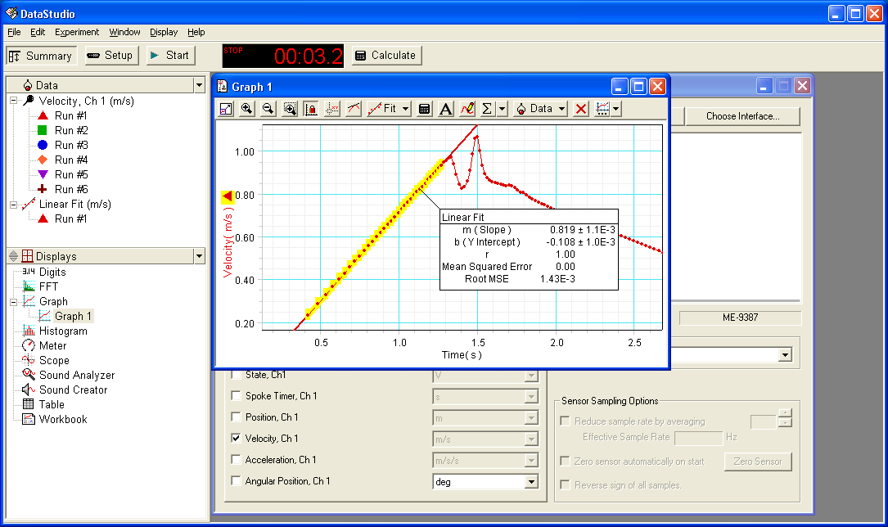
- Carts are roughly 500g, as are the rectangular metal blocks and the small hexagonal blocks. Large hexagonal blocks are about 1000g. Use combinations of these blocks so that the masses are approximately 500g, 1000g, 1500g, 2000g and 2500g.
Cart  Mass (kg)  (inc. block(s)) | Experimental  Acceleration (m/s²)  (from graph) | Theoretical  Acceleration (m/s²)  (from eq.) | Percent error
In the absence of friction and air resistance, theory predicts that
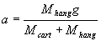
Use this formula to fill in the third column in the table above. (Hangers have a mass of 50g.) Calculate the percent error by taking the difference of the theory and experimental values and dividing that by the theoretical value and expressing the resulting fraction as a percentage. How do your results compare to theory?
Enter in the table below the sum of the mass of the cart (with blocks) and the mass of the hanger since it is the combination of the two that experience the acceleration. Then take the reciprocal (or inverse) of these numbers and enter them in the second column. Copy the experimental accelerations from above into the third column.
Mass of Cart and hanger (kg) | Reciprocal of Mass of Cart and hanger (kg⁻¹) | Experimental  Acceleration (m/s²)  (from graph)
Make a plot of acceleration versus reciprocal mass. Fit the graph (Add a Trendline) to a straight line and display the equation. The slope of the line should be the force, which is this case is the weight of the hanger. How does your slope compare to the weight of the hanger given by M_{hang} g? If your graph is like mine, you will have a small y intercept. Can you account for this y intercept physically?

Vary mass on hanger.
This time keep the mass of the cart (with a block or two in it) fixed and vary the mass on the hanger by adding masses of 10 to 20 grams.
Cart  Mass (kg)  (inc. block(s)) | Hanger plus mass on hanger (kg) | Experimental  Acceleration (m/s²)  (from graph) | Theoretical  Acceleration (m/s²)  (from eq.) | Percent error

