Honors 164  Some Practice | Name: ___________________________

Some equations
$$M_{A}{gℓ}_{A}=M_{B}{gℓ}_{B}$$ | ρ = M / V | W_{in air} = ρ_{obj} × V _{obj} × g
 | $$\frac{V_{\text{submerged}}}{V_{\text{obj}}}=\frac{ρ_{\text{obj}}}{ρ_{\text{water}}}$$ | $$v_{\text{ave}}=\frac{v_{\text{initial}}+v_{\text{final}}}{2}$$
  ρ_{obj} | = | W_{in air} | ρ_{water}
  ρ_{obj} | = | W_{in air} - W_{in water} | ρ_{water}
x(t) = x₀ + v₀ t + a t² / 2 | $$h=\frac{{\text{gt}}^{2}}{2}$$ | %Error = |Exp-Theory|/Theory*100%
t = (2 h / g)^{1/2} | v = R (g / (2 h))^{1/2} | R_{th} = v₀² sin ( 2 θ ) / g
$v=\text{at}$ (zero initial velocity) | $$a=g\text{sin}θ$$ | %Diff = |R₁-R₂|/((R₁+R₂)/2)*100%
$s=\frac{1}{2}{\text{at}}^{2}$(zero initial velocity) | $$x_{\text{ave}}=v_{\text{ave}}t$$ | $$h=\frac{{\text{gx}}^{2}}{2v^{2}}$$
$$F=\text{ma}$$ | $$F=G\frac{m_{1}m_{2}}{r^{2}}$$ | 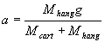
 | $$g=\frac{{\text{GM}}_{\text{earth}}}{{\left(R_{\text{earth}}\right)}^{2}}$$
$$p=\text{mv}$$ | $$P=p_{1}+p_{2}+\text{.}\text{.}\text{.}$$ | $$P_{\text{before}}=P_{\text{after}}$$

Conversion factors
1 inch = 2.540 centimeter | 1 year = 365.25 days | 1 pound = 4.448 Newtons
1 mile = 1.609 kilometer | 1 day = 24 hours | 1 atmosphere = 1.013×10⁵ Pascals
1 meter = 100 centimeter | 1 hour = 60 minutes | 1 Pascal = 1 Newton/meter²
1 kilogram = 1000 grams | 1 minute = 60 seconds

The record for a marathon (which covers approximately 26.22 miles) is approximately 2.094 hours. What is this runner’s average speed in miles per hour?

What is the runner’s average speed in meters per second? (If you haven’t answered the above convert 15 miles per hour.)

A box of unknown mass X is located 15 cm to the right of the ____________________; whereas a 5-kg box is located 25 cm to the left. Determine the unknown mass assuming the lever is balanced.

X
5 kg
25 cm
15 cm

Unknown box mass X:

If a steel ball is projected horizontally from a height of 50.0 cm above the ground, then how long will it take after leaving the launcher before the ball hits the ground?

If the above ball lands at a point that is 80.0 cm from a point directly under the launcher, then what was the horizontal velocity of the ball? (If you did not solve the above, you can assume the time is .400 seconds.)

A solid cylinder of unknown material has mass (m) of 23.3 grams, a height (h) of 6.30 centimeters, and a radius (r) of 1.15 centimeters. What is the density of the unknown material? Show work. (The volume of a cylinder is V_{cyl} = πr²h.)
Density:

Would the cylinder float in water? Explain your answer.
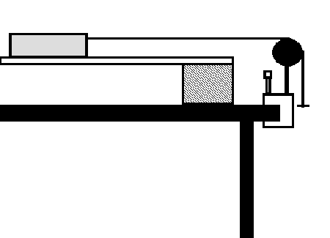

Calculate the ideal acceleration for the situation shown above if the hanger mass is 70 g and the mass on the horizontal (frictionless) surface is 1500g.

Convert 30 pounds per square inch to Pascals (N/m²).

Look up the necessary values to determine the acceleration due to gravity on the surface of the Mars, g_{Mars}.
g_{Mars}:

If Cart A having a mass of 500 g travels down the track with a velocity of 0.720 m/s collides and sticks to Cart B having a mass of 1000 g which was sitting still. Then what is the velocity of the two carts after the collision?

If you can throw a ball at 25 m/s, then what is the farthest away your receiver can be assuming no air resistance and that the ball is caught at the same height at which it was thrown. Explain.

From the graph of a Cart’s position on an incline shown above, extract the Cart’s
- Initial position
- Initial velocity
- Acceleration
- Best guess at the angle of incline

