H164 Lab – Practice Problems for Midterm
Some equations
 | ρ = M / V | W_{in air} = _{obj}  V _{obj}  g
 |  | v(t) = v₀ + at
  ρ_{obj} | = | W_{in air} | ρ_{water}
  ρ_{obj} | = | W_{in air} - W_{in water} | ρ_{water}
x(t) = x₀ + v₀ t + a t² / 2 |  | %Error = |Exp-Theory|/Theory*100%
 |  | %Diff = |R₁-R₂|/((R₁+R₂)/2)*100%
 |  | 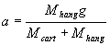
F=dp/dt
4 π² R_{Sp}³ = G M_{sun} T² | a_{centripetal}=v²/r | 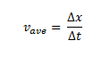

Conversion factors
1 inch = 2.540 centimeter | 1 year = 365.25 days | 1 pound = 4.448 Newtons
1 mile = 1.609 kilometer | 1 day = 24 hours | 1 atmosphere = 1.013×10⁵ Pascals
1 meter = 100 centimeter | 1 hour = 60 minutes | 1 Pascal = 1 Newton/meter²
1 kilogram = 1000 grams | - minute = 60 seconds

1. The Empire State Building has a roof height of 380 m. Neglecting air resistance how long would it take an object dropped from the roof to reach the street below?

What speed would the object have just before hitting the street?

Mass of Venus | 4.86900 × 10²⁴ kg
Mass of the sun | 1.98892 × 10³⁰ kg
Radius of Venus | 6 051.8 km
Radius of Sun | 695,500 km
Average distance from Sun to Venus | 108,000,000 km
Gravitational constant | 6.67300 × 10⁻¹¹ m³ kg⁻¹ s⁻²

2. Using the data provided above determine the acceleration due to gravity on the surface of Venus, i.e. g_{Venus}.

3. Using the data provided above determine the length of a year on Venus in (Earth) days.

4. Usain Bolt holds the World Record for the 100 meter sprint of 9.58 seconds. What is his speed in m/s?
What is his speed in miles per hour?

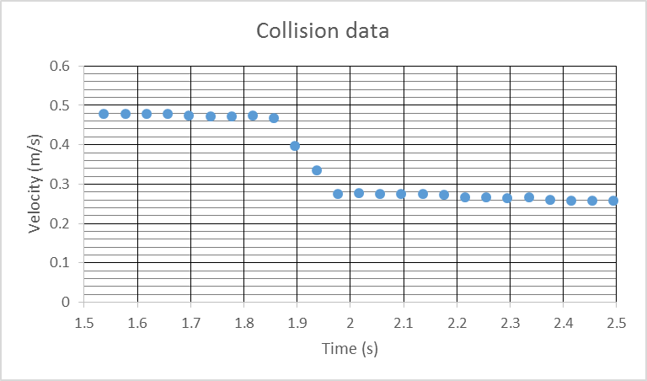
5. The data in the graph above was taken as a cart of mass 1.48 kg collided with and became attached to a second cart of mass 0.995 kg which was initially stationary.
Calculate the momentum of the two-cart system before and after the collision and comment on your results.
Before:

After:

Comment:

Use the same data to determine the force exerted on first cart by the second cart as well as the force exerted on the second cart by the first cart. Comment on your results.
Force on first cart

Force on second cart

Comment

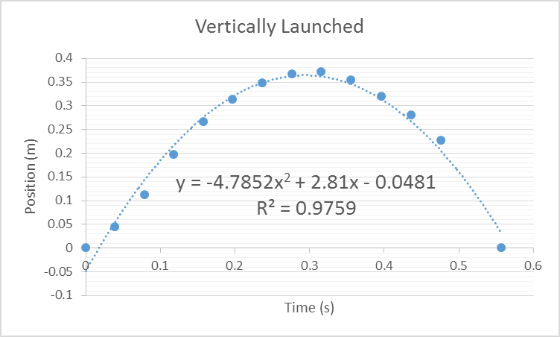
6. The data graphed above was for the position of a vertically launched ball. Note the fit equation. What would be the corresponding equation for the velocity of the ball?



7. A bar of soap has sides of length 10.3, 6.9 and 3.4 cm and a mass of 212 g. When placed in water the submerged height appeared to be 3.1 cm.

Calculate the density of the soap.

Calculate the Buoyant force and compare it to the weight.

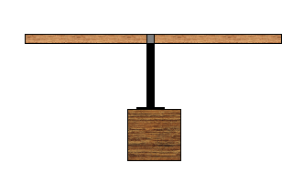
8. A half-meter stick (of mass 100.25g) was balanced as shown above – the center was at 25.2 cm from the left edge of the stick. After balancing the stick a hanger was added to each side. On the right-hand side a bracket (of mass 19.5) attached to a 50.0-g hanger with 20.0 g mass on that hanger was fixed at a location of 35.0 cm from the left edge of the stick. The total mass (bracket, hanger and mass on hanger) as well as the position of the hanger on the left are recorded in the table below. Calculate the corresponding weights and lever (moment) arms.

Right hanger mass including bracket (g) | Position from right edge (cm) | Weight of right hanger ( ) | Lever (Moment) arm of right hanger ( )
 | 35.0
 | 35.0

Left hanger mass including bracket (g) | Position from left edge (cm) | Weight of left hanger ( ) | Lever (Moment) arm of left hanger ( )
70.6 | 12.0
80.6 | 13.5

Do some calculations to test whether this data is consistent with the Law of the Lever.

9. One end of an incline of length 227 cm was raised 9.5 cm to form an incline. What is the ideal acceleration for this scenario?
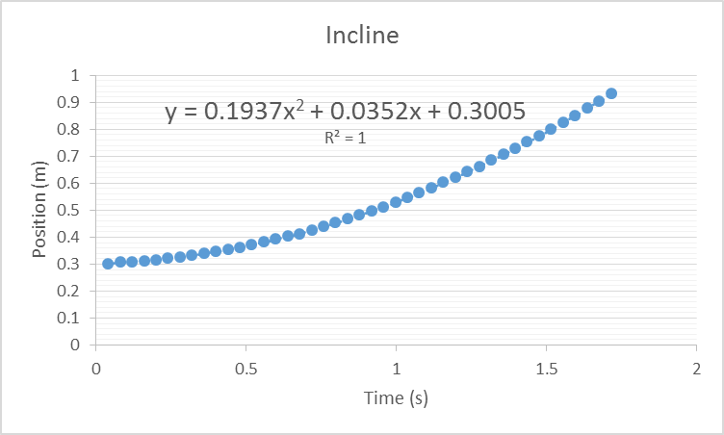
A cart of mass 485g rolled down the track and the data above collected. What is the acceleration indicated by this graph?

If the difference between the ideal acceleration and actual acceleration is due solely to friction then calculate the frictional force acting on the cart.

