Making and Interpreting XY Scatter Graph
A graduated cylinder was placed on a mass balance and a liquid was poured in. The followed data was collected.
Mass (g) | Volume (ml)
141.3 | 19.0
150.3 | 28.4
160.8 | 39.0
168.4 | 46.2
173.1 | 51.0
177.9 | 55.9
183.1 | 61.0
190.0 | 69.2

Objective: Make a graph of mass versus volume. Fit the data to a straight line. Interpret.
Another way to say mass versus volume is to say mass as a function of volume. The convention is to talk about y (the dependent variable) as a function of x (the dependent or control variable). Thus in mass versus volume, mass will be on the y axis and volume will be on the x axis. In Excel it is easiest to make a graph if the x-data comes before the y-data. So the order of the data above was switched in Excel.
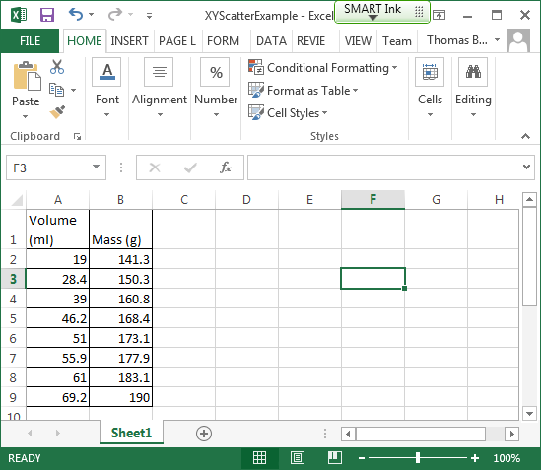
To make an XYScatter graph, start by highlighting the numbers. (Simple column headers can be highlighted, but more complex headers can confuse Excel. Also Excel’s standard formatting is to right justify numbers and left justify text. If you find your numbers are not right justified, look for a hidden space before or after the number.) After highlighting the data, go to the Insert tab and click on the Scatter icon.
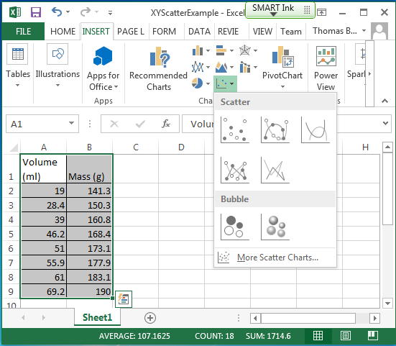
Next with the resulting chart highlighted, click on the (Chart) Design tab, then under Quick Layout on the left, choose Layout 9.
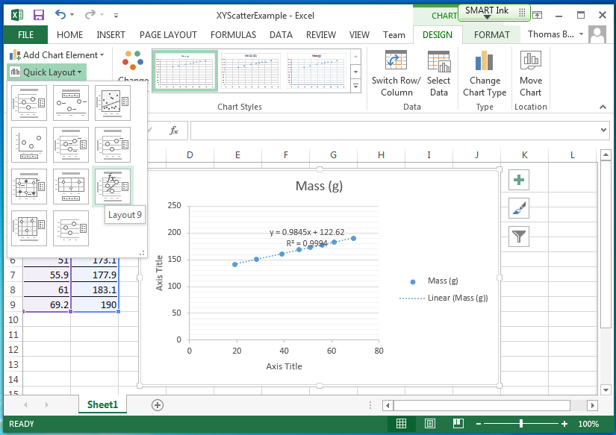

Click on the Axis Titles and change them. Remember that volume was on the x (horizontal) axis and mass was on the y (vertical) axis.
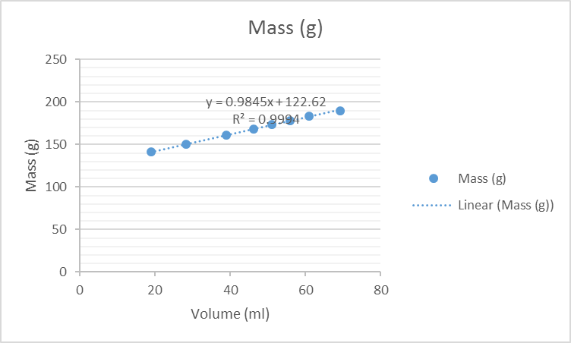
Click on the Title and change it.
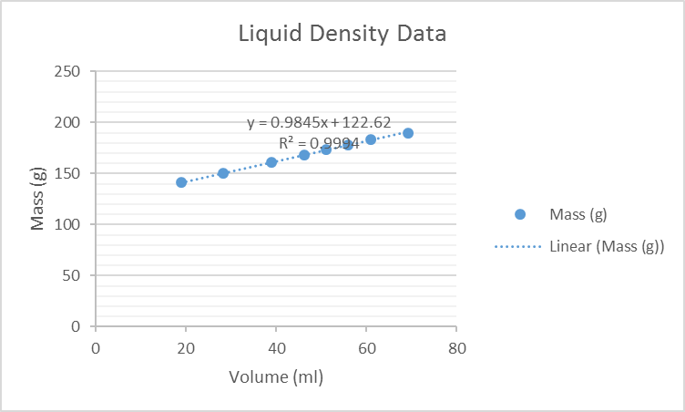
If you want to change the legend, right click on a data point and choose Select Data. Choose Edit from the resulting dialog. Change the Series Name. Click OK and OK.
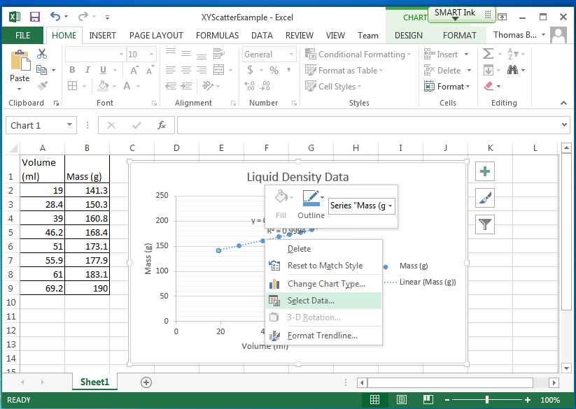
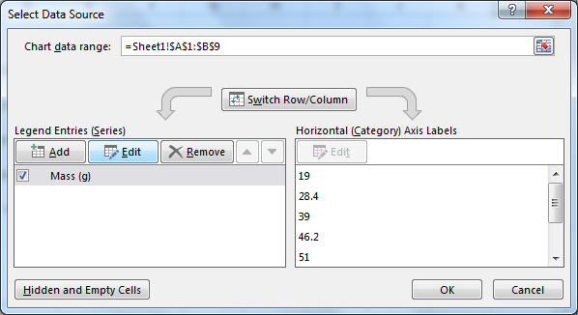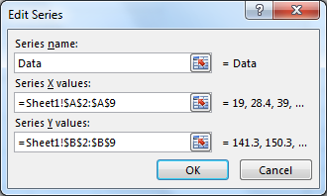
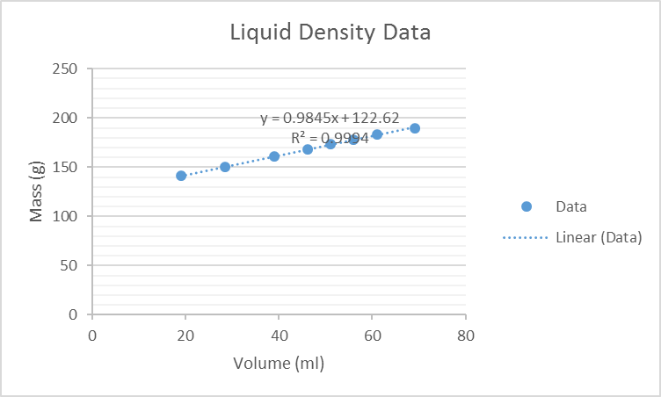
In the above case the legend may not be adding any additional information and might be eliminated by right clicking on it and choosing Delete.
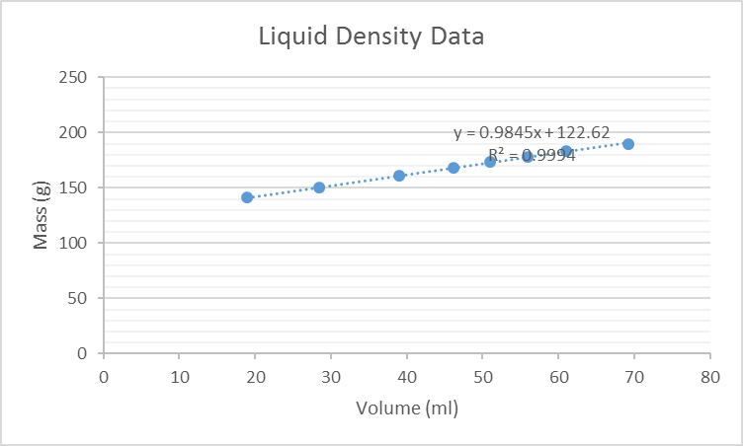

Move the equation by clicking on it and dragging it to another location. Change the font size by highlighting the equation text and then going to the Home tab and using the Font size drop down. (In the same place you can change the Font Color and Background Color.)
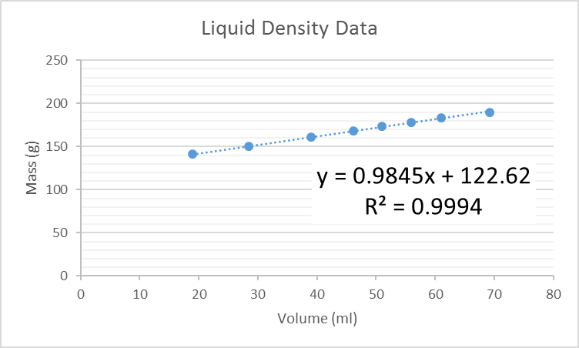

Interpreting the fit line.
Layout 9 includes a “fit” (what Excel calls a Trendline and in other places is known as a regression analysis.) Layout 9 defaults to a straight line which is the desired mathematical fit for this data. Other choices (e.g. Power, Exponential, …) can be obtained by right clicking on the line and choosing Format Trendline.
The equation for a line (y = m x + b) is characterized by two parameters: the slope and the y intercept. We typically expect these values to be meaningful.
What is the value of the slope? What are the units of the slope? What is the interpretation of the slope?
The slope (m) is the coefficient of the x variable. In the fit equation displayed it is 0.9845. Slope is often referred to as rise over run and its units are the y-axis units over the x-axis units. In this case, that is g/ml. This is a mass divided by a volume and its interpretation is the density of the liquid. Putting these pieces together we would say that the experimental density of the liquid is 0.9845 g/ml.
What is the value of the y intercept? What are the units of the y intercept? What is the interpretation of the y intercept?
The y intercept (b) is the constant term in the equation. In the fit equation displayed it is 122.62. The units on the y axis are g. The y intercept is the value obtained when x=0. Since x represents the volume of liquid, and y intercept is the mass measured; the y intercept is the mass when there is no liquid – or just the mass of the empty graduated cylinder. So the mass of the graduated cylinder is 122.62 g.

