Practice Test Summer Lab

Show your work, I cannot give partial credit without it. Make sure to include the proper units in all of your answers and on the axes of your plots.

- A Cart Rolling Down an Incline.

On the Incline Sheet of the Excel file Lab_Practice_Suml.xls you will find data taken using a motion sensor and Data Studio. The data includes the position as a function of time and the velocity as a function of time. The position measured is shown in the picture below.
Motion sensor

x

2.27 - x
9.2 cm
h

The length of the track is 2.27 m and it is raised up 9.2 cm at one end. The cart has a mass of 500.8 g.

- The cart hits a barrier at the bottom and thus there is some “bad” data at the end. Eliminate it. Then determine the measured acceleration graphically, i.e. plot the data, fit it appropriately and extract the acceleration. Include your last name in the title of your graph, for example, “Smith: Measured Acceleration.” (Most of the bad data has already been eliminated.) Paste the graph below.

Graph goes here

- Determine the ideal acceleration. The ideal acceleration is from theory neglecting any friction or air resistance..

Show your work for the ideal acceleration

- Calculate the frictional force assuming that it accounts entirely for the difference between the ideal and measured accelerations.

Measured Acceleration  ( ) | Ideal Acceleration  ( ) | Frictional Force  ( )

Show your work for the frictional force

- Adapt the procedure from Atwood machine: An Energy Approach, that is, fill in the columns for Average Consecutive Velocity, Kinetic Energy, and so on. One difference is that only one object is moving this time. Another is that the height was not directly measured (see the picture above). If you use trigonometry, remember that Excel assumes that angles are given in radians.

- Plot on one graph The Mechanical Energy versus Time and The Mechanical Energy plus Work done against Friction versus Time.

Graph goes here

- Density of an object.

The following data was collected for an object.

Length (cm) | Width (cm) | Height (cm) | Mass (g) | Force weighed in air (N) | Force “weighed” in water (N)
1.9 | 1.9 | 5.1 | 164.2 | 1.673 | 1.495

Make two completely independent calculations of the object’s density (by completely independent, I mean no piece of information can be used in both equations).

Density ( )

Method 1
Method 2

Show your work for the density (Method 1)

Show your work for the density (Method 2)

- The Force Constant of a spring.

On the Spring Sheet of the Excel file Summer_lab_final.xls you will find data taken using a motion sensor and Science Workshop. The data is given below as well. Masses were placed on a hanger, which hung from a spring positioned over a motion sensor. Determine the spring’s force constant.

Mass (kg) | Position of bottom of hanger (m)
0.050 | 0.8115
0.100 | 0.7864
0.150 | 0.7454
0.200 | 0.7365
0.250 | 0.6912
0.300 | 0.6516
0.350 | 0.6386

What is the spring constant?

Show your work for the spring constant

Projectile Motion

The data below (which can also be found on the Projectile Sheet of the Excel file Summer_lab_final.xls) gives the ranges for three trials at various angles, just as in the last part of the projectile lab. For each trial, calculate the average range as well as the standard deviation. Using that data, calculate the initial speed as the ball leaves the launcher. Also calculate the time of flight (the time from when the ball leaves the launcher until it first hits the lab bench). Final calculate the spread in the velocities. If you use trigonometry, remember that Excel assumes that angles are given in radians.

Angle (degrees) | Range Trial 1 (m) | Range Trial 2 (m) | Range Trial 3 (m) | Average Range (m) | Standard deviation Range (m) | Average Velocity (m/s) | Spread in velocity (m/s) | Time of Flight (s)
20 | 0.5176 | 0.5183 | 0.5271
25 | 0.6268 | 0.6089 | 0.6204
30 | 0.6984 | 0.6796 | 0.7028
35 | 0.7441 | 0.7609 | 0.7625
40 | 0.7860 | 0.7774 | 0.7893
45 | 0.7904 | 0.8016 | 0.7934
50 | 0.8003 | 0.7959 | 0.7755
55 | 0.7519 | 0.7588 | 0.7576
60 | 0.6893 | 0.7059 | 0.6890
65 | 0.6064 | 0.6023 | 0.6115
70 | 0.5212 | 0.5009 | 0.5085

Collisions

The data shown in the graph below (which is also found on the Collision sheet of the Excel file) shows the velocity of Cart 1, a cart with a block (total mass 1.0068 kg). The sharp fall off in velocity (around a time of 2.1 s) occurs when this cart collides with and sticks to Cart 2, another cart (of mass 0.5042kg) which was previously stationary.

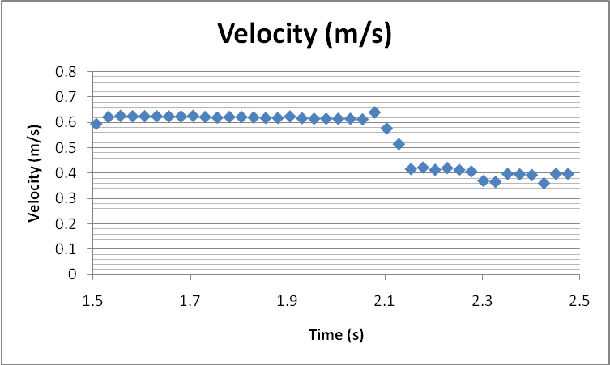

Estimate the acceleration experienced by Cart 1 during the collision.

Estimate the corresponding force by Cart 1.

Estimate the acceleration experienced by Cart 2 during the collision.

Estimate the corresponding force by Cart 2.

Forces in Equilibrium.

Calculate the unknown masses in the set-up shown below. Use a protractor if you need to measure any angles.

M₁  ( ) | M₂  ( )

M₂
M₁

M₃ = 450 g

