Summer Lab Final  June 22, 2010 | Name: _______________________________

Show your work, I cannot give partial credit without it. If you are missing a piece of information, explain what you would do if you had it. Make sure to include the proper units in all of your answers and on the axes of your plots.

1. The table below has data taken using a motion sensor. (It can also be found on the Spring sheet of the Excel file.). Masses were placed on a hanger, which hung from a spring positioned over a motion sensor.

Mass, includes hanger (kg) | Position of bottom of hanger (m) | Displacement from equilibrium (m)
0.05 | 0.853
0.1 | 0.841
0.15 | 0.825
0.2 | 0.813
0.25 | 0.800
0.3 | 0.788
0.35 | 0.774

Use a graph to determine the spring’s force constant and equilibrium position. Enter them below. Determine the displacements, enter them above. Show work and/or explain. Include your last name in the title of the graph.

Graph goes here

Spring constant ( ) | Equilibrium position ( )

Work/Explanation:

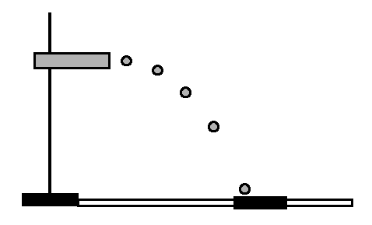
2. A ball was shot horizontally from the heights given in the table below. The corresponding ranges for three trials are given below as well.

Height (cm) | Range (cm) | Range (cm) | Range (cm) | Average Range  ( ) | Standard Deviation ( ) | Average Initial Velocity ( )
20 | 38 | 38.1 | 36.7
40 | 53.6 | 51.7 | 53.1
60 | 65 | 63.5 | 64.3
80 | 68.8 | 69.3 | 69.1
100 | 82.4 | 83.6 | 83.7

- Determine the average range and standard deviation for each height.
- Next calculate the initial velocity of the projectile for each height.
- Paste a graph of Average Range versus height, fit it to a power law. What power do you find experimentally? What power do you expect theoretically?

Graph goes here

Experimental power:

Theoretical power:

- If you had time to repeat the measurements at just one height, which height would you choose and why?

Repeat height:

3. An experiment was performed with two carts and three blocks – each cart and each block has a mass of 500 g. The graph below shows the velocity of Cart 1 heading down a track and colliding with Cart 2, which initially had no velocity. After the collision, the two carts stuck together. Use the data displayed in the graph to determine which of the following scenarios pertains.
- 3 blocks in Cart 1, 0 blocks in Cart 2
- 2 blocks in Cart 1, 1 block in Cart 2
- 1 block in Cart 1, 2 blocks in Cart 2
- 0 blocks in Cart 1, 3 blocks in Cart 2

Which set of masses? Explain your answer.

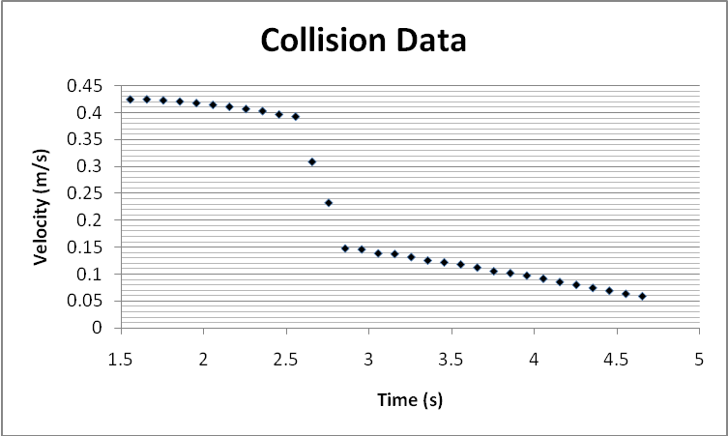

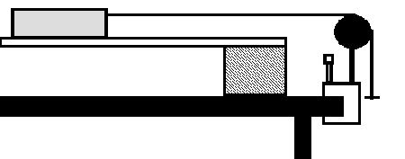

4. In the figure above a 490.85-g cart with one 500.6-g block is pulled by a string attached to a 50-g hanger with no other masses on it. The initial height of the hanger is 75.6 cm above the floor. The position versus time and velocity versus time can be found on the CartPulley sheet of SummerLab1_10.xlsx.

- Determine the measured acceleration graphically, i.e. plot the data, fit it appropriately and extract the acceleration. Include your last name in the title of your graph, for example, “Smith: Measured Acceleration.” Paste the graph below.

Graph goes here

- Determine the ideal acceleration. The ideal acceleration is from theory neglecting any friction or air resistance.

Show your work for the ideal acceleration

- Calculate the frictional force assuming that it accounts entirely for the difference between the ideal and measured accelerations.

Measured Acceleration  ( ) | Ideal Acceleration  ( ) | Frictional Force  ( )

Show your work for the frictional force

- Assuming the friction is entirely between the cart and the track; use the frictional force from above to determine the coefficient of friction.

- Adapt the procedure from Atwood machine: An Energy Approach, that is, fill in the columns for Average Consecutive Velocity, Kinetic Energy, and so on. Save your Excel and submit it as part of the exam.

- Plot on one graph The Mechanical Energy versus Time and The Mechanical Energy plus Work done against Friction versus Time.

Graph goes here

5. A liquid was added to a graduated cylinder that was on a mass balance. The data in the table below was collected. (It can also be found on the Liquid sheet of the Excel file.) Make a graph and from it determine the density of the fluid in kg/m³ and the mass of the graduated cylinder. Include your name in the title of the graph.

Vol. (ml) | Mass (g)
15 | 106.2
25 | 120.4
35 | 131.9
45 | 144.4
55 | 157.4
65 | 170.8
75 | 181.6
85 | 195.9

Graph goes here

Density (kg/m³):

Mass of graduated cylinder:

Would this fluid float on top of water, sink below the water, or mix with the water? How do you know?

6. In the scenario shown below, the hanging mass is 475 g. Determine the tensions of the three strings. Use a protractor to measure any angles. Show all work, give all reasoning.

Tension ( )
A
B
C

A
B
C

