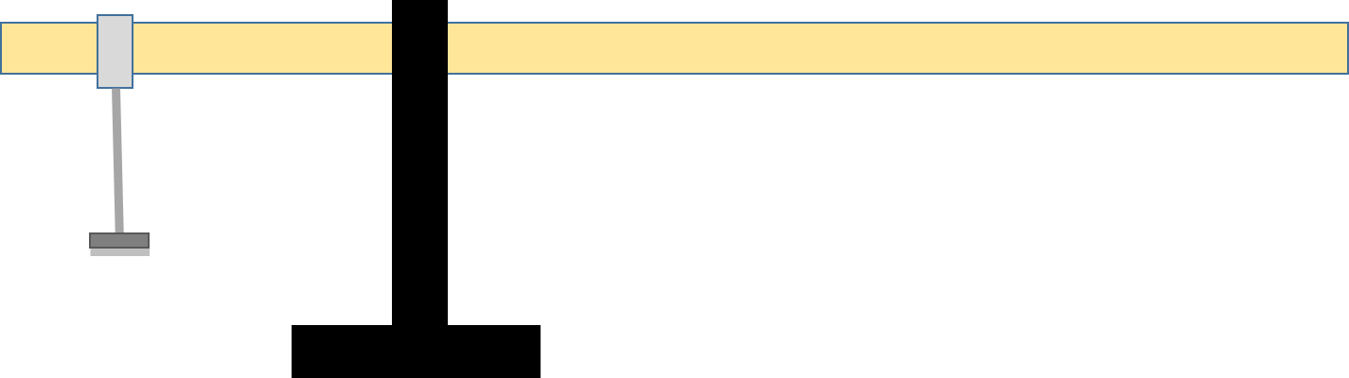

Mass of stick is 99.1 g
Location of Center-of-Mass of stick 25 cm
Mass of bracket + Mass of hanger + Mass on hanger = 20.6 + 50.0 + 50.0 = 120.6 g
Location of bracket 5cm
Location of pivot (fulcrum) 14.1 cm

Analysis 1.
Clockwise torque due to weight of stick acting at 25cm.
R – distance to pivot 25-14.1 = 10.9
Torque_clock = M_stick * g * R_stick * sin(90°) = (.0991)(9.8)(.109)(1) = 0.1059 Nm

Counterclockwise torque due to weight of hanger acting at 5 cm
R – distance to pivot 14.1 – 5 = 9.1
Torque_counter = M_hang * g * R_hang * sin(90°) = (.1206)(9.8)(.091)(1) = 0.1076 Nm

Net torque = 0.1076 – 0.1059 = 0.0017 Nm – close to zero as should be for equilibrium

Reanalysis
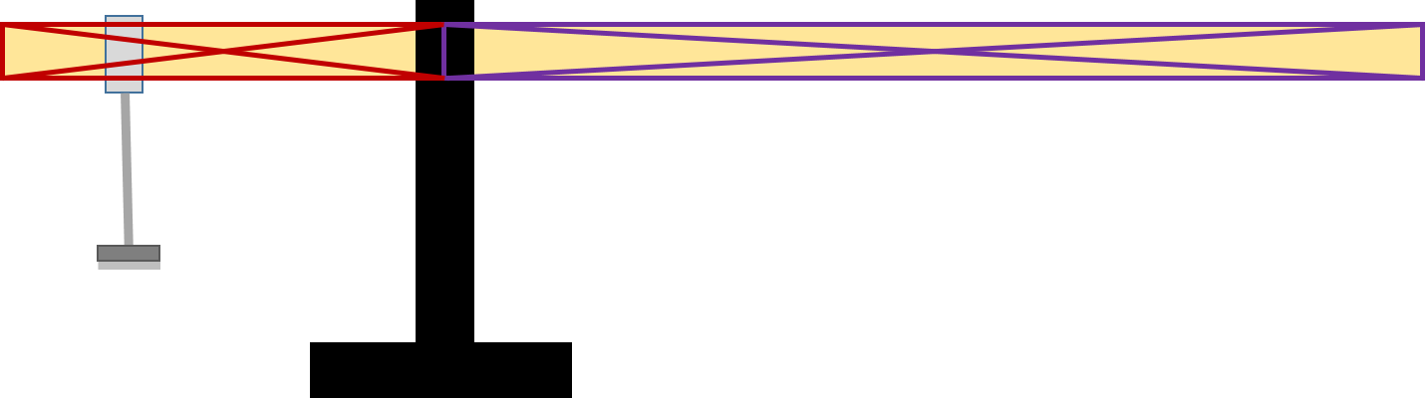

Instead of analyzing the stick as one point – its center of mass; now consider it two points – the left’s center and the right’s center. 14/1 50’s of the stick is on the left
M_left = (14.1/50)* M_stick = 0.02785 kg
The center of the left of the stick is at 14.1/2 = 7.05
R_left = 14.1 – 7.05 = 7.05
Torque_left_stick = (0.02785)(9.8)(0.0705)(1) = 0.01924 Nm

Torque_hang = 0.1076 Nm (has not changed)

Torque_counter = 0.01924 + 0.1076 = 0.1268 Nm

M_right = (35.9/50)M_stick = 0.07115 Kg
The center of the right of the stick is 32.05 (average of 14.1 and 50)
R_right_stick = 32.05 – 14.1 = 17.95 cm
Torque_right_stick = (0.07115)(9.8)(0.1795)(1) = 0.1252 Nm

The net torque is 0.1268 – 0.1252 = 0.0016 Nm (pretty much same as before)

