Physics 105 | Name: _____________________________

Put your name into the header.

Show all your work. Save all of your work and print out the Word document at the end.

I. Friction

The position versus time data was taken for the scenario shown in the figure below can be found in Friction_a.xls. The hanging object has a mass of 270 g (which includes the hanger). The object on the track has a mass of 1017 g.
- Determine the coefficient of kinetic friction. Give your reasoning and show your work.
- Estimate the speed of the object(s) at the end of the time the data was taken. Give your reasoning and show your work.
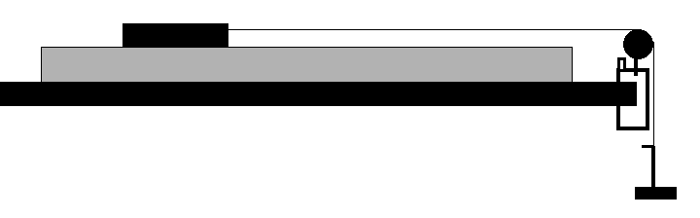

II. Projectile Motion

A ball was shot from the angles given in the table below. The corresponding ranges (landing at the same height from which it is shot) for three trials are given below as well.

Angle (degrees) | Range (cm) | Range (cm) | Range (cm) | Average Range  ( ) | Standard Deviation ( ) | Average Initial Velocity ( )
20 | 53.6 | 53.4 | 53.5
25 | 60.5 | 61.6 | 60.0
30 | 70.5 | 71.7 | 68.1
35 | 76.7 | 76.6 | 74.9
40 | 80.0 | 78.3 | 78.5

- Determine the average range and standard deviation for each angle.
- Next calculate the initial velocity of the projectile for each angle.
- If you had time to repeat the measurements at just one angle, which angle would you choose and why?

Repeat angle:

III. Friction

In the scenario shown below two strings were tied to an object (small hexagon shaped mass with two hooks). Each string passed over a pulley at the edge of the lab bench and tied to a 50-g hanger. Next mass was slowly added to hanger B until the object just started to move – which occurred when the mass added to the hanger reached 60g.

- Use the balance to determine the mass of the object. (For purposes of the practice test, assume the mass is 507g – but note that I might ask you to use a scale on the test.)
- Determine the coefficient of static friction between the object and lab bench.
- Establish a coordinate system and determine the (precise) direction in which you expect the object to start moving.
A (Pulley and hanger)
B (Pulley and hanger)
View from above

IV. Cart on Incline.

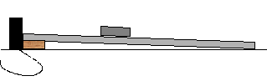

You will find position versus time data taken for a cart (M_{cart} = 498g) with two metal blocks (M_{block1} = 501g, M_{block2} = 502g) moving down an incline (228 cm long) in the Excel file Galileo.xls. Three wooden blocks of height 3.3 cm were used to create the inclines, using one block, then two blocks, then all three blocks.
- Plot a position versus time for each set of data.
- Fit the graph appropriately and use the fit to extract a value for acceleration.
- Include your name in the title (e.g. Smith: Incline Data (One Block)).
- Label the axes appropriately.
- Paste the graphs into this section of this document.
- Enter the experimental accelerations in the table below.
- Calculate the theoretical accelerations and enter then into the table below.
- Calculate the percent error.
- Comment of whether the error you find is systematic or random.

 | Experimental acc. ( ) | Theoretical acc. ( ) | Percent Error
One block
Two blocks
Three blocks

Comment on type of error:

V. Forces

In the scenario shown on the following page, the Force sensor reads a magnitude of 2.34 N for the tension in string B. Determine the tensions of the other two strings and the mass of the hanging object. Use a protractor to measure any angles. Show all work, give all reasoning.

Tension A
Tension C
Mass
A
B
C

