Physics 105  Lab Final | Name: _____________________________  12/07/06

Go to View/Header and Footer and put your name into the header.

Show all your work. Save all of your work and print out the Word document at the end. Email the edited Word document and Excel spreadsheet at the end.

1. Collisions 1

The data on the Collision Sheet of the spreadsheet p105_f06_lab_final.xls is the velocity from a motion sensor tracking Cart 1 (mass: 502 g) as it heads down a track and collides with Cart 2 (mass: 949 g), which initially had no velocity. After the collision, the two carts stuck together.
- Make a graph of the data, title it “Your name: Collision 1” and paste it below (in this section of the Word document).

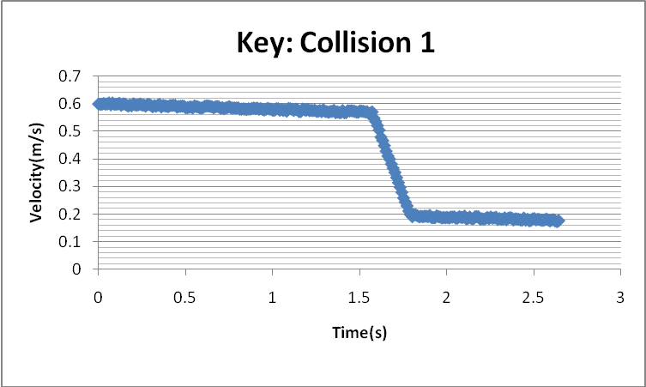

- Determine the momentum of the two-cart system just prior to the collision. Determine the momentum of the two-cart system just after the collision. Explain the physical significance of these results.

System momentum before: M_1 * V_before = (.502)(.572) = 0.287 Kg m/s
System momentum after: (M_1 + M_2)*v_after = (.502 + .949)(.211) = 0.306 kg m/s
Explain: Momentum of the system should be conserved, this is close. 6.4 % difference

- Determine the energy of the two-cart system just prior to the collision. Determine the energy of the two-cart system just after the collision. Explain the physical significance of these results.

System energy before: 0.5 M_1 * V_before^2 = .5*(.502)(.572)^2 = 0.0821J
System energy after: 0.5* (M_1 + M_2)*v_after^2 = 0.5 (.502 + .949)(.211)^2 = 0.0323 J
Explain: Mechanical energy of the system is not conserved in this collision; energy is lost to heat and sound.

- Determine the force acting on Cart 1 during the collision. Determine the force acting on Cart 2 during the collision. Explain the physical significance of these results.

Duration = 1.78 – 1.46 = 0.32
Force on Cart 1: M_1(v_after – v_before)/duration = .502 *(.211 - .572)/.32 = -0.566 N
Force on Cart 2: M_2( v_after – v_before)/duration = 0.949*(.211 -0)/.32 = 0.626 N
Explain: Should be equal and opposite – like in Newton’s Third Law. Magnitudes have about 10% difference.

2. Buoyant

The following data was collected for an object.

Length (cm) | Width (cm) | Height (cm) | Mass (g) | Force weighed in air (N) | Force “weighed” in water (N)
1.9 | 1.9 | 5.1 | 164.2 | 1.673 | 1.495

Make two completely independent calculations of the object’s density (by completely independent, I mean no piece of information can be used in both equations).

 | Density ( kg/m^3 )
Method A | Mass/(length*width*height)  .1642/(.019*.019*.051)  = 8919
Method B | F-air * rho_water/(F_air – F_water)  1.673 * 1000/(1.673-1.495)  9397

3. Balancing
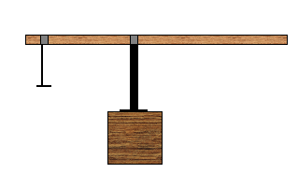
Johnny forgot to measure the mass of a meter stick used in the setup shown above. The 50.0-g hanger is positioned at 5.00 cm from the left edge; it hangs from an 11.0-g bracket and has a 50.0-g mass placed on it. The pivoting bracket also has a mass of 11.0 g and is positioned at 40.0 cm from the left edge. Help Johnny by determining the mass of the meter stick. One of the forces on the meter stick is a normal force from the pivoting bracket; determine that as well. Show your work for each in the blue book.

Mass of the meter stick ( )
Pivoting bracket normal force ( )

Clockwise torque = M_stick *g * 0.10 * sin (90)
A meter stick is 100cm long and has its center at the 50-cm mark. The 50-cm mark is 10-cm from the pivot point. The force is the weight – multiply by g.

CW: .98*M_stick

Counterclockwise Torque (M_hang + M_hang_Bracket+M_on_hang)*g*(0.35)*sin(90)
The hanger is 35 cm from the pivot point
CCW: (.05+ 0.011+0.05)*9.8*.35 = .3807 N-m

CW=CCW
.98*M_stick = .3807
M_stick = .389 kg

Forces up: Normal on stick from pivot bracket

Forces down: W_stick + W_hang_incl_bracket = .389*9.8 + (.05+0.011+0.05)*9.8 = 2.69 N

Forces up = Forces down

Normal on stick from pivot bracket = 4.9 N.

4. The Force Constant of a spring.

The table below has data taken using a motion sensor. Masses were placed on a hanger, which hung from a spring positioned over a motion sensor.

Mass, includes hanger (kg) | Position of bottom of hanger (m)
0.050 | 0.891
0.100 | 0.865
0.150 | 0.818
0.200 | 0.806
0.250 | 0.763
0.300 | 0.714
0.350 | 0.704

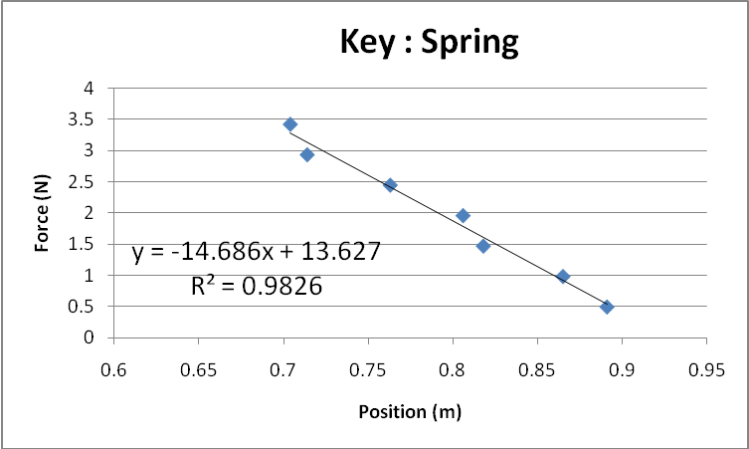

Use a graph to determine the spring’s force constant and equilibrium position. Enter them below. Show work and/or explain. Include your last name in the title of the graph. Paste your graph below.

Remember to

Spring constant ( N/m ) | Equilibrium position ( m )
14.686 | .928 = 13.627/14.686

Work/Explanation:
Calculated weight from mass by multiplying by g. Plot force versus length. Absolute value of slope is spring constant k. Set y (which is a force) from fit equation to zero to find the equilibrium length.

5. Collisions 2

The data shown in the graph above was taken for Cart 1 heading down a track and colliding with Cart 2, which initially had no velocity. After the collision, the two carts stuck together. Which of the following sets of Cart masses is most consistent with the data?
- M₁ = 0.502 kg, M₂=0.723 kg
- M₁ = 0.502 kg, M₂=1.117 kg
- M₁ = 0.723 kg, M₂=0.502 kg
- M₁ = 1.117 kg, M₂=0.502 kg

Which set of masses? Explain your answer.
Read from graph v_before = .57 v_after = .39 m/s

If the masses of the two Carts were equal the v_after would be half. Since it is more than half, this suggests the first cart’s mass is bigger than the second’s. Eliminates A & B

Momentum_before = momentum_after

C:
(.723)*.57 =? (.723+.502) .39
.412 =? .478

D:
(1.117)*.57 =? (1.117+.502)*.39
.637 =? .631

Scenario D is much closer (to conserving momentum) and thus is the most consistent.

6. Energy

The data on the Atwood Sheet of the spreadsheet p105_f06_lab_final.xls is the displacement and velocity versus time data for an Atwood Machine, which has Mass 1 (15.1 g) released from a height 1.50 m above the floor and Mass 2 (11.8 g) initially at floor level. Fill in the table below. Then fill in the missing columns in the Excel spreadsheet and make a plot showing two curves: the Mechanical Energy versus time, and the Mechanical Energy plus Work against Friction versus time. Paste the graph below. (Save the Excel spreadsheet and be sure to attach it in an email to me for purposes of partial credit.)
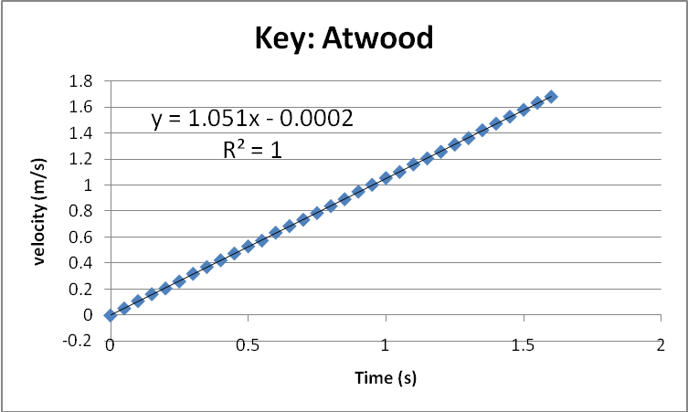

Ideal acceleration (m/s^2 ) | 9.8*(15.1-11.8)/(15.1+11.8)=1.202
Experimental acceleration ( m/s^2 ) | 1.051
Frictional force ( N ) | (.0151+0.0118)*(1.202-1.051)  =0.00406

