Physics 105 | Name: _____________________________

Put your name into the header. Show all your work. Save all of your work and print out the Word document at the end. Email your Excel. Indicate where your answers are.

1. On the Incline Sheet of the Excel file provided, you will find data taken using a motion sensor and Data Studio. The data includes the position as a function of time and the velocity as a function of time. The position measured is shown in the picture below. Note that the cart hits a barrier at the bottom
Motion sensor

x

9.2 cm

The length of the track is 2.27 m and it is raised up 9.2 cm at one end. The cart has a mass of 500.8 g.

- Use the position versus time data to extract the acceleration.

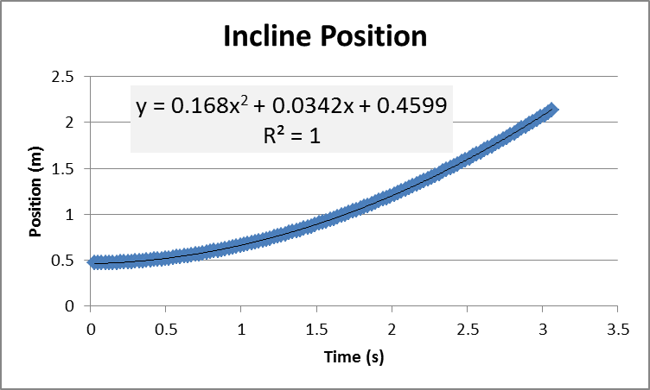

Acceleration ( m/s^2 ) | .168 * 2 = .336

- Use the velocity versus time data to extract the acceleration.

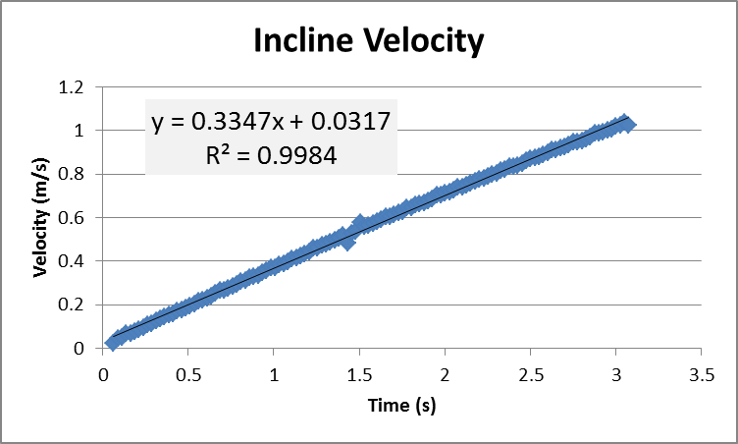

Acceleration ( m/s^2 ) | .3347

- Comment of the consistency of the above results.
Very close as they should be.

- Determine the ideal acceleration. The ideal acceleration is from theory neglecting any friction or air resistance.
Show your work for the ideal acceleration
A_ideal = g sin(theta)
Theta = arcsin (9.2/227) = 2.32 degrees
A_ideal = 9.8 * sin (2.32) = 0.397 m/s^2

- Draw the forces acting on the cart
N
F_fric

W

- Calculate the normal force.
N ormal = m g cos (theta) = .5008 * 9.8 * cos (2.32) = 4.004 Newtons

2. An “unknown mass” is hung from pulley P2 as shown below.
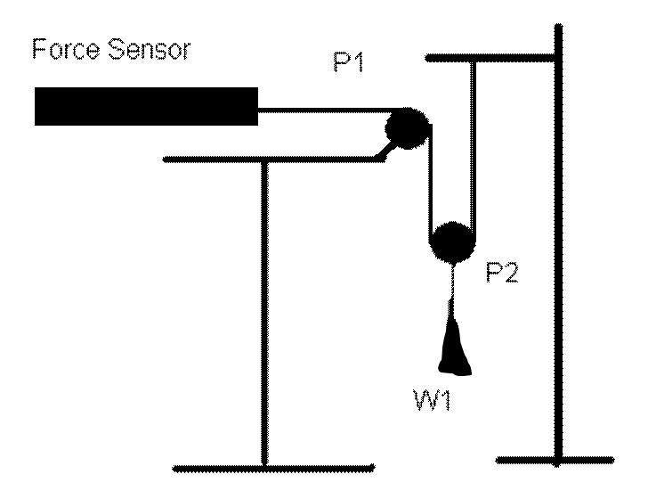

- Use the balance to determine the combined mass of the pulley plus object.
258.6 g = .2586 kg

- Assuming the Force Sensor was tared properly what value you would expect to read from it in the scenario shown above? Explain/show work
Would be half weight .5*(.2586)*(9.8) = 1.267 N

- How does one Tare the Force Sensor? What does that do?
How: press button on side (when nothing) is pulling or pushing on the Force Sensor. It establishes the zero .

3. A pendulum with bob mass 158 g and length 45.6 cm (center of bob to pivot point) was attached to a Force Sensor and swung through a photogate that measured its speed at its lowest point. The following data was collected.

Tension at swing bottom (N) | Speed (m/s) | Net force at swing bottom (N) | Mass times acceleration (N) | Percent difference
1.62 | 0.41 | 0.0716 | 0.05824518 | 20.5703824
1.75 | 0.79 | 0.2016 | 0.21624518 | -7.00985738
2.08 | 1.22 | 0.5316 | 0.51571754 | 3.03297815
2.37 | 1.56 | 0.8216 | 0.84322105 | -2.5974026

4. A friction block with mass 128.3 g is placed on a 227-cm track which is slowly raised to the heights shown in the table before the block just begins to move. Calculate the average and standard deviation.

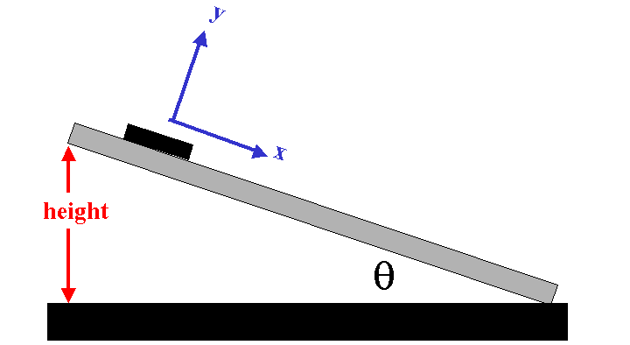

 | Height (cm)
 | 52.9
 | 55.4
 | 58.3
 | 61.3
 | 54.4
 | 61.8
Average | 57.35
St. dev. | 3.70445678

Use the average height to calculate the coefficient of static friction?
Theta = arcsin(57.35/227) = 14.63 degrees
Mu_static = tan (theta) = .261

5. The data in the Vertical Shoot sheet of the Excel file provided was collected while a ball was shot vertically from a launcher and toward a
- Smart Pulley
- Photogate
- Motion Sensor
- Force Sensor

(Select the appropriate measuring device.) Make a plot of position versus time, fit it and it appropriately, and paste it below.
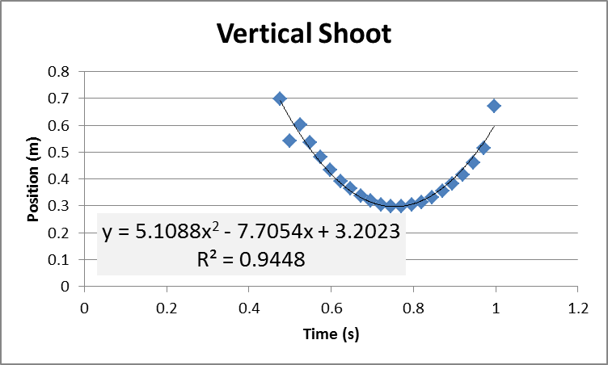

Use your results above to determine the initial velocity of the ball as it just leaves the launcher.
Y= 5.1088 t^2 -7.7054 t + 3.2023
Dy/dt = 10.2176 t – 7.7054
Evaluate at t= .4756
Dy/dt = -2.846 m/s

If a ball was released from rest and fell 41cm before striking the lab table, how long would that fall take?
T = sqrt (2 * h /g) = sqrt (2 *.41 /9.8) = 0.289 s

If the initial velocity were 3.15 m/s, what would be the theoretical range be if the ball was shot at an angle of 30° above the horizontal (and landed at the same height from which it was shot).
R = v^2 sin(2 * theta) / g = 3.15^2 * sin (2 * 30) / 9.8 = 0.877 m

What other angle does theory predict would have the same range?
60 degrees the complement

6. Proceeding from left to right, the masses above (including the hangers) have the following values: 100g, 170g and 150g. Use a protractor to measure the angles the two diagonal lines make with the vertical. Establish a coordinate system and test the equilibrium condition(s) of the central knot.
Testing Equilibrium:
Angle_left = 62 degrees agle_right = 36.5 degrees

X: -(.1)*9.8* sin (62) + (.15) *9.8*sin(36.5 ) = 0.009 N -- CLOSE TO ZERO

Y: (.1)*9.8 cos(62) + (.15)*9.8*cos(36.5) – (.17)*9.8 = -0.024 N – CLOSE TO ZERO

