Corresponding diagram: B – The power supply + is connected to + of the small capacitor which in turn in connected to the + of the tall capacitor. The – of the small cap and tall cap are also connected. Thus the short and tall capacitors are in parallel.

The – of the tall cap is connected to the + of the medium cap. And the – of the medium cap is connected to the – of the power supply. Thus the small-tall combination is in series with the medium cap.

This is the arrangement shown in Figure B.

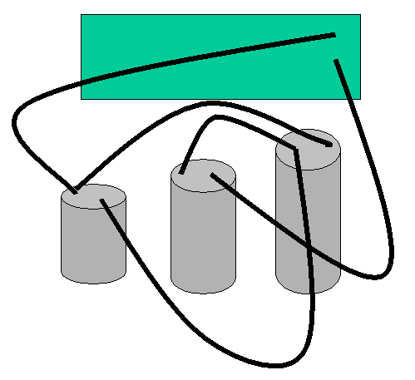

A. | B.
C. | D.

