SHOW WORK! Supply units wherever applicable. Label graphs. Do not waste too much time on any one part of the exam.

Resonance Tube

A resonance tube has a speaker on one end and a plunger mechanism that changes the effective length of the tube. A single frequency wave was fed into the speaker, and the plunger slid. The positions of resonance (loudness) were recorded as follows

Length (cm) | Change in length (cm)
8.6
31.6 | 23.0
57.6 | 26.0
79.4 | 21.8
Average | 23.6

Determine the frequency fed into the speaker.
The average change in length is 23.6 cm = .236 m. The change in length is half of a wavelength. So wavelength is .472 m. Speed of sound is 343 m/s is wavelength * freq. So Freq is 727 Hz.

Draw the standing waves for the 31.6-m length above. Label the nodes and antinodes.

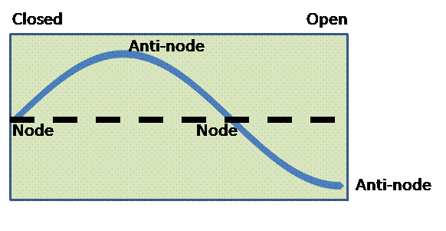

Standing Waves

Standing wave patterns were observed at the following frequencies. The corresponding node-to-node distances were measured. Calculate the velocity for each row of data.

Frequency (Hz) | Node-to-node distance (cm) | Velocity ( m/s )
24 | 111 | 53.28
40 | 68 | 54.4
56 | 49 | 54.88
72 | 36 | 51.84

The length of the cord was measured when little to no tension was applied. Applying a tension stretched the cord somewhat. What effect would this have on the (F/μ)^{1/2} prediction of velocity? Explain.
Compared to the prediction, the stretching increases the length, which reduces the linear mass density (mass over length), which increases the speed since the linear mass density is in the denominator. Thus, we expect the prediction to under-estimate the actual speed.

Pendulum

The so-called Variable Pendulum (rigid-rod pendulum) that we used for the amplitude variations was used in conjunction with a photo-gate to collect the following data on the pendulum periods. The pendulum was released from the angle given at the top of each column. Copy and paste the data to Excel and calculate the average period and the standard deviation for each of the amplitudes below.

Amplitude  (degrees) | 10 | 20 | 30 | 40 | 50
 | Period ( s ) | Period ( s ) | Period ( s ) | Period ( s ) | Period ( s )
 | 1.0764 | 1.0812 | 1.089 | 1.0984 | 1.1135
 | 1.0763 | 1.0812 | 1.0888 | 1.0981 | 1.113
 | 1.0764 | 1.081 | 1.0888 | 1.0978 | 1.1123
 | 1.0763 | 1.081 | 1.0886 | 1.0976 | 1.1118
 | 1.0763 | 1.081 | 1.0884 | 1.0973 | 1.1112
 | 1.0762 | 1.0809 | 1.0884 | 1.097 | 1.1108
 | 1.0763 | 1.0808 | 1.0882 | 1.0968 | 1.1102
 | 1.0763 | 1.0808 | 1.0881 | 1.0965 | 1.1098
 | 1.0762 | 1.0808 | 1.0879 | 1.0963 | 1.1094
 | 1.0762 | 1.0807 | 1.0879 | 1.0961 | 1.1089
Average (s ) | 1.07629 | 1.08094 | 1.08841 | 1.09719 | 1.11109
Standard deviation (s ) | 7.37865E-05 | 0.0001713 | 0.0003872 | 0.000781 | 0.0015502

Determine the effective length of the pendulum. Explain.
L = g*T²/(4 π²)
Use T = 1.07629 – small angle only since above formula comes from small angle approximation.
L = .288 m

Mass on a spring

The data found on the Spring worksheet of the Excel file provided has position versus time data for a spring with two different masses (250 g and 450 g) hanging from it. Fit the data to the following form

$y(t)=y_{\text{eq}}+A\text{cos}\left(\frac{2π}{T}t+φ_{0}\right)$,

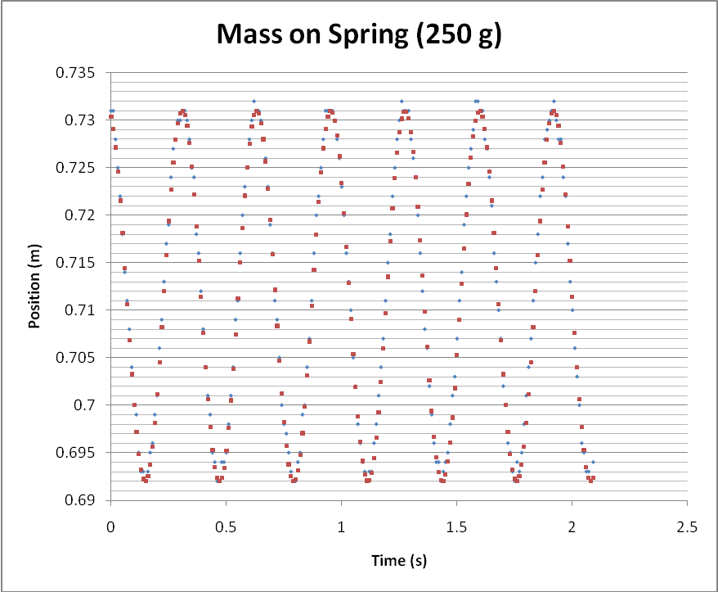

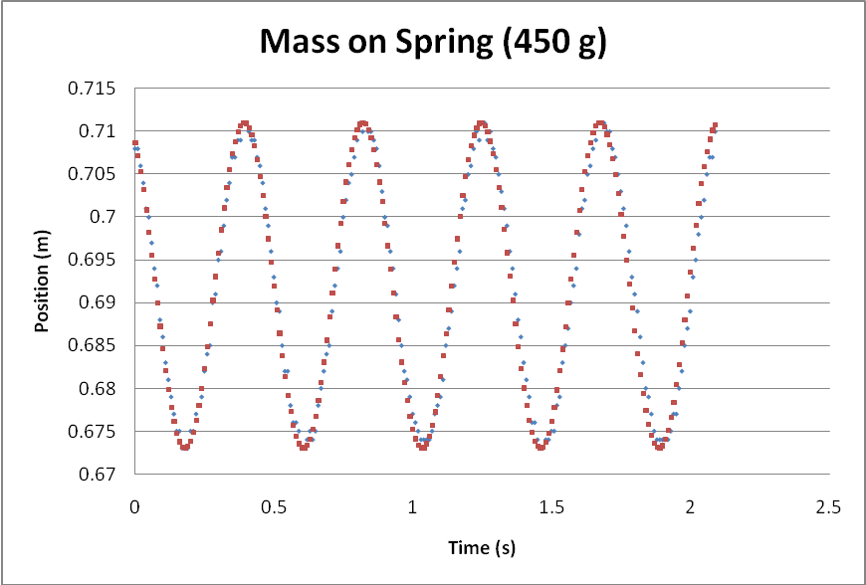

Paste the resulting fits into this Word document. Then enter the fit parameters into the table below.

Hanger + Mass (g) | y_{eq} (m) | A (m) | T (s) | ϕ₀
250 | .7115 | .0195 | .322 | .25
450 | .692 | 0.019 | .427 | .5

Use the change in equilibrium position corresponding to the addition of the 200-g mass to determine the spring constant k. (This can also be done graphically.)

Spring constant ( N/m ) | 100.5

Δm g = k Δx
(.200)(9.8) = k (.7115 - .692)
K = 100.5

Using this spring constant determine the theoretical periods for the two masses. Then calculate the percent difference between the period from the fit and the calculated/theoretical period.

Hanger + Mass (g) | Theoretical Period ( s) | Period from Fit ( s ) | Percent Error
250 | .313 | .322 | 2.88%
450 | .420 | .427 | 1.67%

Lenses

The light source in the set-up shown below was placed at some distance to the lens and then the screen’s position was varied until an image was formed on it.
lens
screen
Light source

The data collected is contained in the following table.

Distance from light source to lens (cm) | Distance from lens to screen (cm) | The focal length of the lens (cm) | Magnification
25 | 58 | 17.47 | 2.32
30 | 42 | 17.50 | 1.40
35 | 35 | 17.50 | 1.00
40 | 31 | 17.46 | 0.78
45 | 28 | 17.26 | 0.62
50 | 27 | 17.53 | 0.54
55 | 26 | 17.65 | 0.47
60 | 25 | 17.65 | 0.42
65 | 24 | 17.53 | 0.37
 | Average (cm) | 17.51
 | Stand. Dev. ( cm) | 0.12

Calculate the focal length and magnification for each trial. Calculate the average focal length as well as the standard deviation.

Draw a ray diagram for the first row of data in the table above.
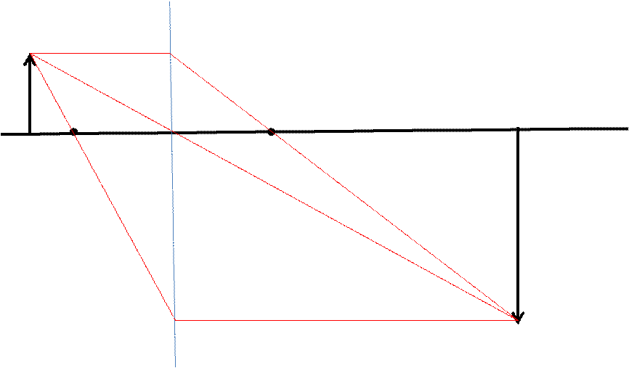

Two-Slit Interference

A blue laser with a wavelength of 472 nm was shone through a two-slit apparatus, which was 2.45 m from the screen/wall. The distance from the center of one fringe to the center of the fourth consecutive fringe (as shown below) was found to be 1.20 cm.

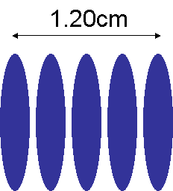

Determine the distance between the slits.

Distance between slits (m ) | 0.00039

y = m λ L / d becomes d = m λ L / y

Distance between adjacent spots/fringes is .3 cm or 0.003
d = (1) (472 × 10⁻⁹) 2.45 / 0.003 = 0.00039 m

m=1 adjacent spots

What would happen to the distance between the fringes if a red laser was used? Explain.
Red light has a longer wavelength. Since y, the distance between fringes, is proportional to the wavelength, if the wavelength increases so would the distance between fringes.

RC Circuits

The data in the Charge worksheet of the file p106_lab_final.xls is for a circuit with a battery (DC power supply), a capacitor and a resistor. Fit the data to the form appropriate for a charging capacitor. Find the electric potential and time constant parameters. Paste the plot in this document. If the resistor has a resistance of 2.15 kΩ, then find the value of the capacitance.

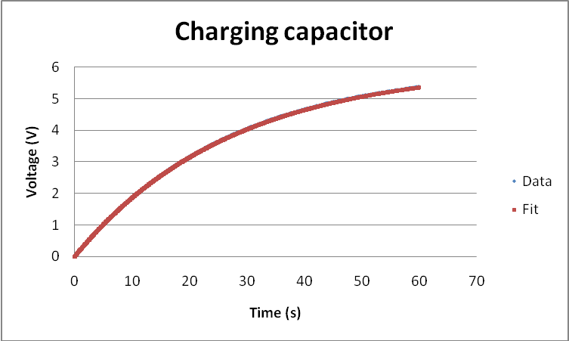

PLOT GOES HERE.

Electric Potential parameter ( V ): 6

Time constant ( s ): 27

Capacitance ( mF ): 27/2.15 = 12.6

Capacitors

Capacitor C₁ was connected to a 5.00-V battery for long enough time to charge it. It was then disconnected from the battery. A second capacitor C₂ was then placed in parallel with C₁ and both were found to have voltages of 3.25 V. Determine the ratio of capacitances C₂/C₁. Show work.
C₂ / C₁ = (V₁ – V₁’)/V₂’ = .538

Refraction

Below you will find the paths taken by white light as it passed from air into a transparent semicircular-shaped material and back into air. Using a protractor, make measurements to test the Law of Reflection. Explain your reasoning and clearly indicate what measurements you made on the sheet.
Angle of incidence 46°
Angle of refraction 28°

n₁ sin θ₁ = n₂ sin θ₂

n₁ = 1 (Air)

n₂ = 1.53 (no units)

Next perform measurements to calculate the material’s index of refraction n.

n ( -- ) | 1.53
Explain your reasoning.
Drew a normal. Measured angles of incidence and refraction. Used Snell’s Law with the index of refraction for the incident ray as 1 because it was in air. Solved for index of refraction of material.
- 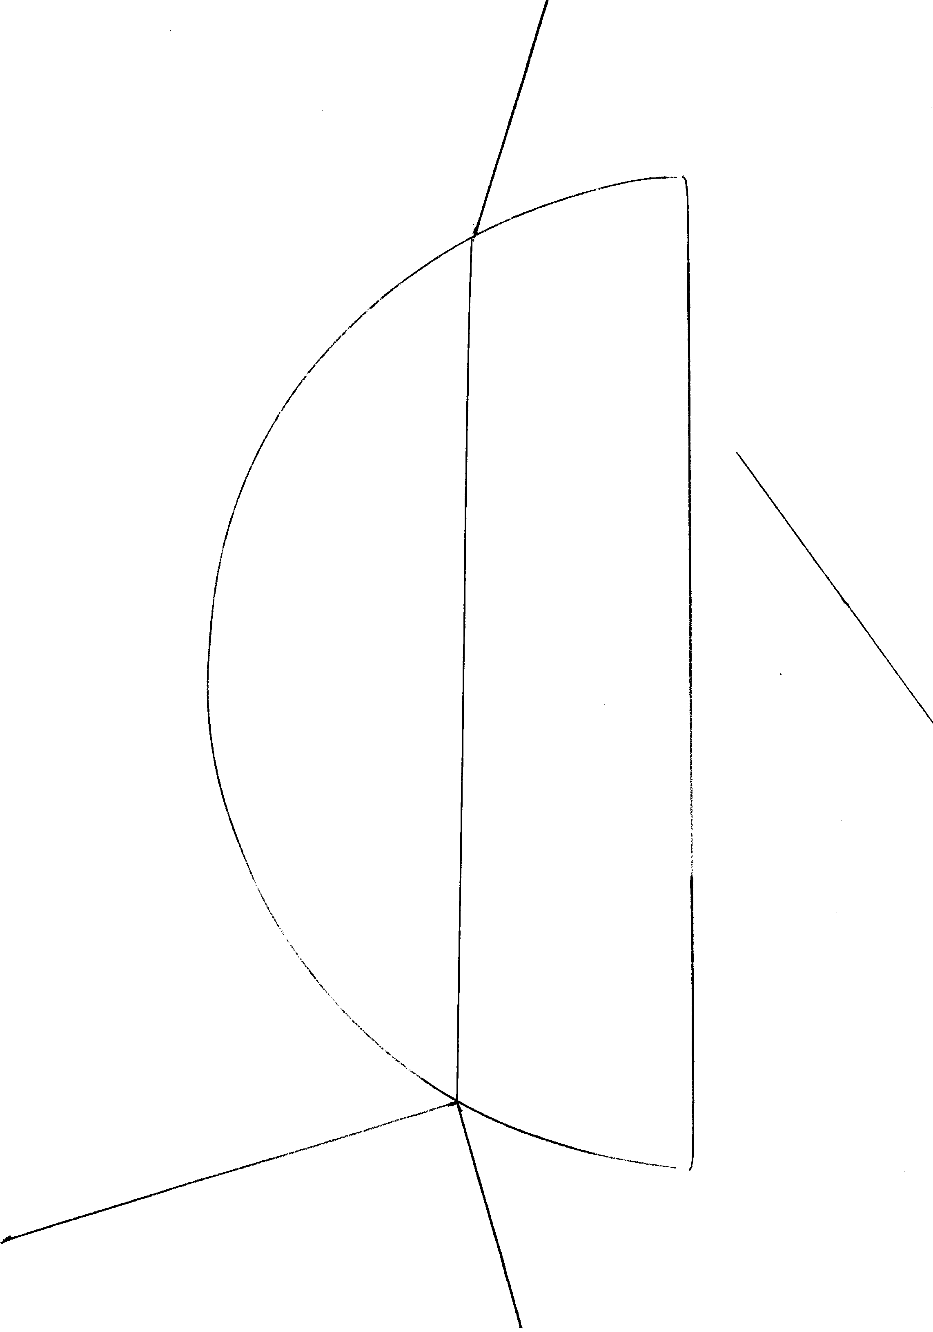Electric Field Lines

Use the surface plot and contour plot of a charge distribution provided below to draw the electric field lines. Also indicate places on the plot where the electric potential is zero and where the electric field is zero.

