Show work. Include units. Provide reasoning. Say what you would do even if you do not have all of the necessary information (e.g. the answer from another part).

You must do the first problem, and then you can select seven of the remaining nine problems.

×
×
•
A
B
C

1. The arrangement of currents shown above includes
i. Current A of 5 amps going into the page at (0, 3)
ii. Current B of 8 amps going into the page at (4, 3)
iii. Current C of 11 amps coming out of the page at (4,0).
where distances are measured in millimeters.
- Calculate the magnetic field (magnitude and direction) at point A due to Current C.
- Calculate the force per length (magnitude and direction) on Current A due to Current B.
- Calculate the net force per length (magnitude and direction) on Current A due to Currents B and C.

2. Assume that specifications call for a device to work when it is experiencing accelerations up to an including 140 m/s². To test your device, you subject it to vibration.
- If the vibration has a frequency of 32 Hz, what should its amplitude be?
- If the device being tested has a mass of 0.650 kg, what is its energy while vibrating at this amplitude and frequency?
- At what displacement is the energy one-half potential, one-half kinetic?

3. In each of the three scenarios below, you are adding the two traveling given

Scenario | Traveling Wave 1 | Traveling Wave 2
I. | y1(x, t) = 0.04 sin(50 x – 1000 t + 1.24) | y1(x, t) = 0.04 sin(49 x – 980 t + 0.48)
II. | y1(x, t) = 0.04 sin(50 x – 1000 t + 1.24) | y1(x, t) = 0.04 sin(50 x + 1000 t + 0.48)
III. | y1(x, t) = 0.04 sin(50 x – 1000 t + 1.24) | y1(x, t) = 0.04 sin(50 x – 1000 t + 0.48)

- Which scenario above is a simple traveling wave? What is the amplitude of that traveling wave?
- Which scenario above is a standing wave? On what length of string would such a standing wave be the fundamental?
- Which scenario above yields the phenomenon of beats? What is the beat frequency for the scenario?

4. Two speakers, A and B, are driven by the same source and play a frequency of 498 Hz. Speaker B is fixed in place, while speaker A can be moved. A microphone is placed a distance 1.80 m from Speaker B.
A. Find two stationary positions, y, of Speaker A that will lead to constructive interference at the microphone.
B. Find one stationary position of Speaker A that will lead to destructive interference at the microphone.
C. If Speaker A moves at a speed of 2.10 m/s toward the microphone, what beat frequency will be recorded by the microphone?
B
A

y
1.80 m

5. Two converging lenses, having focal lengths +12.00 cm and +6.00 cm are 22.00 cm apart. An object of height 1.65 cm is placed 36.00 cm in front of the 12.0-cm lens.
- Draw a ray diagram.
- Calculate the position of the final image.
- What is the height of the final image?
- Is the final image upright or inverted?
- Is the final image virtual or real?

6. A thin oily film lies on top of water. You notice that red light (λ=660 nm) is strongly reflected from the film.
- Draw a picture of the important rays (incident, transmitted, reflected) that lead to the reflection. Indicate any phase shifts.
- Determine three possible thicknesses of the oily film starting with the thinnest.
- For the middle thickness determine any visible wavelength of light that would experience destructive interference.

Air n=1

Oil n=1.47

Water n=1.35

7. There was some (square) graph paper lying next to a block with index of refraction n=1.45.
- What is the speed of light in the block?
- Using the way the light ray falls on graph paper determine the incident angle at point A. Draw it in a picture.
- Determine the incident angle at point B.
- Is any light transmitted at point B? Explain in detail.

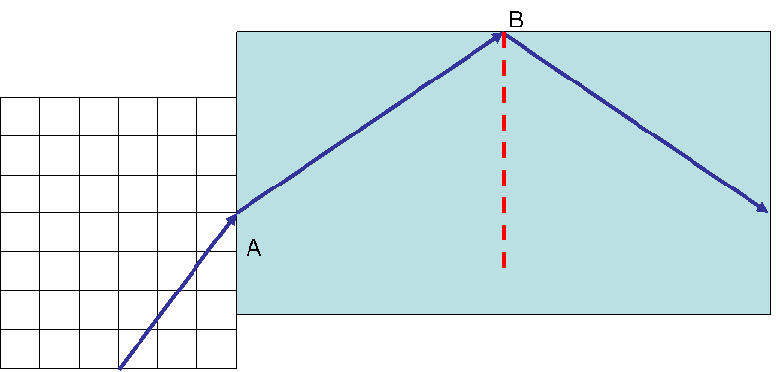

8. For the resistor circuit shown below, determine

- The equivalent resistance;
- The current through the 1.54-kΩ resistor;
- The voltage across the 2.32-kΩ resistor;
- The current through the 1.47-kΩ resistor.

9. For the RC circuit shown below, determine
A. The initial current when the switch is flipped to connect the battery into the circuit.
B. The charge that leaves the battery after a long time.
C. The time for 70% of the ultimate charge to be reached.
D. The time to lose 80% of its charge when the switch is flipped back.

10. For the charge distribution shown below

+2
+2
-4
A
B
C

The arrangement of charges shown above includes Charge A of +2 µC at (0, 3), Charge B of -4 µC at (4, 3) and Charge C of +2 µC at (4,0), where distances are measured in centimeters.
- Draw the electric field lines for this charge arrangement.
- Calculate the electric field (magnitude and direction) at the origin (0,0).
- Calculate the electric potential at the origin.
- Draw a surface that has zero net electric flux.

