Physics 106  Laboratory Midterm | Name: _________________________  March 23, 2007

SHOW WORK! Supply units wherever applicable. Label graphs. Do not waste too much time on any one part of the exam.

Resonance Tube

A resonance tube has a speaker on one end and a plunger mechanism that changes the effective length of the tube. A single frequency wave was fed into the speaker, and the plunger slid. The positions of resonance (loudness) were recorded as follows

Length (cm)
8.6
31.6
57.6
79.4

Determine the frequency fed into the speaker.

Draw the standing waves for the first two scenarios above. Label the nodes and antinodes.

The speed of sound increases somewhat as the temperature increases. If the experiment were performed on a hotter day (and the air conditioning is not working in the lab), then you would expect the lengths observed above to
- Increase
- Decrease
- Stay the same
Explain:
Pendulum

The so-called Variable Pendulum (rigid-rod pendulum) that we used for the amplitude variations was used in conjunction with a photo-gate to collect the following data on the pendulum periods. The pendulum was released from the angle given at the top of each column. Copy and paste the data to Excel and calculate the average period and the standard deviation for each of the amplitudes below.

Amplitude  (degrees) | 10 | 20 | 30 | 40 | 50
 | Period ( s ) | Period ( s ) | Period ( s ) | Period ( s ) | Period ( s )
 | 1.0764 | 1.0812 | 1.089 | 1.0984 | 1.1135
 | 1.0763 | 1.0812 | 1.0888 | 1.0981 | 1.113
 | 1.0764 | 1.081 | 1.0888 | 1.0978 | 1.1123
 | 1.0763 | 1.081 | 1.0886 | 1.0976 | 1.1118
 | 1.0763 | 1.081 | 1.0884 | 1.0973 | 1.1112
 | 1.0762 | 1.0809 | 1.0884 | 1.097 | 1.1108
 | 1.0763 | 1.0808 | 1.0882 | 1.0968 | 1.1102
 | 1.0763 | 1.0808 | 1.0881 | 1.0965 | 1.1098
 | 1.0762 | 1.0808 | 1.0879 | 1.0963 | 1.1094
 | 1.0762 | 1.0807 | 1.0879 | 1.0961 | 1.1089
Average ( )
Standard deviation ( )

Determine the effective length of the pendulum. Explain.

Mass on a spring

The data found on the Spring worksheet of the Excel file provided has position versus time data for a spring with two different masses (250 g and 450 g) hanging from it. Fit the data to the following form

$y(t)=y_{\text{eq}}+A\text{cos}\left(\frac{2π}{T}t+φ_{0}\right)$,

Paste the resulting fits into this Word document. Then enter the fit parameters into the table below.

Hanger + Mass (g) | y_{eq} (m) | A (m) | T (s) | ϕ₀
250
450

Use the change in equilibrium position corresponding to the addition of the 200-g mass to determine the spring constant k. (This can also be done graphically.)

Spring constant ( )

Using this spring constant determine the theoretical periods for the two masses. Then calculate the percent difference between the period from the fit and the calculated/theoretical period.

Hanger + Mass (g) | Theoretical Period ( ) | Period from Fit ( ) | Percent Difference
250
450

Superposition of Sound

Two speakers were connected to the same Power Amplifier which was generating a sine wave of an unknown frequency. The speakers were facing each other and separated by a meter. A microphone was placed in the middle (at a position of 50 cm) and began recording the sound. The microphone was moved 2 centimeters every 5 seconds and a graph of the resulting data is shown below.

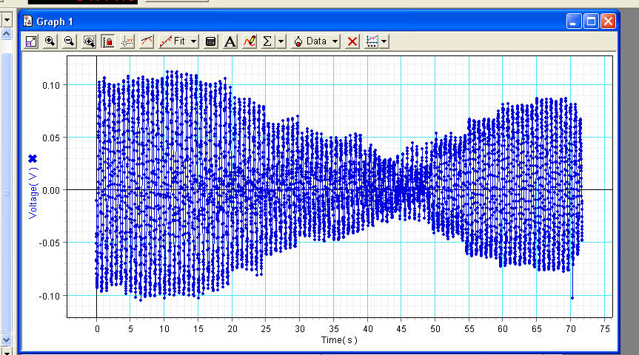
Are the two speakers in phase or out of phase? Explain.

At what position was the microphone when the destructive interference was observed? Explain.

Use the data to estimate the frequency of the sound waves coming from the speakers. Explain.

Standing Waves

Standing wave patterns were observed at the following frequencies. The corresponding node-to-node distances were measured. Calculate the velocity for each row of data.

Frequency (Hz) | Node-to-node distance (cm) | Velocity ( )
24 | 111
40 | 68
56 | 49
72 | 36

Plot the node-to-node distance versus frequency and fit it to a power law. Title it Standing Wave Data. Paste it below.

Compare your fit to what you should expect theoretically.

The length of the cord was measured when little to no tension was applied. Applying a tension stretched the cord somewhat. What effect would this have on the (F/μ)^{1/2} prediction of velocity? Explain.
Refraction and Reflection

On the last page you will find the paths taken by white light as it passed from air into a transparent semicircular-shaped material and back into air. Using a protractor, make measurements to test the Law of Reflection. Explain your reasoning and clearly indicate what measurements you made on the sheet.

Next perform measurements to calculate the material’s index of refraction n.

n ( )
Explain your reasoning.

Account for the ray seen on the right. Explain your reasoning including detailed calculations.

What would the critical angle be for this material?
