PHY 106  Homework 6 | Name: ____________________  February 18, 2008

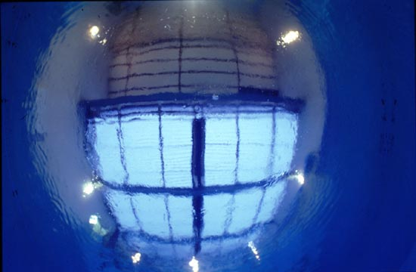
http://www.camerasunderwater.info/optics/Refraction.html

- You are two meters below the surface of a pool of water (n=1.33). There is an angle beyond which you will only see light reflected from within the pool, which tends to be darker.
- What is this angle?
- What is the radius of the lighter “circle”?

- The thick solid line represents the path a light ray takes in the presence of the rectangular plastic slab of thickness 3.00 cm. The long dashed line represents the path it would take in the absence of the plastic slab. The ray is shifted laterally by a (perpendicular) distance d. If the incident angle θ_{i} is 37° and the index of refraction is n=1.54 find d. (The surrounding substance is air which you can take to have an index of refraction n=1.)

θ_{i}

3 cm

d

- You wish to see an image of your face for applying makeup or shaving. If you want the image to be upright, virtual, and magnified 1.45 times when your face is 25 cm from the mirror, what kind of mirror should you use, convex or concave? What should its focal length be? Its radius of curvature? Draw a ray diagram representing the situation.

- Two converging lenses, having focal lengths +2.0 cm and +5.0 cm are 14 cm apart. An object of height 1.0 cm is placed 3.0 cm in front of the 2.0-cm lens.
- Draw a ray diagram.
- Calculate the position of the final image.
- What is the overall magnification?
- Is the final image upright or inverted?

