PHY 106  Homework 4 | Name: ____________________  February 9, 2009

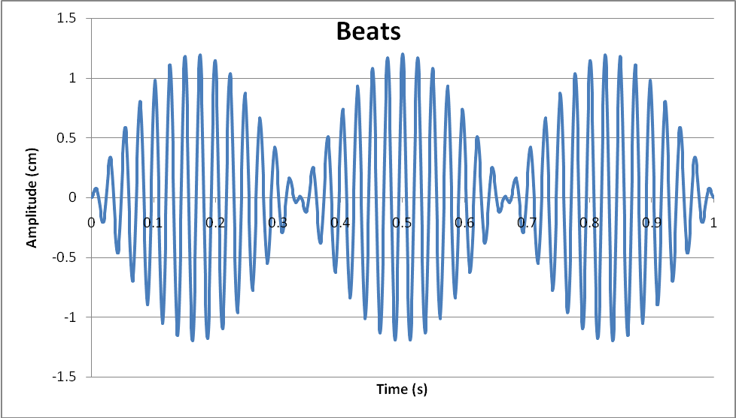

- Two waves were added to arrive at the beat pattern shown above.
- What is the amplitude of the constituent waves?
- What is the average frequency of the constituent waves?
- What is the difference in frequencies between the constituent waves?

- A source having a frequency of 440 Hz moves relative to still air with a velocity of 175 miles per hour. Suppose the source moves toward the listener. What is the wavelength of the sound between the source and listener? What is the frequency heard by the listener? Suppose the source passes the listener and is now moving away. What is the wavelength of the sound between the source and listener? What is the frequency heard by the listener?

- Two speakers, driven by the same oscillator, are placed 2.95 m apart. A listener is originally at point O, which is located 8.75 m from the center of the line connecting the two speakers. The listener then walks to point P, which is a perpendicular distance 0.345 m from O before reaching the first minimum is sound intensity.
- What is the frequency of the oscillator?
- What is the next highest frequency for which this point is again a minimum in the sound intensity?

P
0.345 m
2.95 m
8.75 m
O

- Two speakers are driven by a common oscillator at 690 Hz and face each other at a distance of 1.30 m. Locate the points x along a line joining the two speakers and measured from the left speaker at which relative minima would be expected.
x

1.30 m

- Anna and Jeff both played pan flutes (a series of pipes with various lengths). Anna, who played a note of 1200 Hz, was in a car traveling at 80 km/hr toward Terry. Jeff was a fixed distance from Terry. Terry heard no beats. Assuming Terry heard the fundamental frequency of each pipe and that the pipes are open at both ends,
A. Determine the length of the pipe Anna played.
B. Determine the length of the pipe Jeff played.

