Show work. Include units. Provide reasoning. Say what you would do even if you do not have all of the necessary information (e.g. the answer from another part).

The speed of light is 3.00 × 10⁸ m/s.

- Two converging lenses, having focal lengths +10.00 cm and +5.00 cm are 18.50 cm apart. An object of height 1.45 cm is placed 30.00 cm in front of the 10.0-cm lens.
  - Draw a ray diagram.
  - Calculate the position of the final image.
  - What is the height of the final image?
  - Is the final image upright or inverted?
  - Is the final image virtual or real?

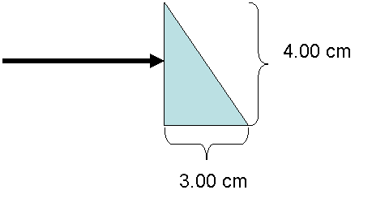
- A horizontal beam of white light falls upon a prism with the dimensions of a 3-4-5 triangle. The prism is made of material which has an index of refraction for red light of n_{red}=1.64 and an index of refraction for violet light of n_{violet}=1.70.
  - If red light has a wavelength of 700 nm in a vacuum, what is the wavelength of red light in the material?
  - What happens when the red light hits the hypotenuse side of the prism? Calculate all relevant angles and draw a picture.
  - What happens when the violet light hits the hypotenuse side of the prism? Calculate all relevant angles and draw a picture.

- Light from a helium-neon laser (λ=633 nm) is used to illuminate two narrow slits. The interference pattern is observed on a screen 3.20 m behind the slits. Thirteen bright fringes are seen spanning a distance of 5.22 cm.
  - What is the spacing between the adjacent fringes?
  - What is the spacing between the slits d?
  - If the fourth fringe on either side of the center is substantially fainter than the others, estimate the thickness of the slits a.

- A thin oily film lies on top of water. You notice that red light (λ=670 nm) is strongly reflected from the film.
  - Draw a picture of the important rays (incident, transmitted, reflected) that lead to the reflection. Indicate any phase shifts.
  - Determine three possible thicknesses of the oily film starting with the thinnest.
  - For the middle thickness determine any visible wavelength of light that would experience destructive interference.

Air n=1

Oil n=1.50

Water n=1.33

