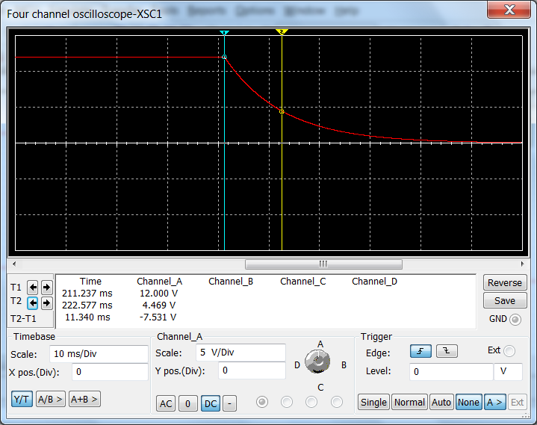

Part 1. NEW FLOAT

Express the following decimal number as a float. Use 1 bit for the sign, 23 bits for the significand (mantissa), 8 bits for the exponent. Do not use two’s complement. The exponent uses “biasing” – we will use 128.

-892307.8058904

892307 → 1101 1001 1101 1001 0011 (20 places)
3 places left
.8058904 * 2^3 = 6.4471232 → 6 → 110

Exponent 20 + 128 → 148 → 1001 0100

Start by expressing 890.043 as a “pseudo-fixed point number” using as many digits as necessary to represent the whole number 890 and represent the fractional part using the rest of the 23 places.
1 | 1 | 0 | 1 | 1 | 0 | 0 | 1 | 1 | 1 | 0 | 1 | 1 | 0 | 0 | 1 | 0 | 0 | 1 | 1. | 1 | 1 | 0

Next imagine moving the dot that separates whole number and fraction above to the very beginning. That will be our mantissa (we are not completely following the IEEE standard – that will prevent you from just finding some website that does the work for you). Take the number of places that you had to move the dot and add 128 (the bias); that result will be the mantissa. The sign is simply 0 for a positive number or 1 for a negative number.

Sign
1
Mantissa
1 | 1 | 0 | 1 | 1 | 0 | 0 | 1 | 1 | 1 | 0 | 1 | 1 | 0 | 0 | 1 | 0 | 0 | 1 | 1. | 1 | 1 | 0
Exponent
1 | 0 | 0 | 1 | 0 | 1 | 0 | 0

