PHYSICS 201
LAB 10

Part 1. All from NAND

Build a NOT, an AND and an OR from NAND gates. Paste them below.

Paste NOT made from NANDs here.

Paste AND made from NANDs here.

Paste OR made from NANDS here.

Part 2. DRAM Flip-Flop

Build the DRAM circuit shown in the lecture. Set the circuit so that the output is high and then place the circuit into the hold state. Describe what happens and its significance.

Paste your DRAM here.

Part 3. Analog-to-Digital Chip

Use the ADC chip to make the circuit shown below. The potentiometer (found under Basic) allows one to vary the input voltage Vin. My screen capture below shows the potentiometer at 80%, paste a copy of your circuit showing the display for some other percentage. Also fill in the table below with percentages and corresponding hex code. (The SOC has to go through an “edge”.)

Percentage | Hex code
0%
20%
40%
60%
80% | CC
100%

Part 4. Inequality Comparator.

As shown in the slideshow, build a circuit that takes in two four-bit words (word A and word B) and has two outputs. The first output should be 1 if the two words are the same and 0 otherwise. The second input should be 1 if the word A is greater than word B and 0 otherwise (assuming A and B are interpreted as unsigned binary numbers). Label the inputs A0, A1, etc., where A0 is the least significant bit.

Part 5. Microinstructions.

Source: Digital Computer Electronics (Malvino and Brown)

In this section we will consider the steps involved in performing a simple instruction. We will use as our example the instruction for loading Accumulator A with a value stored at a particular address in the RAM. Recall that the instruction itself is also stored in the RAM. The steps are called timing states. In this example, there are six timing states.

Determine for the timing states of the Load Accumulator A instruction described below
- Which parts of the circuit are active? (Hint: the Controller/Sequencer is active whenever anything is happening and the Instruction Register is active during the execute cycle.)
- “Who’s driving the bus?”
- And who’s reading from the bus?

Load Accumulator A
Step | Active | Driving Bus | Reading bus
1 | Ctrl, PC, MAR | PC | MAR
2 | Ctrl, PC | -- | --
3 | Ctrl, MAR, Mem, MDR, IR | MDR | IR
4 | Ctrl, IR, MAR | IR | MAR
5 | Ctrl, IR, MAR, mem, MDR, Acc | MDR | Acc
6 | Ctrl, IR | -- | --

Note that the arrows are numbered. Fill in the table with the number of the arrows along which information is flowing for each of the timing steps.
Load Accumulator A
Step | Arrows along which information flows
1 | 4, 6
2 | --
3 | 7, 9, 10, 13
4 | 14, 12, 6
5 | 14, 7, 9, 10, 15
6 | 14,

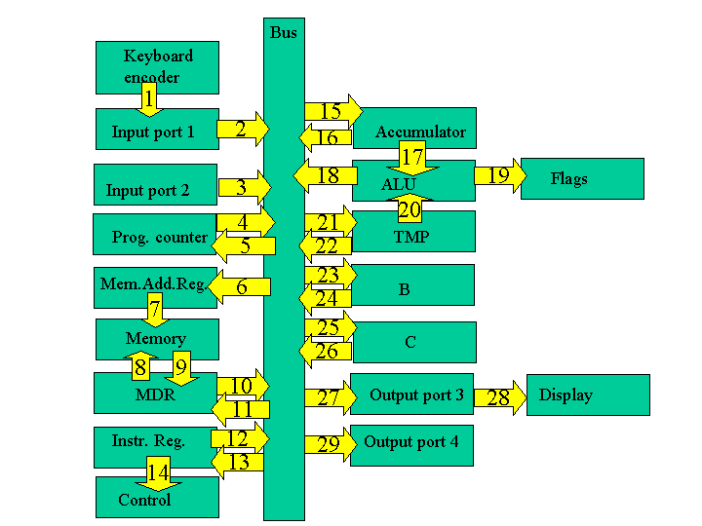

Load Accumulator A

The first few steps are the same for all instructions and are collectively known as the fetch cycle.

Fetch Cycle
- Address State: the value of the program counter (which recall is the address of line of the program to be performed) is put into memory address register.
- Increment State: the program counter is incremented, getting it ready for the next time.
- Memory State: the current line of the program is put into instruction register.

The remaining steps depend on the specific instruction and are collectively known as the execution cycle.

Execution Cycle
- Recall the instruction consisted of a load command and an address. A copy of the address is now taken over to the memory address register.
- The value at that address is loaded into Accumulator A.
- For the load command, there is no activity during the sixth step. It is known as a "no operation" step (a "no op" or "nop").

Part 5B. The add command

Let us repeat the above procedure for an add instruction. This instruction adds a value stored at a particular address in the RAM to whatever is in Accumulator A and places that answer back in Accumulator A. Recall that the instruction itself is also stored in the RAM.

The first few steps are the same for all instructions and are collectively known as the fetch cycle.

Fetch Cycle (the first three steps are the same as abovesame as above)

Execution Cycle
- Recall the instruction consists of an add command and the address of the number to be added. A copy of the address is now taken over to the memory address register.
- The value at that address is loaded into TMP.
- The values in Accumulator A and TMP are added and the result is sent to Accumulator A. You may wonder why when the result is placed in the Accumulator A, it is not again added to TMP (producing what is called a "racing accumulator"). The cure for this potential problem is edge clocking. Edge clocking makes it possible to load only during a very short interval of time. It is also possible to activate different processes on different edges.

Add
Step | Active | Driving Bus | Reading bus
1
2
3
4
5
6

Add
Step | Arrows along which information flows
1
2
3
4
5
6
Recall that in lecture we distinguished load, load immediate and load indirect commands. There would similarly be distinctions between add, add immediate and add indirect commands.

