Simulation charging
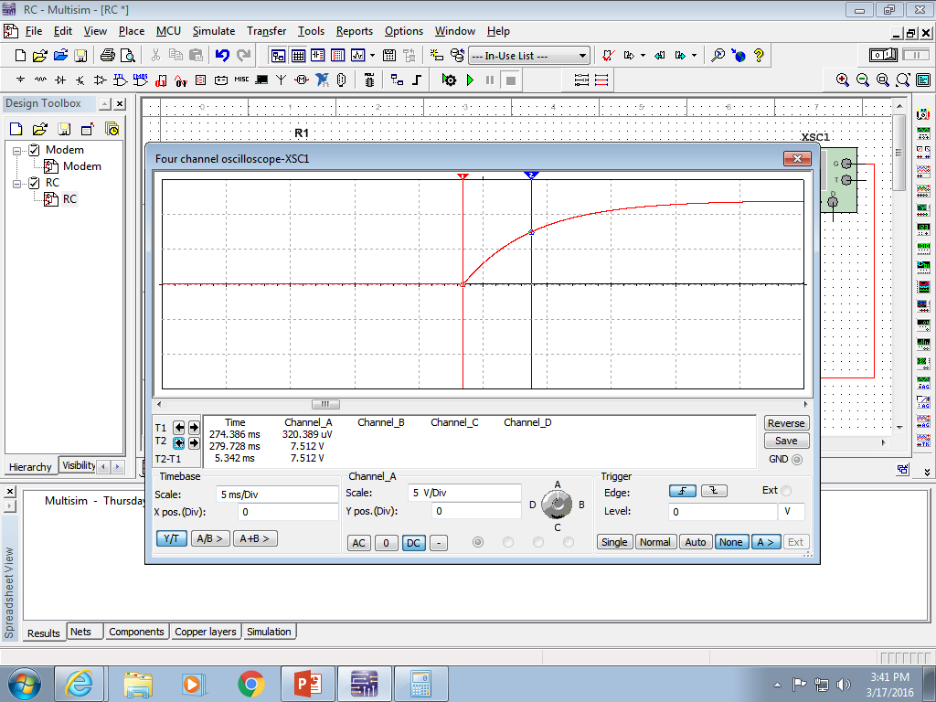
Place needle 1 at “corner” where numbers start to change. Place second needle at level when voltage is 63% of saturation. Read off time difference t2-t1 = 5.342 ms above.
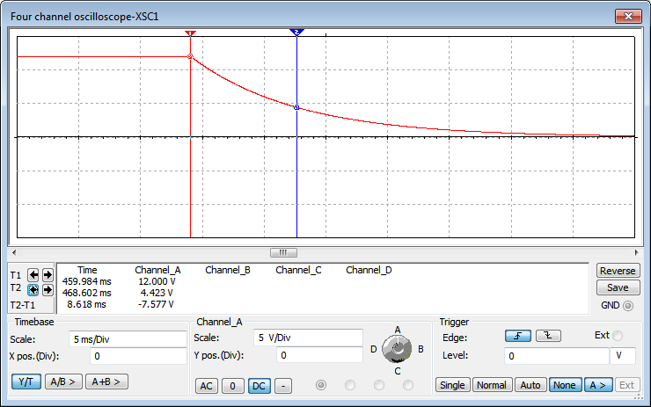
Place needle 1 at “corner” where numbers start to change. Place second needle at level when voltage is 37% of saturation. Read off time difference t2-t1 = 8.618 ms above.

Theory
C2-C3 parallel → Add → 5.2 micro-farad
C1 – C23 series → reciprocal addition → 1.69 micro-farad

Charging
R1-R2 parallel → .768 kilo-ohm
R12 series R3 → 3.20 kilo-ohm

Time constant R*C = 1.69 * 3.20 = 5.41 ms

Discharging
C-eq same 1.69 micro-farad
R3-R4 series → 5.1 kilo-ohm
Time constant → R*C = 1.69 * 5.1 → 8.62 milli-second

