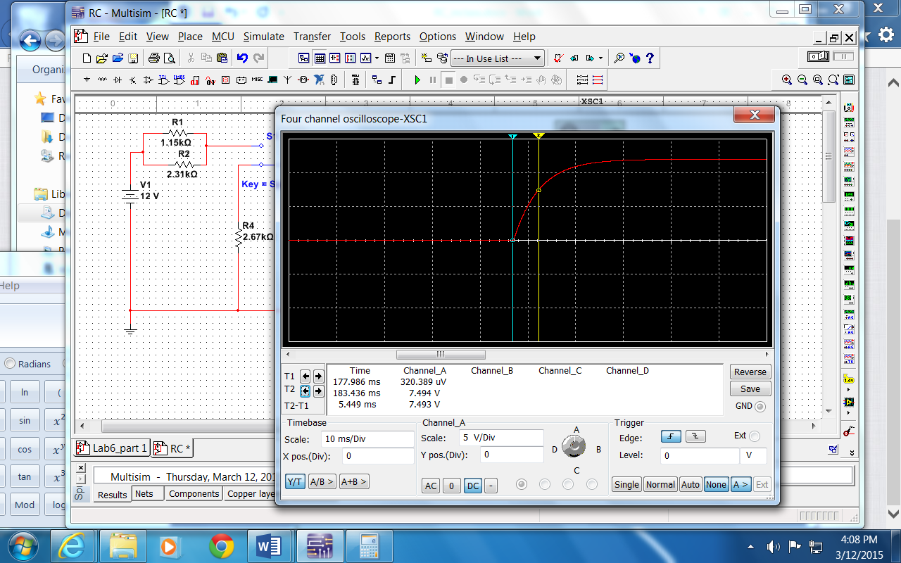
.63% of 12 = 0.63 * 12 = 7.56
Needle 1 where switch was switched
Needle 2 at 7.56 volts
Time T2-T1 = 5.449 ms
Simulation Charging Time constant

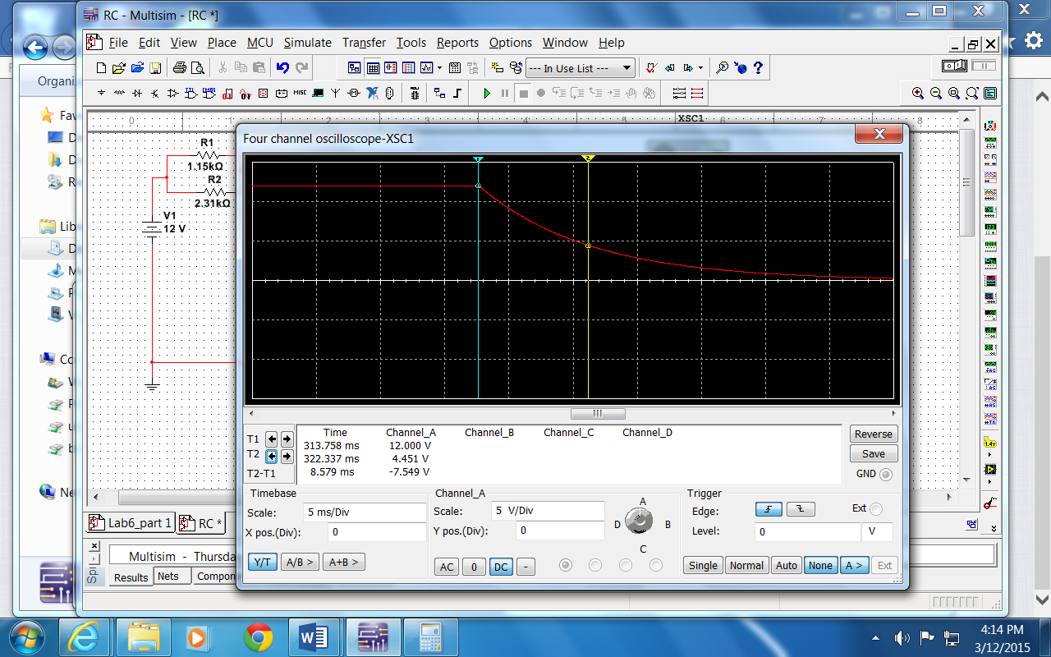
Simulation Discharge
Needle 1 at corner
Needle 2 at 37% of 12 = 0.37*12 = 4.44
T2-t1 = 8.579 ms
PPPPPPPPPPPPPPPPPPPPPPPPPPPPPPPPPPPPPPPPPPPPPPPPPPPPPPPPPPPPPPPPPPPPPPPPP

Charging theory
Equivalent Capacitance: C2 & C3 parallel C23_eq = 3.9 + 1.3 = 5.2 microfarad
C23_eq & C1 are in series 1/C123 = 1/C1 + 1/C23 → C123 = 1.688 microfarad
R1 & R2 parallel → 0.768 kilo-ohm
R12 in series R3 → 0.768 + 2.43 = 3.198 kilo-ohm
Microfarad * kilo-ohm = (10^(-6) farad) * (10^3 ohm) = 10^(-3) farad-ohm = 10^(-3) second = ms
Time constant = R*C = 1.688 * 3.198 = 5.4 ms

Discharging theory
Equivalent Capacitance: SAME AS ABOVE C123 = 1.688 microfarad
Equivalent resistance: R3 & R4 in series: 2.67 + 2.43 = 5.1 kilo-ohm
Time constant R*C = 1.688* 5.1 = 8.6 ms

