Part 1. IV curve of a diode using Electronics Workbench.

Using Electronics Workbench Multisim, construct the circuit below.

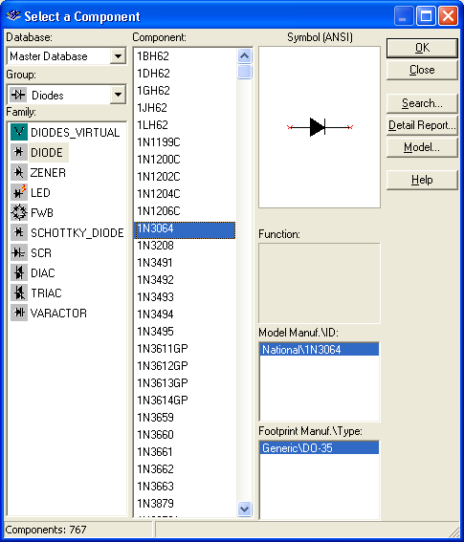

Note that a diode (found under the diode button, next to the basic (resistor) button) is represented as an arrow and a vertical line. Choose the 1N3064 diode. The arrow is on the anode side, and the cathode is on the vertical line side. Set the internal voltmeter resistance to 1000 MΩ and the internal resistance of the ammeter to 1 nΩ, so that the meters are very nearly ideal. Vary the battery voltage from 0.0 t0 1.0V, and record the voltage across the diode and the current through the diode

Voltage across battery | Voltage across diode  (in V) | Current through diode  (in mA) | Resistance across diode  ( Supply Units!)
0.0
0.1
0.2
0.3
0.4
0.5
0.6
0.7
0.8
0.9
1.0

Be sure that you convert all voltages to volts and all currents to milliamps. Next fill in the resistance column. Recall that the resistance is the ratio of Voltage to Current. Compare this to the result you found in Lab 1, Part 1, Number 13. Did the resistance across the resistor (in Lab 1) depend on voltage? Does the resistance of the diode (in this lab) depend on the voltage? Which is Ohmic? And which is non-Ohmic?

Part 2. Rectification

The current coming out of the wall socket is AC (alternating current), and a number of devices (including a computer) require DC current. A rectifier changes AC into DC. The circuit below is called a half-wave rectifier.

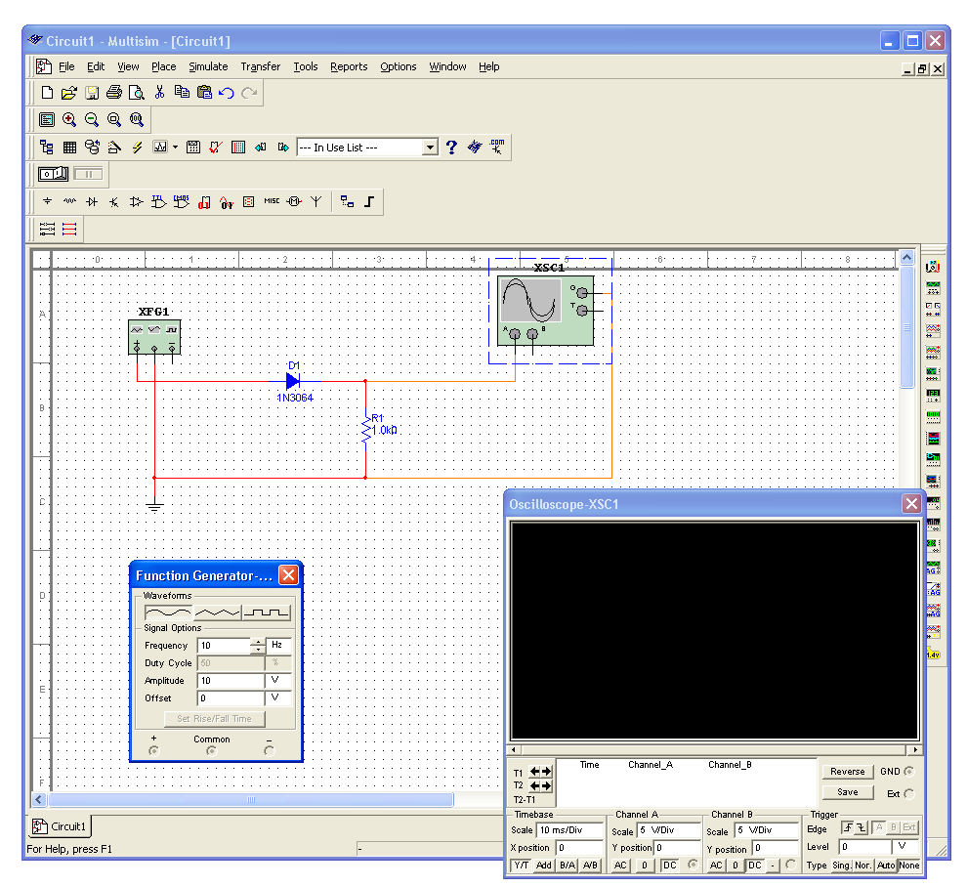
The box on the left is a function generator (found on the right, second from the top). Set its frequency to 10Hz. It will serve as an alternating voltage supply. The box with the sine wave is an oscilloscope (found on the right, fourth from the top). Think of the oscilloscope as a time-dependent voltmeter.

First build the circuit above without the diode. Run a simulation and place a copy of the expanded oscilloscope screen below. Then insert the diode into the circuit and repeat.

Finally build the circuit below, simulate it, and place a copy of its oscilloscope screen below. This circuit is known as a full-wave bridge rectifier. Explain the path taken by the current when the voltage is positive and when it is negative. (Draw a picture twice, indicate on the first the path taken by the current when the voltage at + is positive; indicate on the second the path taken by the current when the voltage at + is negative.)

Part 3. Beginning Transistors. Build the circuit below in Electronics Workbench. The item we have not seen before is an npn transistor (found under Transistors, which are next to the diodes). There are many types of transistors, but the basic principle is the same for all of them. Note that the transistor is a three-terminal device. In the circuit below, the terminal on the top is called the collector; the terminal in the middle and to the left is called the base; and the terminal bottom on the bottom is called the emitter. The collector should be at a higher (more positive) voltage than the emitter.

Vary the voltage VBB and fill in the table below. (If the simulation bombs out at any voltage say VBB= 0.7, then adjust the voltage to 0.71.)

VBB (V) | VBE (V) | IB (mA) | VCE (V) | IC (mA) | VCE/IC  ( ) | IC/IB
0.1 | 0.1 | 0.000014 | 9.999 | 0.001776 | 5630 | 126.9
0.2 | 0.2 | 0.000028 | 9.999 | 0.001776 | 5630 | 63.4
0.3
0.4
0.5
0.6
0.7 | 0.635 | 0.006439 | 8.582 | 1.419 | 6.048 | 220
0.8
0.9
1.0
1.1
1.2 | 0.689 | 0.051 | 0.245 | 9.756 | 0.02511 | 191.3
1.3
1.4
1.5
1.6
1.7
1.8
1.9
2.0

If you were going to use the data above to identify three regions: on, transition and off, where would you say those regions were?

Part 4. Building ROM.

The circuit shown below is a Poor Man’s version of ROM.

The following values have been “burned” into it.

B | A | Value
0 | 0 | 7
0 | 1 | D
1 | 0 | 6
1 | 1 | E

Build your own ROM and “burn” in the following values. Paste a copy of it below.

B | A | Value
0 | 0 | B
0 | 1 | F
1 | 0 | 5
1 | 1 | 3

