PHYSICS 201  LAB 1 | January 16, 2012

Part 1. Ohm’s law and an Introduction to Electronics Workbench.

- Start up Electronics Workbench (Start/All Programs/National Instruments/Circuit Design Suite 12.0/Multisim 12.0).

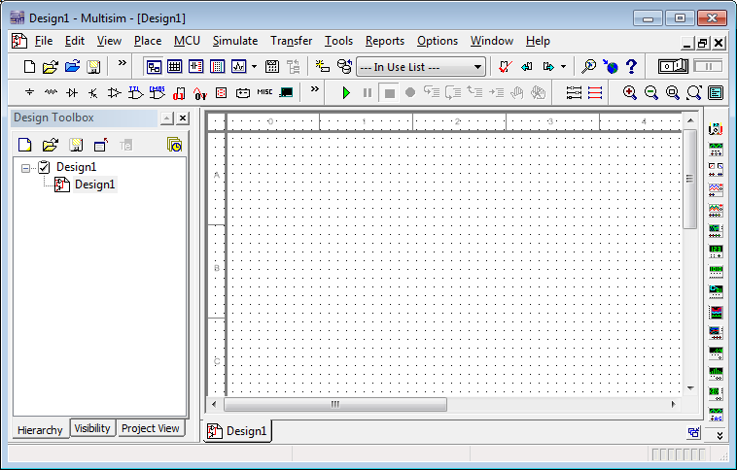
- Click on the Source button (see above). Select a DC source from the list and click OK.

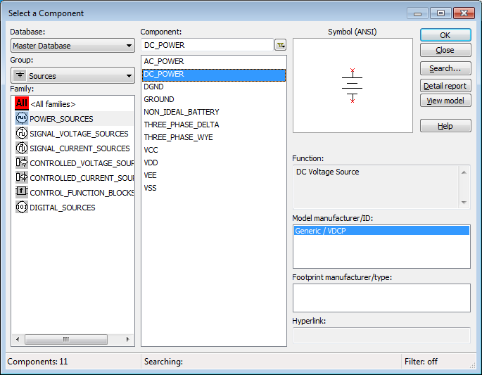
- Click Power_Sources/DC_Power/OK (see above). The cursor now includes a DC Power Source (a battery) icon, click on the location of the workspace where you want to place the battery.
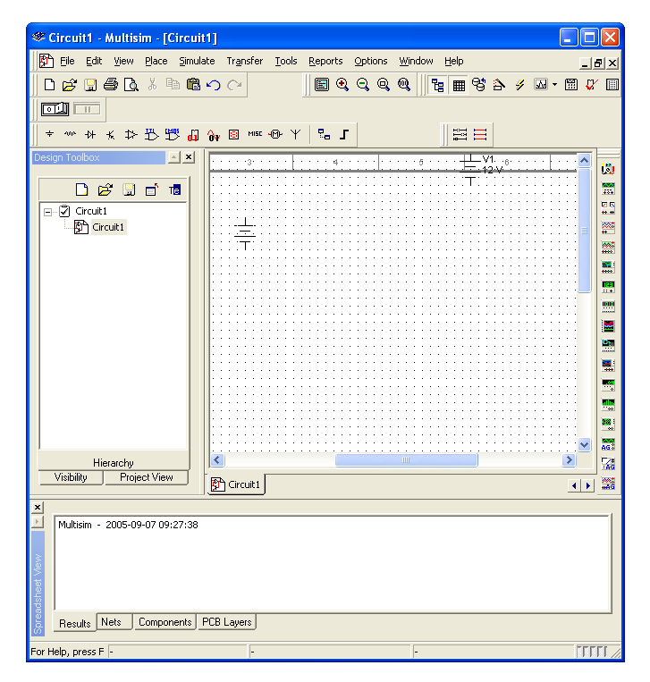
- Close the dialog box. Right click on the battery and choose Properties. Change the Voltage to 5 V and click OK.
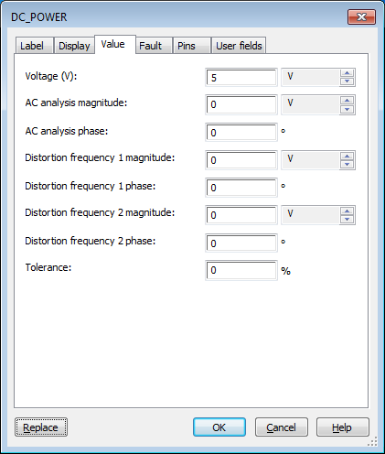

- Click on the Place Basic button, choose Resistor from the list on the left, then choose 2.7kΩ on the resulting list on the right, click OK. Place that resistor on the workspace.

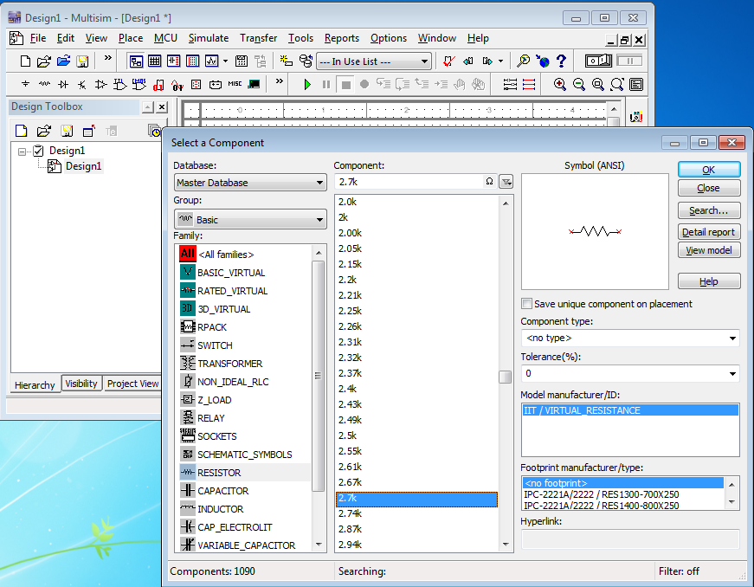
- Add a second resistor (this time 1.2kΩ) onto the workspace. Right click on the second resistor and rotate it.
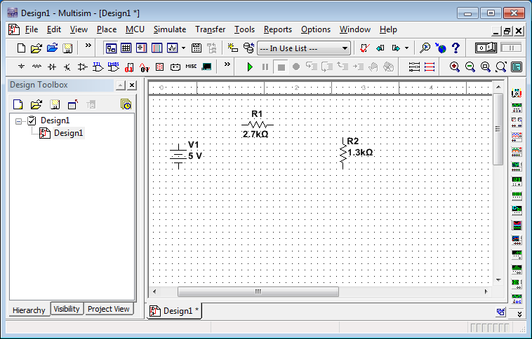

- Add an ammeter. Click on the Place Indicator icon. Select Ammeter/Ammeter_V.
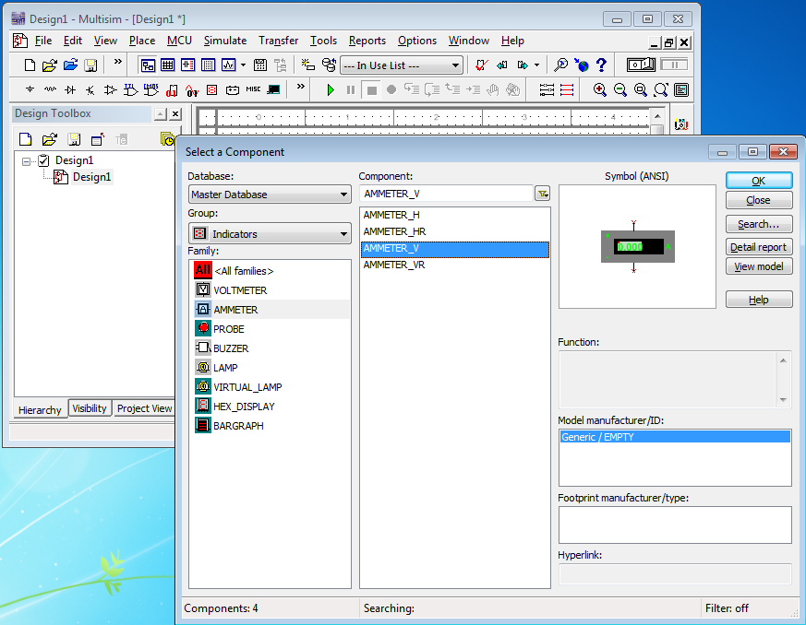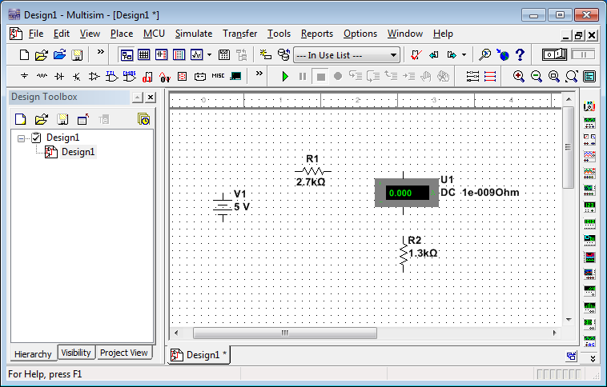

- Connect the battery and resistors in series as shown below. Click at the end of R₁ (a dot will appear) and move it making a line over to the beginning of the ammeter click again to end the line. This is the simulation’s equivalent of connecting the two by a wire.
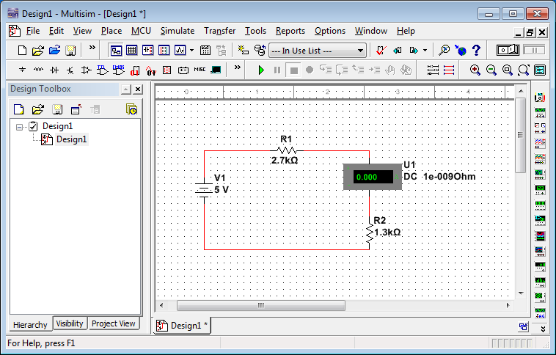

- Add a “ground” to the circuit between R₂ and the battery. Click on the Sources button, choose Ground and OK. Place a Ground onto the workspace. Connect the ground to the circuit.

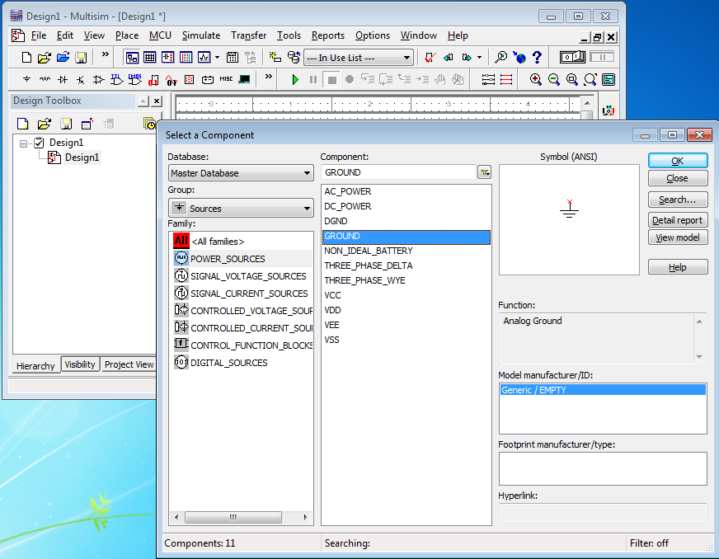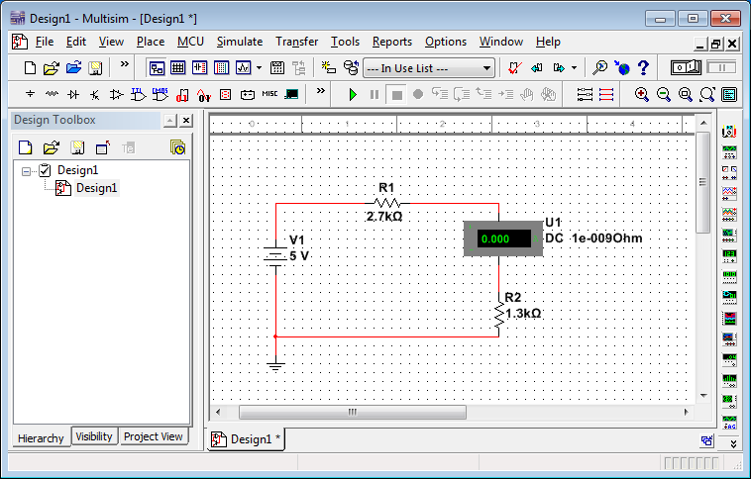

- Hook a voltmeter across (in parallel with) R₁. Click on Place Indicators. Choose Voltmeter, click OK, place a voltmeter onto the workspace. Connect the positive terminal to the beginning of R₁ and the negative terminal to the end of R₁. (I had to highlight the existing circuit and move it lower to make room.)
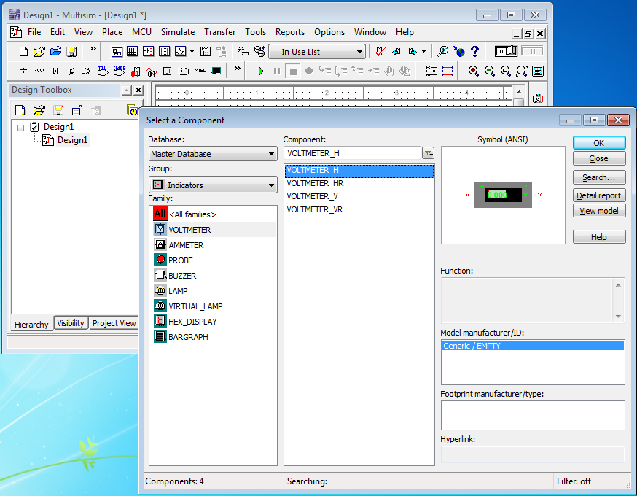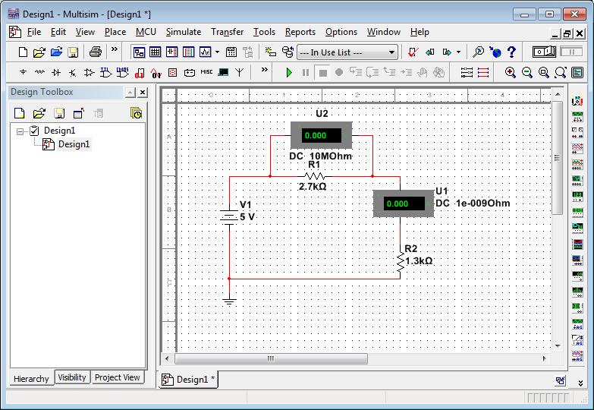

- Right click on the voltmeter. Choose Properties. Make sure the voltmeter is in DC mode.
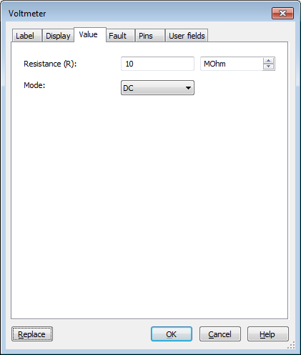

- Click the Activate simulation button which is often on the upper right, but is sometimes on the left because the tools wrapped around. Read the voltage across as well as the current through R₁ off of the voltmeter. Enter it into the table below.
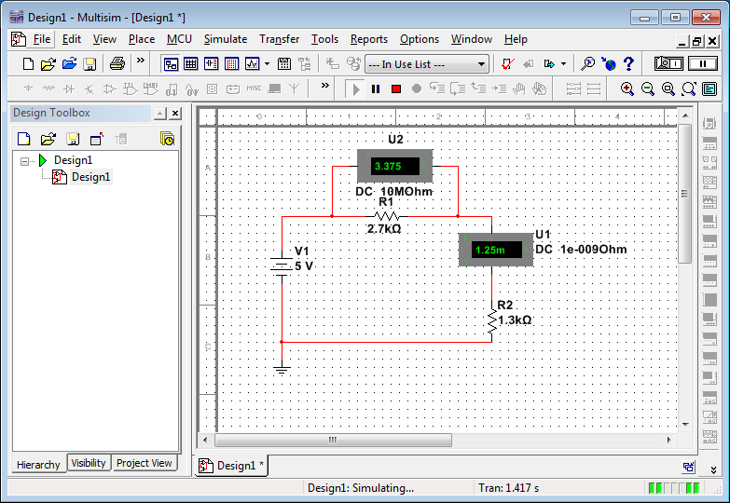

- Save your circuit file. Next change the voltage to 10 V. Repeat the measurements and enter them below. Then 15V, 20V and 25V.

Battery voltage (V) | Voltage across R1 (V) | Current through R1 (mA) | Voltage/Current  ( FILL IN UNIT)
5
10
15
20
25

- Bring a copy of your circuit over from Electronics Workbench and paste it into your Word document: With the Activate Simulation button off, drag from the upper left to lower right of your circuit, then go to Edit/Copy on the Workbench menu. Paste the resulting picture into a Word document.

Paste circuit here

Part 2. Binary and hexadecimal numbers.

All of the information stored in and processed by a computer is represented in bits (binary digits, 1's and 0's). Why?

Convert the following decimal numbers into binary and hexadecimal (use 16 bits).

Decimal | Binary | Hex
75
457
4575

Convert the following binary numbers into decimal. (Assume they are unsigned.)

Binary | Decimal | Hex
11010101
10101010
10101001

Part 3. Negative Numbers.

Let us extend our representation to include negative numbers. Note that -26 is that number which when added to +26 gives zero. Assuming we are using eight bits to represent a number calculate the two’s complement of 26. First replaces 1’s with 0’s and vice versa.

0 | 0 | 0 | 1 | 1 | 0 | 1 | 0

Copy the result above into the top row below and then add 1 to your result.

+ | 0 | 0 | 0 | 0 | 0 | 0 | 0 | 1

Copy the result above into the second row below and add to demonstrate that 26 + (-26) = 0.

 | 0 | 0 | 0 | 1 | 1 | 0 | 1 | 0
+
 | 0 | 0 | 0 | 0 | 0 | 0 | 0 | 0

Repeat the steps above to find –106. (0’s → 1’s)

And add 1.

+ | 0 | 0 | 0 | 0 | 0 | 0 | 0 | 1

Next, add 26 and –106.

+

Does the answer above make sense? How do you know?

Part 4. More on Negative Numbers

If we use 16 bits, what is the largest integer (signed) we can represent?

What is its binary representation?

What is the smallest (most negative) integer?

What is its binary representation?

Part 5. Negative Numbers in Other Bases

Construct the 10's complement of the decimal number 472. What number (other than -472) will produce the zeros shown below when added to 472?

 | 4 | 7 | 2
+
 | 0 | 0 | 0

Construct the 16's complement of the hexadecimal number 5C6.

 | 5 | C | 6
+
 | 0 | 0 | 0

Part 6. Interpretation

Interpret the following eight-bit binary string

1 | 1 | 1 | 0 | 1 | 0 | 1 | 0

A. As an unsigned integer

B. As an signed integer

C. Convert it to hex

The calculator found under Start/Programs/Accessories/Calculator (in Programmer View) allows one to work in binary-number mode by clicking on the Bin radio button. How many bits does it use to represent its binary numbers?

What’s the largest number it can represent? Does the calculator assume it is signed or unsigned? How do you know?

Part 7. Fractions (Fixed point binary numbers)

Express the following fractions in binary form. Use eight bits for the whole number and eight bits for the fraction.

Decimal | Binary
789.782
233.2423

Part 8. IP Stuff

Go to Start, type cmd (or command) and click OK. At the prompt, type ipconfig /all. That should provide information about the computer’s network set-up. Convert the IP address and subnet mask to binary. You should include all leading zeros.

 | Dotted-Decimal Notation | Binary Representation

IP Address
Subnet mask

What is your computer’s physical address?

How many hexadecimal characters does it use?

To how many bits does that correspond?

In principle how many distinct physical addresses could there be?

