1. Write the maxterm expression for the following truth table.

A | B | C | Out
0 | 0 | 0 | 1
0 | 0 | 1 | 0
0 | 1 | 0 | 1
0 | 1 | 1 | 1
1 | 0 | 0 | 0
1 | 0 | 1 | 0
1 | 1 | 0 | 1
1 | 1 | 1 | 1

A. Maxterm expression: (A+B+C’) (A’+B+C) (A’+B+C’a)

B. Build the corresponding circuit in Electronics Workbench, entitle the file Maxterm.ms11, save it to your test folder and paste a copy of the circuit below.

2. Express -123 (negative one hundred twenty three) as a 16-bit number.

1 | 1 | 1 | 1 | 1 | 1 | 1 | 1 | 1 | 0 | 0 | 0 | 0 | 1 | 0 | 1

3. Construct the 16's complement of the hexadecimal number 6B9.

 | 6 | B | 9
+ | 9 | 4 | 7
1 | 0 | 0 | 0

4. Interpret the following eight-bit binary string

1 | 1 | 1 | 0 | 0 | 1 | 1 | 0

A. As a signed integer | -26

B. As an unsigned integer | 230

11100110
00011001
00000001
00011010

C. Convert it to hex | E6

5. Represent 48.36 as a binary number, using eight bits for the whole number and eight bits for the fractional part.

0 | 0 | 1 | 1 | 0 | 0 | 0 | 0 | . | 0 | 1 | 0 | 1 | 1 | 1 | 0 | 0

.36 * 2^8 = 92.16
92 -> 1011100 need leading zero

6. What range of numbers will be represented using an 18-bit unsigned number?

Lowest: 0 | To Highest: 2^18 -1 = 262,143

7. What range of numbers will be represented using a 22-bit signed number?

Lowest: -2^21 = -2,097,152 | To Highest:2^21 -1 = 2,097,151

8. Convert the truth table below to its Karnaugh style version.

A | B | C | D | W
0 | 0 | 0 | 0 | 1
0 | 0 | 0 | 1 | 1
0 | 0 | 1 | 0 | 1
0 | 0 | 1 | 1 | 1
0 | 1 | 0 | 0 | 0
0 | 1 | 0 | 1 | 0
0 | 1 | 1 | 0 | 0
0 | 1 | 1 | 1 | 1
1 | 0 | 0 | 0 | 1
1 | 0 | 0 | 1 | 1
1 | 0 | 1 | 0 | 1
1 | 0 | 1 | 1 | 1
1 | 1 | 0 | 0 | 1
1 | 1 | 0 | 1 | 0
1 | 1 | 1 | 0 | 1
1 | 1 | 1 | 1 | 0

 | D | 0 | 1 | 1 | 0
A | B\C | 0 | 0 | 1 | 1
0 | 0 | 1 | 1 | 1 | 1
0 | 1 | 0 | 0 | 1 | 0
1 | 1 | 1 | 0 | 0 | 1
1 | 0 | 1 | 1 | 1 | 1

Write a simplified expression for the W output below.

Expression for W:
B’ (first and last row) + A’CD (third column, first and second row)
AD’ (last two rows, first and last column)

9. Write the minterm expression for the following truth table.

A | B | C | Out
0 | 0 | 0 | 1
0 | 0 | 1 | 0
0 | 1 | 0 | 0
0 | 1 | 1 | 0
1 | 0 | 0 | 1
1 | 0 | 1 | 0
1 | 1 | 0 | 1
1 | 1 | 1 | 1

A. Minterm expression: A’B’C’ + AB’C’ + ABC’ +ABC

B. Build the corresponding circuit in Electronics Workbench, entitle the file Minterm.ms11, save it to your test folder and paste a copy of the circuit below.

10. In a Venn diagram, condition or input A is true inside the circle labeled "A" and false outside the circle. The intersection of the circles represents A AND B being true, and so on. Shade in the regions that correspond to inputs that lead to true outputs.

(A⊕B′)+C (⊕ means excluded or) | A′B′C+ABC′+A′C
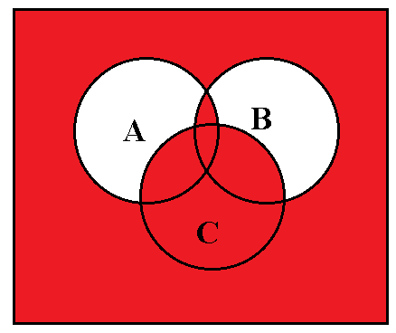 | 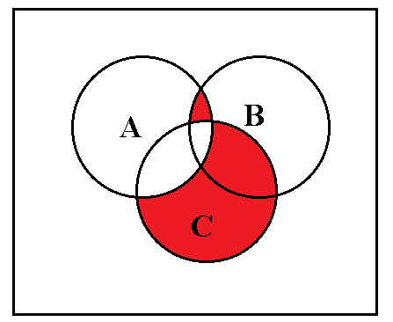

A | B | C | B’ | (A⊕B′) | (A⊕B′)+C
0 | 0 | 0 | 1 | 1 | 1
0 | 0 | 1 | 1 | 1 | 1
0 | 1 | 0 | 0 | 0 | 0
0 | 1 | 1 | 0 | 0 | 1
1 | 0 | 0 | 1 | 0 | 0
1 | 0 | 1 | 1 | 0 | 1
1 | 1 | 0 | 0 | 1 | 1
1 | 1 | 1 | 0 | 1 | 1

11. Using the 01 to correspond to rock, 10 to correspond to paper, and 11 to correspond to scissors, fill in the Karnaugh-style truth table below for the outcomes in which Player A wins or ties. Select the “don’t cares” to maximize the simplification. Then write a simplified expression in terms of inputs W, X, Y and Z.

Player A | Player B | Outcome
Rock | Rock | Tie | ✓
Rock | Paper | B wins
Rock | Scissors | A wins | ✓
Paper | Rock | A wins | ✓
Paper | Paper | Tie | ✓
Paper | Scissors | B wins
Scissors | Rock | B wins
Scissors | Paper | A wins | ✓
Scissors | Scissors | Tie | ✓

 |  | Player B |  | Rock | Scissors | Paper
 |  | Z | 0 | 1 | 1 | 0
Player A | W | X\Y | 0 | 0 | 1 | 1
 | 0 | 0 | 1 | 1 | 1 | 1
Rock | 0 | 1 | 0 | 1 | 1 | 0
Scissors | 1 | 1 | 0 | 0 | 1 | 1
Paper | 1 | 0 | 1 | 1 | 0 | 1

Simplified expression for Player A wins or ties.
W’Z (first two rows, middle two columns)
+WXY (third row, last two columns)
+ X’Y’ (first and last row, first two columns)
+X’Z’ (four corners)

