PHYSICS 201
LAB 2

Save your Electronics Workbench files. Name them in a logical manner. If you are working in a team, each partner should have a copy. I may allow you to use them on the tests.

Part 1. Ohm’s law and an Introduction to Electronics Workbench.

- Start up Electronics Workbench (Start/All Programs/Electronics Workbench/Multisim8 or double click the multisim.exe file found at c:\Program Files\Electronics Workbench\EWB8 ).

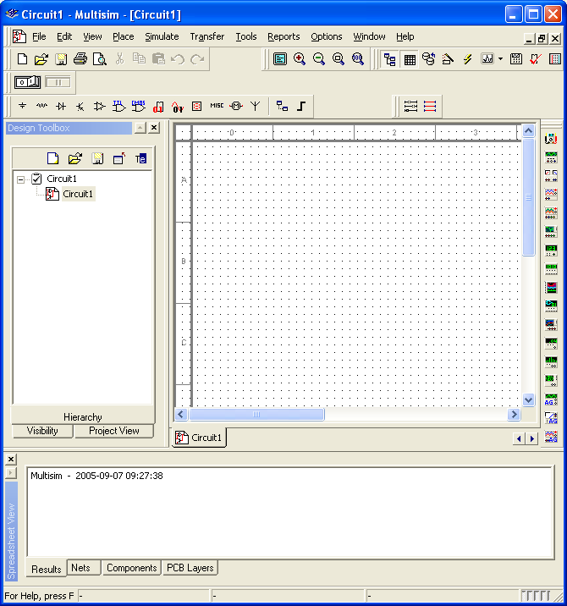

- Click on the Source button (see above). Select a DC source from the list and click OK.
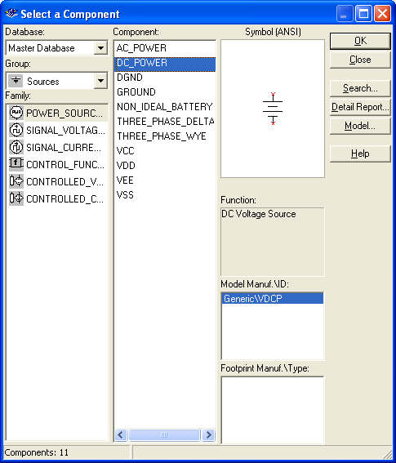

- The cursor now includes a DC Power Source (a battery) icon, click on the location of the workspace where you want to place the battery.
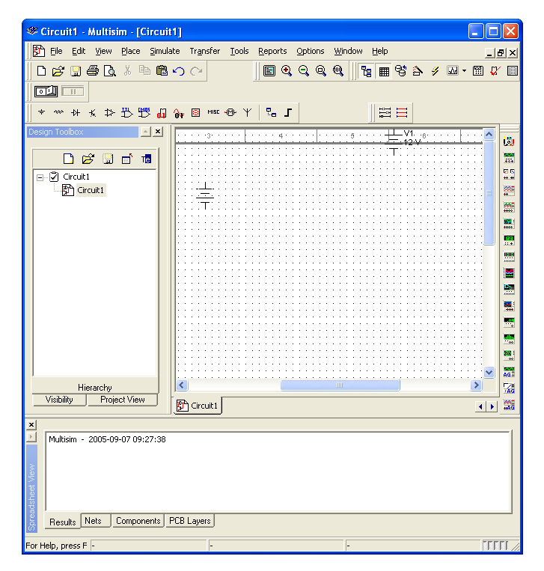
- Right click on the battery and choose Properties. Change the Voltage to 5 V and click OK.
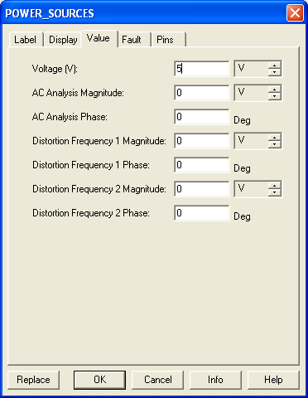

- Click on the Place Basic button, choose Resistor from the list on the left, then choose 1.3kΩ on the resulting list on the right, click OK. Place that resistor on the workspace.

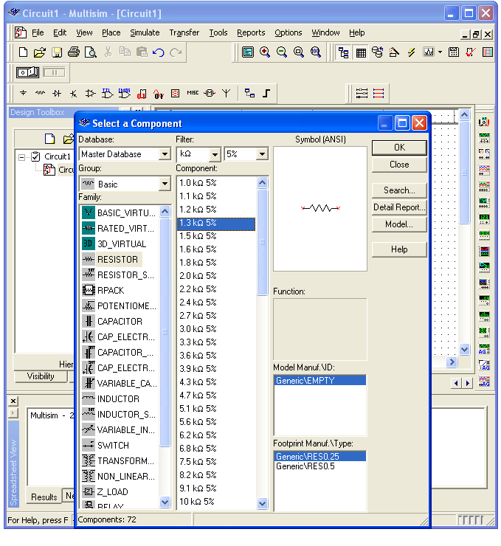

(Note the Filter drop-down list in the center-top of the “Select a Component” dialog. If you wanted to see a more complete list of resistor values, you would use the drop-down list to select ALL.)

- Add a second resistor (this time 2.7kΩ) onto the workspace. Right click on the second resistor and rotate it.

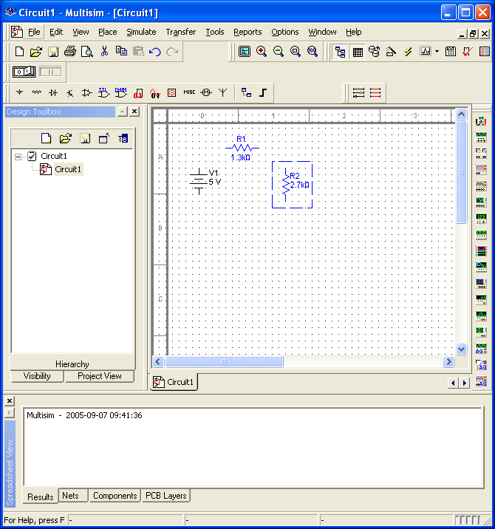

- Connect the battery and resistors in series as shown below. Click at the end of R₁ (a dot will appear) and move it making a line over to the beginning of R₂ click again to end the line. This is the simulational equivalent of connecting the two resistors by a wire.

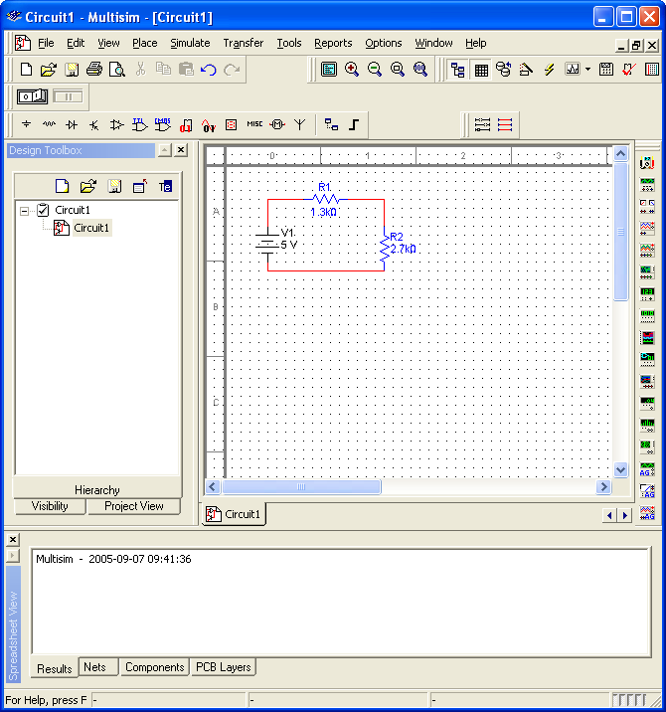

- Add a “ground” to the circuit between R₂ and the battery. Click on the Sources button, choose Ground and OK. Place a Ground onto the workspace. Connect the ground to the circuit.
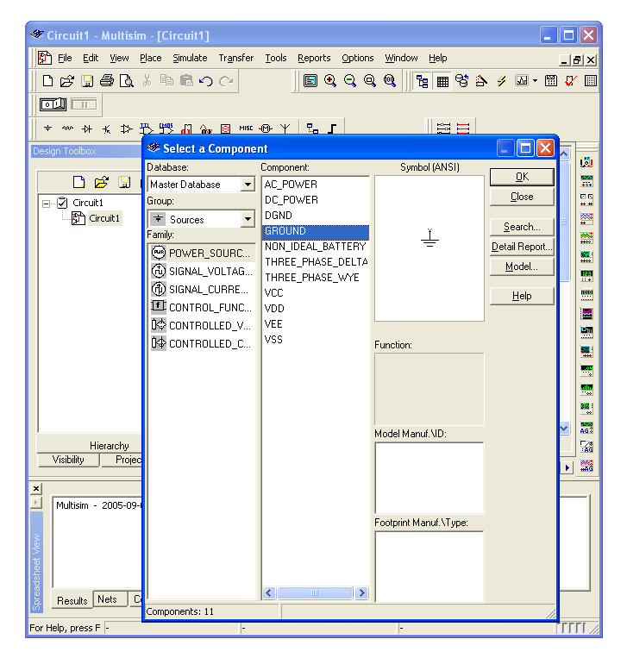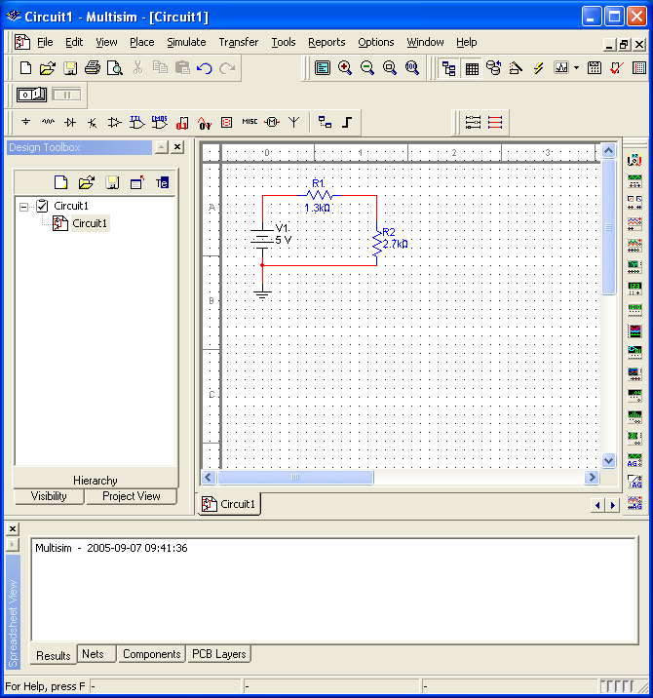

- Hook a voltmeter across (in parallel with) R₁. Click on Place Indicators. Choose Voltmeter, click OK, place a voltmeter onto the workspace. Connect the positive terminal to the beginning of R₁ and the negative terminal to the end of R₁. (I had to highlight the existing circuit and move it lower to make room.)

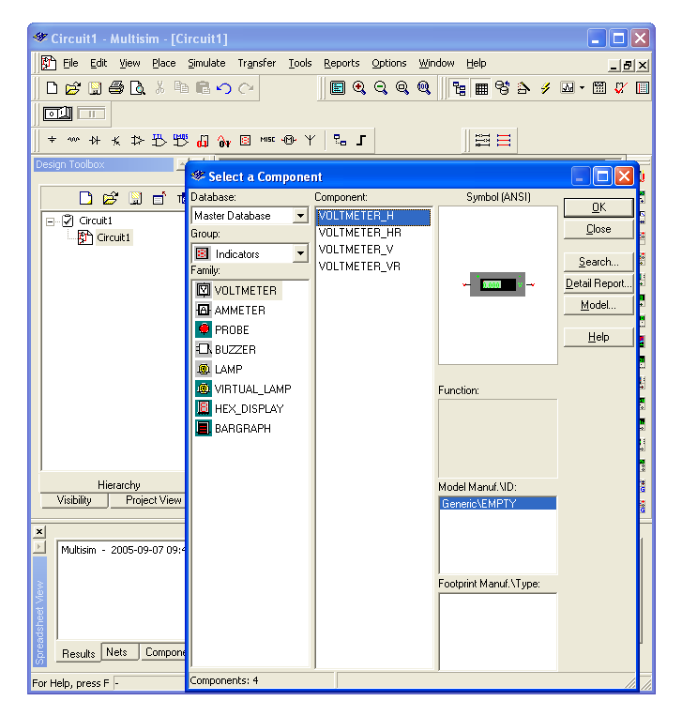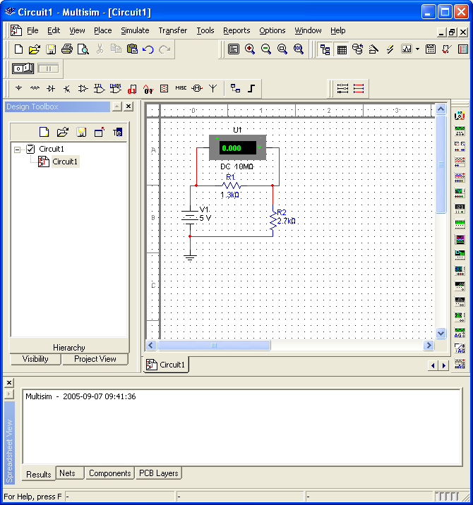
- Right click on the voltmeter. Choose Properties. Make sure the voltmeter is in DC mode.
- Click the Activate simulation button (it looks like a light switch – it may be on the right or left depending on the size of your Multisim window). Read the voltage across R₁ from the voltmeter. Enter it into the table below.

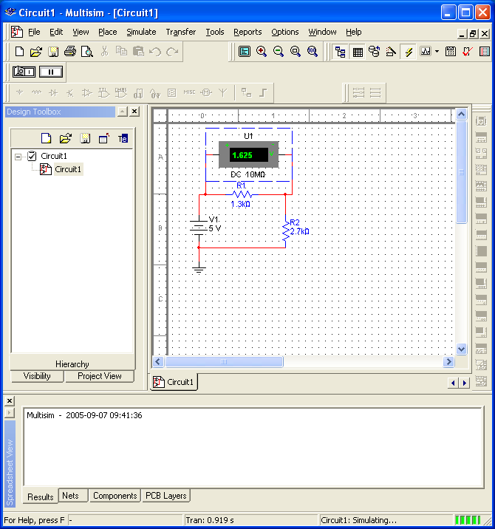

- Save your circuit file. Next place the voltmeter across (in parallel with) R₂. Repeat the measurements and enter them below.
- Bring a copy of your circuit over from Electronics Workbench and paste it into your Word document: Drag from the upper left to lower right of your circuit, then go to Edit/Copy on the Workbench menu. Paste the resulting picture into a Word document.
- Change the resistor values to R₁ = 1.6 kΩ and R₂ = 3.3 kΩ and repeat.

Resistance 1 | Resistance 2 | Voltage across R₁ (V) | Voltage across R₂ (V) | Sum of voltages (V)
R₁ = 1.3 kΩ | R₂ = 2.7 kΩ
R₁ = 1.6 kΩ | R₂ = 3.3 kΩ
Part 2. The AND gate.

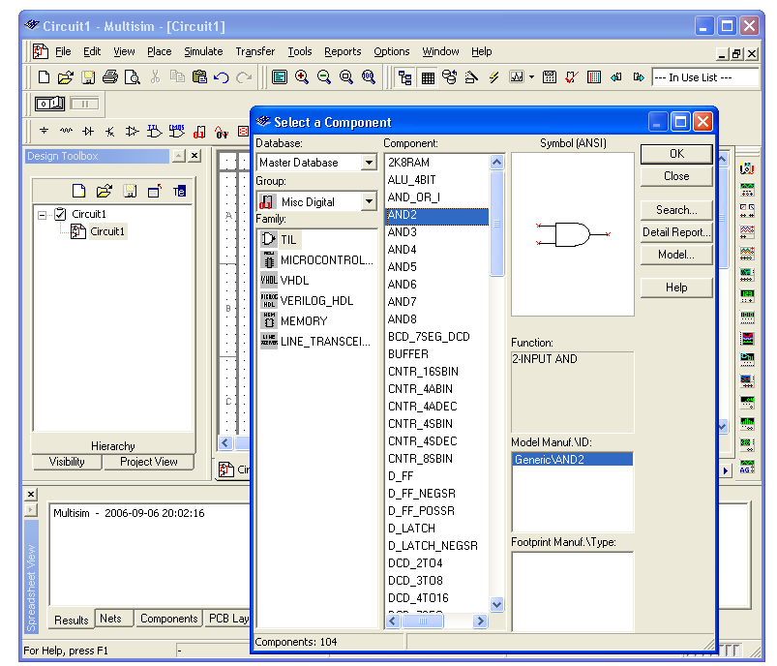

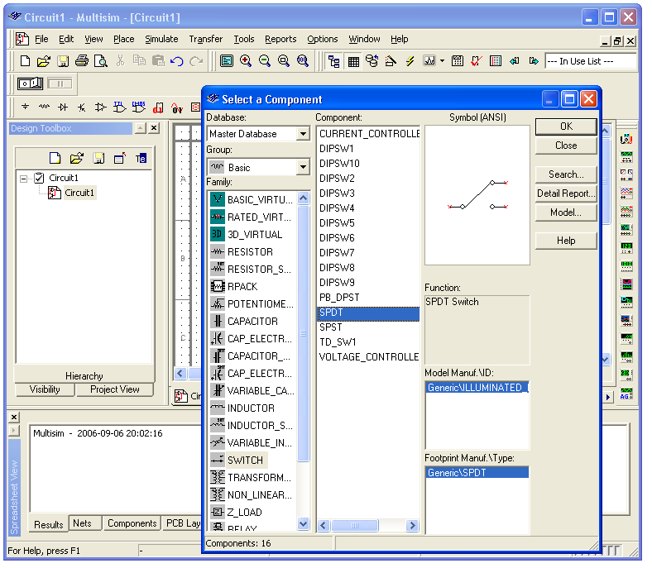

Simulate the circuit below. The new items are an AND gate and switches (seen above). Right click on the first switch, choose Component Properties, and under the Value tab, type the letter “a” in the Key text box. This means that entering the letter “a” from the keyboard flips the switch. Make the key for the other switch “b.” Fill in the truth table below by using the switches to connect A and B to the high and low lines.

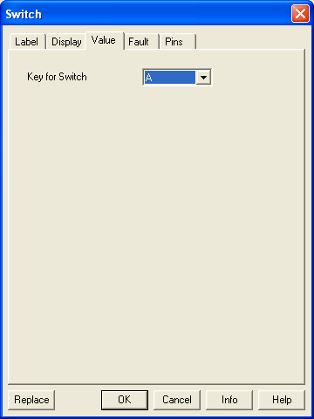

Note that switch A is in the high position – not because the switch is in the upper position but because it is connected to the high end of the battery (the long lines).

A | B | Voltage | High or low
Low (0) | Low (0)
Low (0) | High (1)
High (1) | Low (0)
High (1) | High (1)

Part 3. XOR.

Repeat the above exercise using the EOR (excluded or) gate.

A | B | Voltage | High or low
Low (0) | Low (0)
Low (0) | High (1)
High (1) | Low (0)
High (1) | High (1)

Part 4. Truth Table comparisons and De Morgan’s Theorem.

De Morgan’s Theorem states that

AB = (A΄ + B΄)΄
A + B = (A΄B΄)΄

where AB means A AND B, A + B means A OR B and A΄ means NOT A. In other words, you can construct the equivalent of an AND gate using NOTs and ORs, and you can construct the equivalent of an OR gate using NOTs and ANDs. Below I show a circuit corresponding to the right-hand-side of the first equation above. Build a circuit corresponding to the right-hand-side of the second equation above. Paste your circuit below mine. Use it to fill in the truth table below.

Truth table for right-hand side of second de Morgan’s theorem above
A | B | Voltage | High or low
Low (0) | Low (0)
Low (0) | High (1)
High (1) | Low (0)
High (1) | High (1)

Part 5. Seven-Segment Displays

One way to display a number is to use a seven-segment display as shown below. A digit (0-9) is input in binary form. The beginning of the truth table for lighting the appropriate segments is shown below.
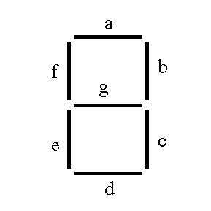
(Think of 1 as “lit.”)
 | W | X | Y | Z | a | b | c | d | e | f | g
0 | 0 | 0 | 0 | 0 | 1 | 1 | 1 | 1 | 1 | 1 | 0
1 | 0 | 0 | 0 | 1 | 0 | 1 | 1 | 0 | 0 | 0 | 0
2 | 0 | 0 | 1 | 0
3 | 0 | 0 | 1 | 1
4 | 0 | 1 | 0 | 0
5 | 0 | 1 | 0 | 1
6 | 0 | 1 | 1 | 0
7 | 0 | 1 | 1 | 1
8 | 1 | 0 | 0 | 0
9 | 1 | 0 | 0 | 1
Fill in the rest of the truth table. Write an expression for the “b” output.

B =

Part 6. Sum of products and Product of sums

Write the sum of products and product of sums expressions for the following truth table.

A | B | C | Out
0 | 0 | 0 | 0
0 | 0 | 1 | 0
0 | 1 | 0 | 1
0 | 1 | 1 | 1
1 | 0 | 0 | 1
1 | 0 | 1 | 1
1 | 1 | 0 | 0
1 | 1 | 1 | 1

Sum of products:

Another term for sum of products is ________________________.

Product of sums:

Another term for product of sums is ________________________.

Part 7. Venn Diagrams

In a Venn diagram, condition or input A is true inside the circle labeled "A" and false outside the circle. The intersection of the circles represents A AND B being true, and so on. Shade in the regions corresponding to the expressions below.

(A′B)′ | (A+B′)(A′+B)
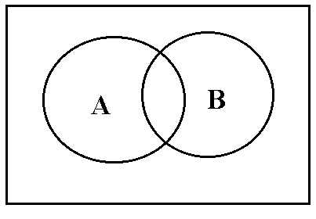

(A⊕B)⊕C (⊕ means excluded or) | A′B+AB′C+A′C′
