PHYSICS 201
Lab 10
Name: __________________________

Executing a small program

The following program and data are stored in memory. Consider the execution of the program starting at Address 0. Determine the value in the accumulator before executing each line.

Address | Value | Value in Accumulator A as one begins to execute the instruction
0 | LOAD INDIRECT 4 | XXX
1 | ADD 5
2 | ADD IMMEDIATE 6
3 | STOP
4 | 6
5 | 7
6 | 8
7 | 9
8 | 10
9 | 11

Stack Operation Demonstration Program

Convert the following infix instructions into postfix and vice versa.

Infix | Postfix
 | 10 25 2 * + 40 +
 | 5 7 3 2 + 4 * * +
 | 3 5 * 7 9 + 2 * 4 + *
7*3+2*4*5+6
(5+4)*(3+2)+(7*6)
9*3+(7*(5+6)*4+8)*2

You can test your results by entering your postfix expressions into the program found at

http://www.cs.orst.edu/~minoura/cs261/javaProgs/stack/Polish.html

Stack Vocabulary.

When one jumps to a subroutine, one has to store the address of the Program Counter so that when it comes time to return from the subroutine, one knows where to return. One subroutine may call another, so a whole series of return addresses may be needed. To handle multiple calls, one uses a stack. Give definitions of the following stack terminology.

Stack

LIFO

Pop

Push

Stack Pointer

- Microinstructions for a subroutine call.

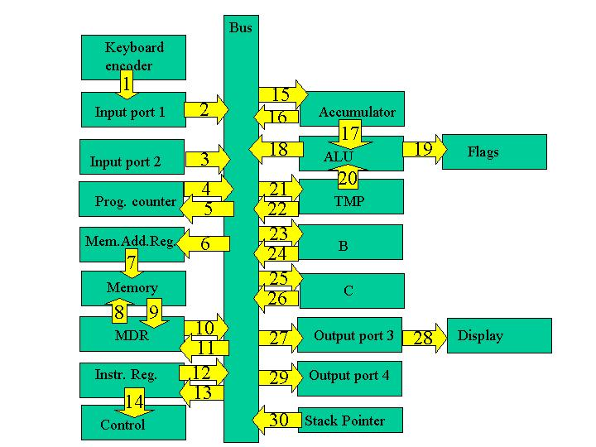

The execution cycle of a subroutine call involves

4. Assume the Stack Pointer holds the last location of the stack (a designated portion of memory) that was written to. In order to place a new value onto the stack, the stack pointer must be incremented.
5. Next place the stack pointer’s (SP) value into the memory address register (MAR) so we are now accessing the next available spot in the stack.
6. Push the value of the program counter (PC) onto the stack (memory location currently pointed to).
7. Take the address of the subroutine which is part of the instruction (in the instruction register) and place it in the PC.

Determine for the timing states of the subroutine call instruction described below
- Which parts of the circuit are active? (Hint: the Controller/Sequencer is active whenever anything is happening and the Instruction Register is active during the execute cycle.)
- “Who’s driving the bus?”
- And who’s reading from the bus?

Subroutine Call
Step | Active | Driving Bus | Reading bus
1
2
3
4
5
6
7

Note that the arrows are numbered. Fill in the table with the number of the arrows along which information is flowing for each of the timing steps.

Subroutine Call
Step | Arrows along which information flows
1
2
3
4
5
6
7

Microinstructions for a return from a subroutine.

Repeat the exercise for a return from the subroutine which pops a value off the stack and places it in the program counter.

- Put the SP’s value (which is pointing to the last thing written in the stack) into the MAR.
- Take the last value of the stack (line in memory currently pointed to) and put it into the PC.
- Decrement the SP so that it has the address of the previous item of data put on the stack.

Subroutine Return
Step | Active | Driving Bus | Reading bus
1
2
3
4
5
6

Note that the arrows are numbered. Fill in the table with the number of the arrows along which information is flowing for each of the timing steps.

Subroutine return
Step | Arrows along which information flows
1
2
3
4
5
6

