PHYSICS 201
Lab 11
Name:_____________________

- Inequality Comparator.

Build a circuit that takes in two four-bit words (word A and word B) and has two outputs. The first output should be 1 if the two words are the same and 0 otherwise. The second input should be 1 if the word A is greater than word B and 0 otherwise (assuming A and B are interpreted as unsigned binary numbers). Label the inputs A0, A1, etc., where A0 is the least significant bit.

Test the second (greater than) output using a Logic Converter. Below I show the use of the Logic Converter for a 4-to-1 MUX (just as an example of using the Logic Converter). Note that you can connect up to eight inputs and one output. The Logic Converter provides a truth table and an expression. Do not click the Simulate button, rather right click and choose Properties. Click the buttons under Conversions until the truth table is filled in. Paste below a screen capture of your comparator connected to a Logic Converter with the corresponding truth table displayed.

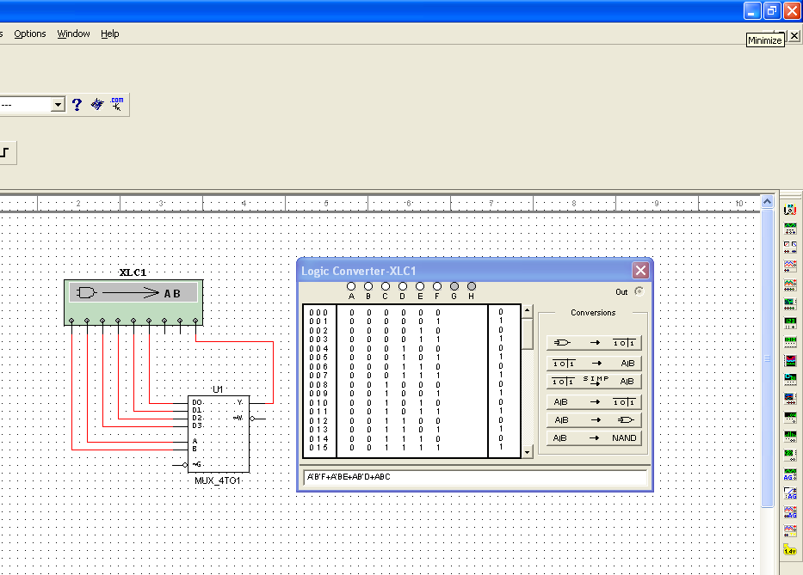

Save your comparator as a subcircuit and then use it to make an eight-bit version of the comparator (a comparator that compares two eight-bit words). Please indicate which word is more significant. Paste the circuit below.

Imagine the four-bit word was representing a signed integer. What problem would arise? Suggest a way of resolving it.

- Associative memory.

What is associative memory? What is another name for it?

What do comparators have to do with the above?

- Evaluating postfix using a stack.

Show the state of the stack at each stage of the following postfix calculation. Use a column of the table to represent what’s on the stack at that stage. Start at the left and proceed to the right.

6 3 4 + 5 2 * + 7 + * 8 9 * +

 | 3
6 | 6
Time →

Show the state of the stack at each stage of the following postfix calculation. Use a column of the table to represent what’s on the stack at that stage. Start at the left and proceed to the right.

2 8 4 + * 7 6 + 5 + * 3 + 9 *

 | 8
2 | 2
Time →

- Coding Control (ROM).

Determine the value of the control pins for the timing states of a Load instruction.

 | Program Counter Enable  (Active High) | Program Counter Load  (Active Low) | Program Counter Increment  (Active Low) | Memory Address Register Load  (Active High) | Memory Read  (Active High) | Memory Write  (Active High) | Memory Data Register Enable  (Active High) | Memory Data Register Load  (Active High) | Instruction Register Enable  (Active High) | Instruction Register Load  (Active High) | Accumulator Enable  (Active High) | Accumulator Load  (Active High) | ALU Add  (Active High) | ALU Enable (Active high) | TMP Register Load  (Active High) | TMP Register Enable  (Active High)
Address state

Increment state
Memory State

Instr. Address to MAR
Data to Accumulator
No-op | 0 | 1 | 1 | 0 | 0 | 0 | 0 | 0 | 0 | 0 | 0 | 0 | 0 |  | 0 | 0

Determine the value of the control pins for the timing states of a Add instruction.

 | Program Counter Enable  (Active High) | Program Counter Load  (Active Low) | Program Counter Increment  (Active Low) | Memory Address Register Load  (Active High) | Memory Read  (Active High) | Memory Write  (Active High) | Memory Data Register Enable  (Active High) | Memory Data Register Load  (Active High) | Instruction Register Enable  (Active High) | Instruction Register Load  (Active High) | Accumulator Enable  (Active High) | Accumulator Load  (Active High) | ALU Add  (Active High) | ALU Enable (Active high) | TMP Register Load  (Active High) | TMP Register Enable  (Active High)
Address state

Increment state
Memory State

