PHYSICS 201  LAB 2 | Name:  September 11, 2018

Save your Electronics Workbench files. Name them in a logical manner. If you are working in a team, each partner should have a copy. I may allow you to use them on the tests.

Part 1. The AND gate.

For the next circuit, you can find a two-input AND gate under Misc. Digital after you choose the TTL family and a switch under Basic as shown below.

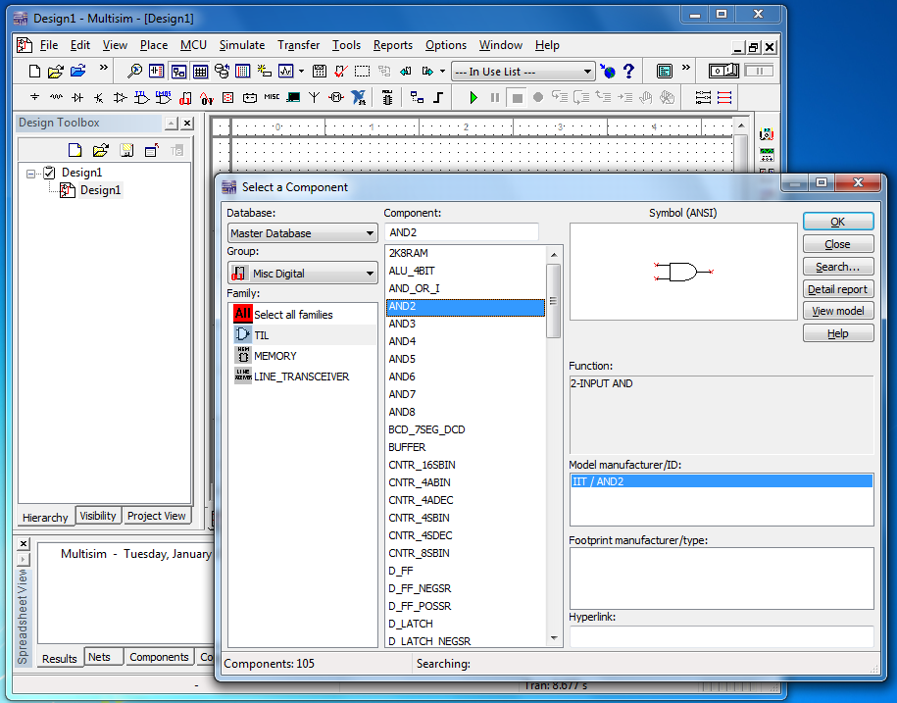

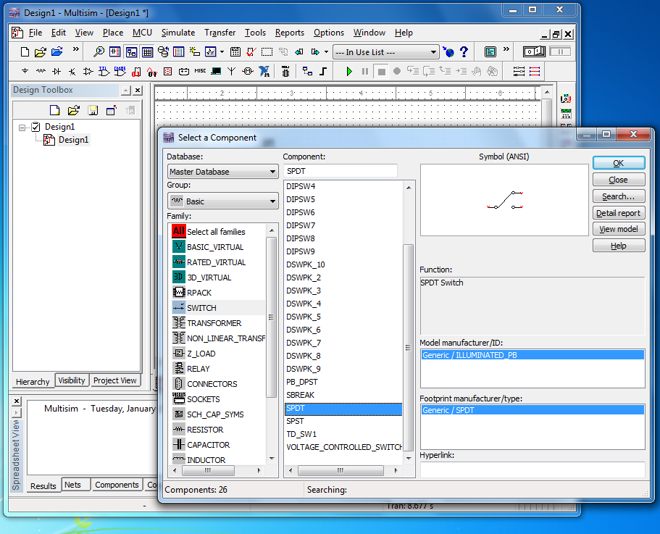

Simulate the circuit below. The new items are an AND gate and switches (seen above). Right click on the first switch, choose Component Properties, and under the Value tab, type the letter “a” in the Key text box. This means that hitting the letter “a” from the keyboard flips the switch. Make the key for the other switch “b.” Fill in the truth table below by using the switches to connect A and B to the high and low lines. You can change the color of the wire by right clicking on it and choosing Net color. In the figure below Switch A (which was flipped horizontally) is connected high – not because it is in the upward position but because it is connected to the long side of the battery.

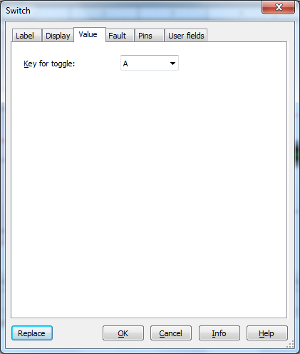

Note that switch A is in the high position – not because the switch is in the upper position but because it is connected to the high end of the battery (the long lines).

A | B | Voltage | High or low
Low (0) | Low (0)
Low (0) | High (1)
High (1) | Low (0)
High (1) | High (1)

Part 2. XOR.

Repeat the above exercise using the XOR2 (excluded or) gate. Be careful not to grab an Excluded NOR by mistake.
A | B | Voltage | High or low
Low (0) | Low (0)
Low (0) | High (1)
High (1) | Low (0)
High (1) | High (1)

Part 3. Truth Table comparisons and De Morgan’s Theorem.

De Morgan’s Theorem states that

AB = (A΄ + B΄)΄
A + B = (A΄B΄)΄

where AB means A AND B, A + B means A OR B and A΄ means NOT A. In other words, you can construct the equivalent of an AND gate using NOTs and ORs, and you can construct the equivalent of an OR gate using NOTs and ANDs. Below I show a circuit corresponding to the right-hand-side of the first equation above. Build a circuit corresponding to the right-hand-side of the second equation above. Paste your circuit below mine. Use it to fill in the truth table below.

Truth table for right-hand side of second de Morgan’s theorem above
A | B | Voltage | High or low
Low (0) | Low (0)
Low (0) | High (1)
High (1) | Low (0)
High (1) | High (1)

Part 4. Seven-Segment Displays

One way to display a number is to use a seven-segment display as shown below. A digit (0-9) is input in binary form. The beginning of the truth table for lighting the appropriate segments is shown below.

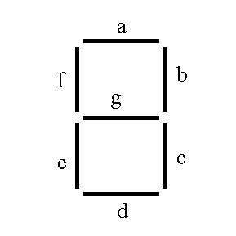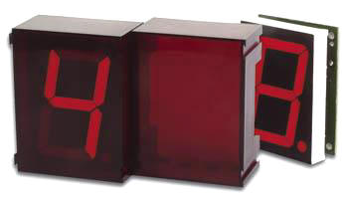

(Think of 1 as “lit” and 0 as “dark”.)
 | W | X | Y | Z | a | b | c | d | e | f | g
0 | 0 | 0 | 0 | 0
1 | 0 | 0 | 0 | 1
2 | 0 | 0 | 1 | 0
3 | 0 | 0 | 1 | 1
4 | 0 | 1 | 0 | 0 | 0 | 1 | 1 | 0 | 0 | 1 | 1
5 | 0 | 1 | 0 | 1
6 | 0 | 1 | 1 | 0
7 | 0 | 1 | 1 | 1
8 | 1 | 0 | 0 | 0
9 | 1 | 0 | 0 | 1
Fill in the rest of the truth table. Write an expression using inputs W, X, Y and Z for the “a” segment’s output.

A =

Part 5. Sum of products and Product of sums

Write the sum of products and product of sums expressions for the following truth table.

A | B | C | Out
0 | 0 | 0 | 0
0 | 0 | 1 | 1
0 | 1 | 0 | 1
0 | 1 | 1 | 1
1 | 0 | 0 | 0
1 | 0 | 1 | 1
1 | 1 | 0 | 0
1 | 1 | 1 | 0

Sum of products:

Another term for sum of products is ________________________.

Product of sums:

Another term for product of sums is ________________________.

Part 6.

Most resistors have a color code (three, four or five stripes) to indicate their resistance. The ones we use have four. In this case, the colors of the first three stripes correspond to numbers as follows:

Color | Digit
Black | 0
Brown | 1
Red | 2
Orange | 3
Yellow | 4
Green | 5
Blue | 6
Violet | 7
Gray | 8
White | 9

If the digits were d1, d2, and d3, the resistance would then be

R=d₁ d₂ × 10^{d3} Ω.

For example, green blue orange would be

R=56 × 10³ Ω or 56 kΩ.

Another example: Brown-Brown-Red would be 11 × 10² Ω or 1.1 ×10³ Ω or 1.1 kΩ.

The last stripe gives the “tolerance”. The resistances are not exact, but rather are supposed to fall in a range around the stated value. The tolerance tells you how narrow the range is supposed to be. A gold stripe indicates that the tolerance is 5%, silver 10%, no fourth stripe 20%. So continuing the example above green blue orange silver means

R=56 × 10³ Ω ±5.6 × 10³ Ω

50 × 10³ Ω < R < 62 × 10³ Ω.

The 5.6 × 10³ Ω is 10% of the 56 × 10³ Ω, so the resistance should fall between 56-5.6 kΩ and 56+5.6 kΩ, which we have rounded slightly to yield the range above.

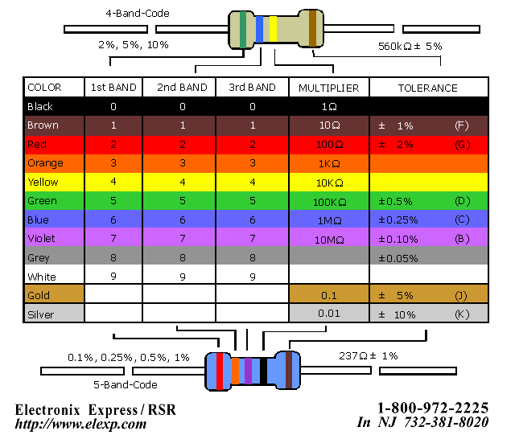

(The above image is taken from http://www.elexp.com/t_resist.htm.)

The circuits we want to simulate have resistors with the following color schemes. Determine their stated resistances.

 | Stripe  Color 1 | Stripe  Color 2 | Stripe  Color 3 | Tolerance Color | Average Resistance
R₁ | Orange | Orange | Red | Gold
R₂ | Brown | Black | Orange | Gold
R₃ | Yellow | Violet | Red | Gold

Part 7. Current through parallel resistors.

Create a circuit with a battery, two resistors in parallel (use values as close as possible to the R₁ and R₂ values from above). Include a ground as well. Place the ammeter in the following four places:
- Between the battery and the resistors before the wires “split.”
- In the branch with R₁ (in series with R₁).
- In the branch with R₂ (in series with R₂).
- After the branches have rejoined.
You can introduce a junction – a place where current might split off by going to Place/Junction (symbolically this act places a dot on the simulation area to which you can attach wires). Place a copy of each configuration into this Word document. Record the current for the voltages found in the table below.

Voltage  (V) | Current “Before”  ( ) | Current  With R₁  ( ) | Current  With R₂  ( ) | Current  “After”  ( )
1.0
2.0
3.0
4.0
5.0

What is the relationship among these currents?

Part 8. Voltmeter

Simulate a circuit with R₁ and R₃ (use the values from Part 6) in series and that combination in parallel with R₂. Connect that entire combination to a battery and include a ground.

Place a voltmeter (under Indicators) across R₁ and record the voltmeter reading for the battery voltages found in the table below. Make sure your voltmeter is in DC mode.

Place the voltmeter across R₂ and repeat.
- Place the voltmeter across R₃ and repeat.
- Place a copy of one of the above configurations over to this Word document.

Voltage  Supplied (V) | Voltage  across R₁  ( ) | Voltage  across R₂  ( ) | Voltage  across R₃  ( )
1.0
2.0
3.0
4.0
5.0

What is the relationship between these voltages?

