Name:

PHYSICS 201
LAB 8

Part 1. Float conversions.

Express the following decimal number as a float. Use 1 bit for the sign, 23 bits for the significand (mantissa), 8 bits for the exponent. Do not use two’s complement. The exponent uses “biasing” – we will use 128.

-890.043

Start by expressing 890.043 as a “pseudo-fixed point number” using as many digits as necessary to represent the whole number 890 and represent the fractional part using the rest of the 23 places.

Next imagine moving the dot that separates whole number and fraction above to the very beginning. That will be our mantissa (we are not completely following the IEEE standard – that will prevent you from just finding some website that does the work for you). Take the number of places that you had to move the dot and add 128 (the bias); that result will be the exponent. The sign is simply 0 for a positive number or 1 for a negative number.

Sign
Mantissa
Exponent

Part 1b. Decimal to Float when the number is less than 1

Express the following decimal number as a float. Use 1 bit for the sign, 23 bits for the significand (mantissa), 8 bits for the exponent. Do not use two’s complement. The exponent uses “biasing” – we will use 128.

0.0945

Multiply by 2^23 and convert the whole number portion to binary. Since the number is less than 1 you will be short of the 23 bits desired. If you are X bits short of 23 then multiply the original number by 2^(23+X) to determine the mantissa.

You have to shift X places to get a 1 in the first position. You are making the mantissa part bigger so you have to compensate with a negative power of 2 [2^(-X)]. Take the number of places that you had to move the dot (-X) and add 128 (the bias); that result will be the exponent. The sign is simply 0 for a positive number or 1 for a negative number.

Sign
Mantissa
Exponent

Part 1c

Express the following float as a decimal number.
Sign
0
Mantissa
1 | 0 | 0 | 1 | 1 | 0 | 0 | 1 | 1 | 0 | 0 | 1 | 1 | 0 | 0 | 1 | 1 | 0 | 0 | 1 | 1 | 0 | 0
Exponent
1 | 0 | 1 | 0 | 1 | 0 | 1 | 0

Convert the mantissa to a decimal and divide by 2²³. That should yield a fraction that is more than a half and less than one.

Convert the exponent to decimal and subtract 128 (unbias) to obtain the power of 2.

(Sign) * (Mantissa Result) * 2^(Exponent Result)
Evaluate the above in a calculator.

Part 2. IV curve of a diode using Electronics Workbench.

Using Electronics Workbench Multisim, construct the circuit below.

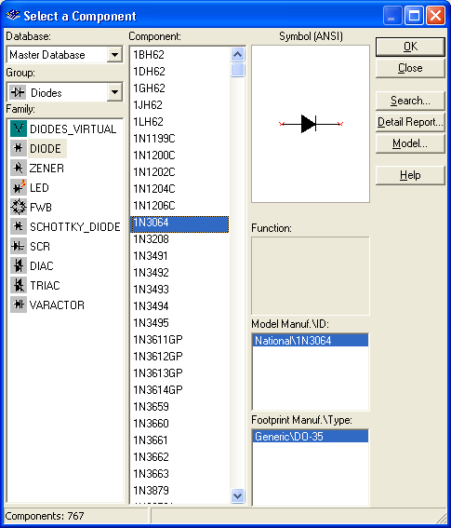

Note that a diode (found under the diode button, next to the basic (resistor) button) is represented as an arrow and a vertical line. Choose the 1N3064 diode. The arrow is on the anode side, and the cathode is on the vertical line side. Set the internal voltmeter resistance to 1000 MΩ and the internal resistance of the ammeter to 1 nΩ, so that the meters are very nearly ideal. Vary the battery voltage from 0.0 t0 1.0V, and record the voltage across the diode and the current through the diode

Voltage across battery | Voltage across diode  (in V) | Current through diode  (in mA) | Resistance across diode  ( Supply Units!)
0.0
0.1
0.2
0.3
0.4
0.5
0.6
0.7
0.8
0.9
1.0

Be sure that you convert all voltages to volts and all currents to milliamps. Next fill in the resistance column. Recall that the resistance is the ratio of Voltage to Current. Compare this to the result you found in Lab 1, Part 1, Number 13. Did the resistance across the resistor (in Lab 1) depend on voltage? Does the resistance of the diode (in this lab) depend on the voltage? Which is Ohmic? And which is non-Ohmic?

Part 3. Rectification

The current coming out of the wall socket is AC (alternating current), and a number of devices (including a computer) require DC current. A rectifier changes AC into DC. The circuit below is called a half-wave rectifier.

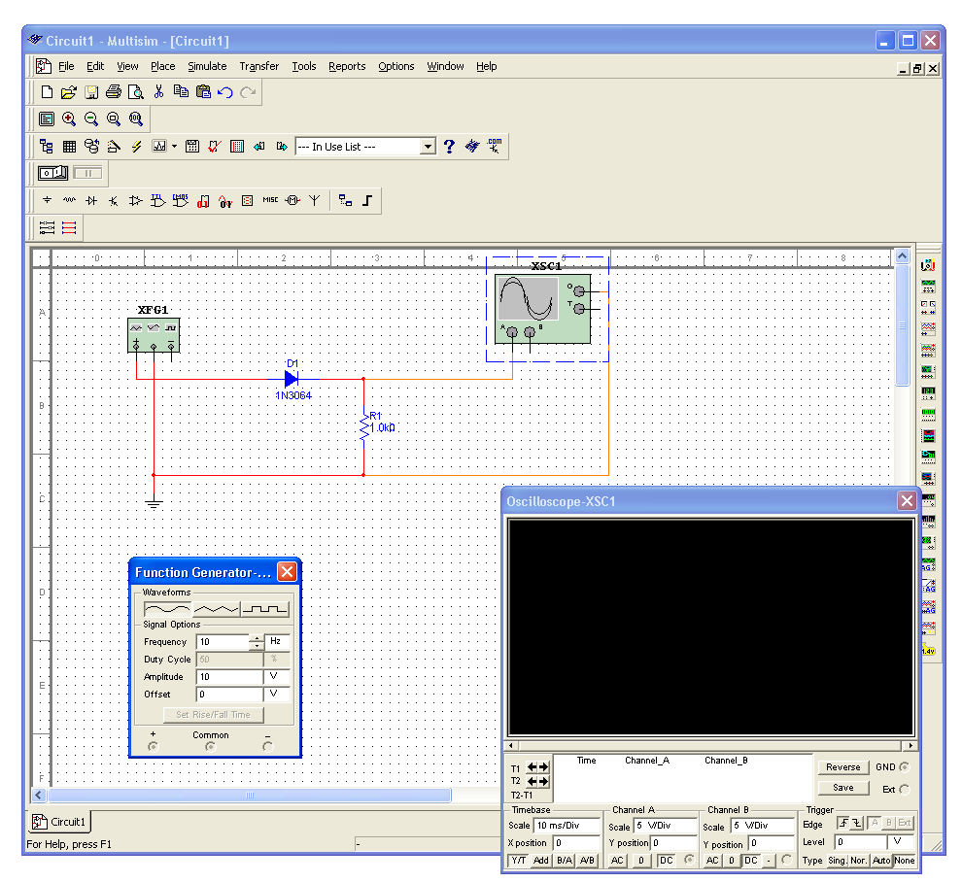
The box on the left is a function generator (found on the right, second from the top). Set its frequency to 10Hz. It will serve as an alternating voltage supply. The box with the sine wave is an oscilloscope (found on the right, fourth from the top). Think of the oscilloscope as a time-dependent voltmeter.

First build the circuit above without the diode. Run a simulation and place a copy of the expanded oscilloscope screen below. Then insert the diode into the circuit and repeat.

Finally build the circuit below, simulate it, and place a copy of its oscilloscope screen below. This circuit is known as a full-wave bridge rectifier. Explain the path taken by the current when the voltage is positive and when it is negative. (Draw a picture twice, indicate on the first the path taken by the current when the voltage at + is positive; indicate on the second the path taken by the current when the voltage at + is negative.)

Part 4. Diode clamps.

Simulate the circuit shown below. Set the amplitude on the signal generator to 5 V and examine the output on the oscilloscope. Then raise the amplitude on the signal generator to 10 V and repeat. What is the effect? Change to the triangular and square waves. Is the effect similar? Paste the resulting oscilloscope screens in your report.

Explain what is happening in this circuit. You may wish to construct a DC version of the circuit shown below and vary the battery that replaced the signal generator from volatges below 5 V to voltages over 5 V.
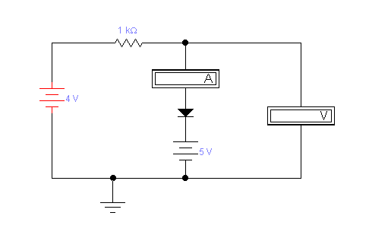
When is the diode conducting current and when is it not? And what was the effect on the “waveform” you put in?

Part 5. Laser printing

Describe the stages of laser printing. What is the role of the laser? Where do the photoconductors come in? Why is the paper warm when it comes out? Sometimes when there’s a paper jam, the print out is very easily smudged; explain what happens in such a case. (Do not simply paste a long explanation that does not specifically address the questions.)

