PHYSICS 201  LAB 4 | Name:____________________________  Sept. 2019

A multiplexer (MUX) allows one to select one from a number of data inputs. Each input is assigned an address. Thus in addition to the data inputs, there are select inputs. The address is put into the select inputs. A demultiplexer (DEMUX) directs an input to one of many possible outputs. It too has addresses to choose which of the possible outputs the data will be directed toward.

Part 1. Multiplexer

Build a 4-to-1 Multiplexer (MUX) from AND’s, OR’s, NOT’s etc. We discussed it in lecture. Paste a copy of the circuit below.

Part 2. Make it a subcircuit.

A subcircuit is like a “black box”. It has input pins and output pins but hides the circuitry within. To create a subcircuit from one of your circuits, drag from the upper left-hand corner to the lower right-hand corner creating a box that includes the interior parts of your circuit but cuts across wires that will serve as inputs or output to your circuit. For example to make a subcircuit for the XOR logic, drag across a rectangle with inputs A and B and output “A XOR B” on the outside and everything else on the inside.

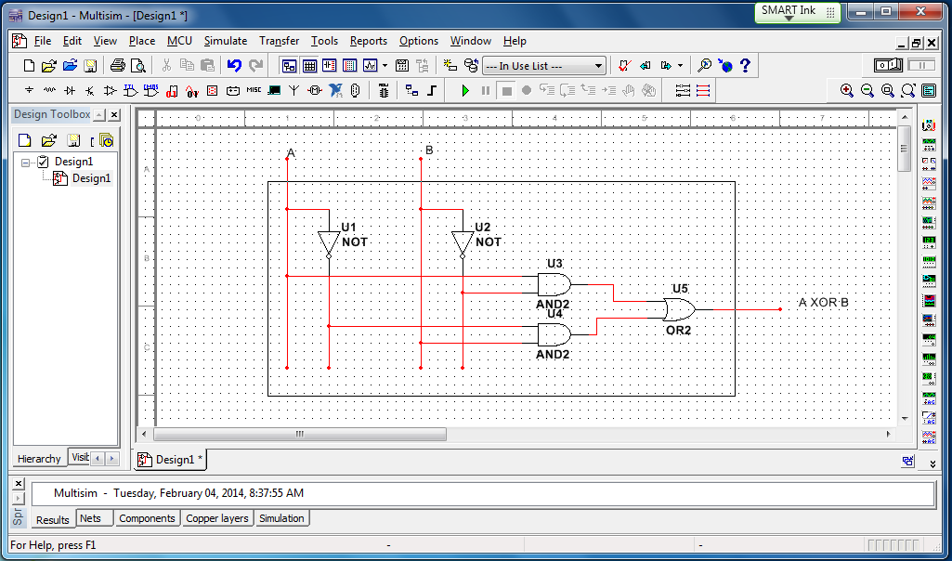

Choose Place/Replace by subcircuit from the menu. Give the subcircuit a name.

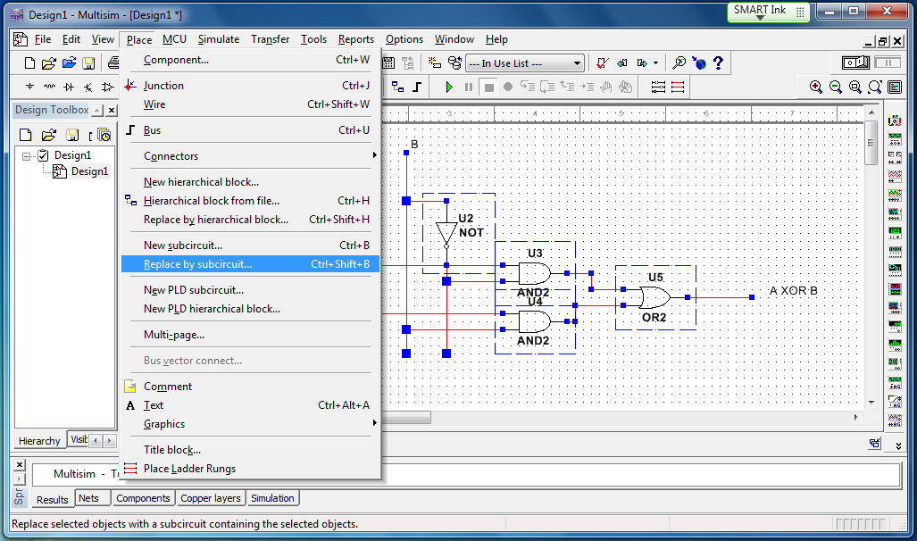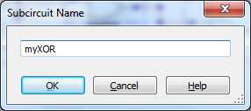

Note that creating a subcircuit gives you a child in the hierarchy on the left and after you click on the child two tabs across the bottom.

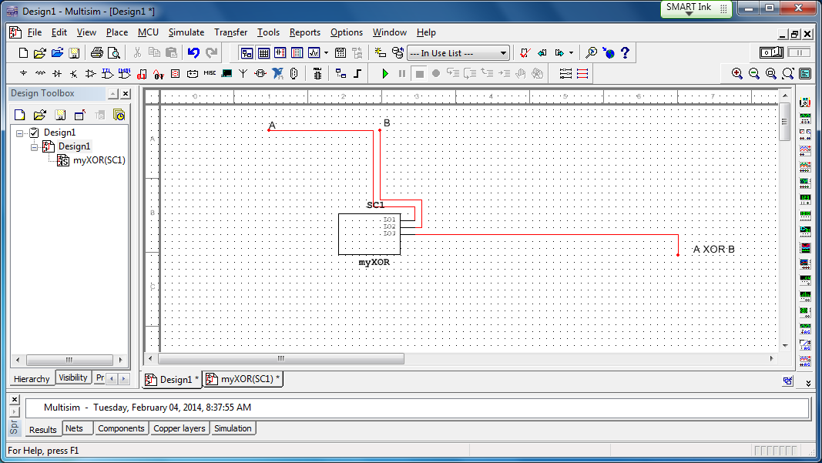

One shows the circuitry replaced by the subcircuit rectangle and the other shows the contents of the subcircuit. Creating a subcircuit can be confusing so first make a copy of your 4-to-1 MUX circuit file. Then on one of the copies make a subcircuit version of the 4-to-1 MUX and paste a screen capture of it.

Part 3. Bit manipulation using your subcircuit MUX.

Build a circuit with four data inputs (switches connected to high and low ends of a battery) labeled D0, D1, D2 and D3. Have two select inputs labeled S0 and S1 also connected to switches and finally one output (connected to a red probe indicator). Paste four copies of your circuit as described below .

- Use the address inputs to select D0. Have the D0 input low so that the output should be low.
- Use the address inputs to select D0. Have the D0 input high so that the output should be high.
- Use the address inputs to select D1. Have the D1 input low so that the output should be low.
- Use the address inputs to select D1. Have the D1 input high so that the output should be high.

Part 4. Chip version.

Find a 4-to-1 MUX under the Misc. Digital category. Connect four data inputs (use switches so the input can be set high or low). Also connect the select/address inputs to switches. Finally connect both outputs to red probes found in the indicator category. Paste the circuit below.

In the address/select inputs, which input A or B is “more significant”? (If A and B correspond to a two-digit binary number, one of them is the 1’s place and the other the 2’s place. The 2’s place is said to be more significant.) How do you know?

Part 5. Decoder

Let us consider a device that is a bit simpler than a demultiplexer. It does not have any data inputs and only two select inputs. The output corresponding to the address of the select inputs is high; the rest are low. The truth table is below.

INPUTS |  |  | OUTPUTS
S1 | S0 | L0 |  | L1 | L2 | L3
0 | 0 | 1 |  | 0 | 0 | 0
0 | 1 | 0 |  | 1 | 0 | 0
1 | 0 | 0 |  | 0 | 1 | 0
1 | 1 | 0 |  | 0 | 0 | 1

Build it from gates and paste a copy of your circuit below.

Part 6.

Add a data input to the circuit built in the previous section. The desired truth table is shown below. Paste your circuit below it.

S1 | S0 | Data | Y0 | Y1 | Y2 | Y3
0 | 0 | 0 | 0 | 0 | 0 | 0
0 | 0 | 1 | 1 | 0 | 0 | 0
0 | 1 | 0 | 0 | 0 | 0 | 0
0 | 1 | 1 | 0 | 1 | 0 | 0
1 | 0 | 0 | 0 | 0 | 0 | 0
1 | 0 | 1 | 0 | 0 | 1 | 0
1 | 1 | 0 | 0 | 0 | 0 | 0
1 | 1 | 1 | 0 | 0 | 0 | 1

Part 7.

Build a circuit that has four possible sources (labeled in order A0, A1, A2, A3) and four possible destinations (labeled in order B0, B1, B2, B3) but one shared channel. Set up the circuit so that source A1 is connected to destination B3 (not directly connected, but connected by the shared channel and the particular connection chosen through the use of select/address inputs. Use subcircuits. (You must label your inputs and outputs to receive full credit.)
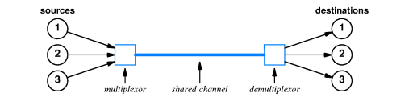

Part 8.

For the circuit below you should use theory (equations/formulas) to find the current passing through the2.55-kΩ and 2.15-kΩ resistors as well as the voltage drop across them. Show your equations or explain your logic (you can attach sheets if you don’t want to type out algebra). Then simulate the circuit in Electronics Workbench with voltmeter(s)/ammeter(s) in the appropriate places and verify your results. Paste into your report document a copy of the circuit with a meter reading out at least one of the desired. (Or print it.)
 | Current through ( ) | Voltage across ( )
2.55-kΩ
2.15-kΩ

