Name:_____________________________

PHYSICS 201
LAB 6

Part 1. The D flip-flop (level clocking).

Warning: this lab is about memory and you know what happens to memory (RAM anyway) when one turns off the power. So you cannot turn the Simulate button on and off in the middle of a set of measurements.

Flip-flops serve as the elementary units for memory in digital systems. Two features are needed:
- The circuit must be able to “hold” either state (a high or low output) and not simply reflect the input at any given time.
- But in some circumstances, we must be able to change (to “set” and “reset”) the values.

After dealing previously with combinational logic in which the output depends solely on the input, we may have to change our way of thinking about sequential logic in which the output depends additionally on the previous state of the device.

Build the circuit shown below. You can find the 7475 Latch under Misc. TTL.

The real 7475 chip has 4 data latches; the circuit simulation above shows only two of them. The D Latch is also known as a bistable latches or a D flip-flop. The D flip-flop has two inputs, D (for data) and EN (for enable – but also sometimes called the clock). The two data inputs share the same Enable input. Finally the D flip-flop has two ouputs Q and Q´. The two outputs Q and Q´ should be the inverses of one another (that’s what the prime means), this is standard for all types of flip-flops, and any time Q and Q´ are not inverses the flip-flop will be considered to be in an undesired state. The truth table for a single D flip flop is

D | EN | Q | Q´
0 | 1 | 0 | 1
1 | 1 | 1 | 0
X | 0 | Q₀ | Q₀´

The table above says that if EN=1, then Q is whatever D is. This is the write action (“set” if D=1 or “reset” if D=0). On the other hand, if EN=0, then Q=Q₀, where Q₀ stands for the previous value of Q. Thus Q stays whatever it was before. This is the “hold” or “no change” action. Use your circuit to fill in the table below. Identify the type as set, reset or no change. (Be careful, just because Q does not change does not mean that the action type was “no change.” You could be writing a 1 on top of another 1.)

E | D | Q | Q΄ | Type
1 | 0 | 0 | 1 | reset
0 | 0 | 0 | 1 | Hold
0 | 1 | 0 | 1 | Hold
1 | 1 | 1 | 0 | Set
1 | 0 | 0 | 1 | reset
0 | 0 | 0 | 1 | Hold
1 | 0 | 0 | 1 | Reset
0 | 0 | 0 | 1 | Hold
0 | 1 | 0 | 1 | Hold
1 | 1 | 1 | 0 | set
1 | 0 | 0 | 1 | reset
1 | 1 | 1 | 0 | set
1 | 0 | 0 | 1 | reset

Part 2. The D Flip-flop (edge triggering).

Above we saw that the enable (clock) input determined if/when we could write and the data input determined what we wrote. The flip-flop above is said to be “level sensitive,” which means that the time when one can set or reset the flip-flop’s value is determined by the enable’s (clock’s) level (whether it is high or low). If the data input does not have a consistent value while the clock is high, the changes in the input will be reflected in the flip-flop’s output. The change may be a desired change in the data input (but such changes take time), or it may be an undesired fluctuation (noise). If we shrink down the interval during which writing is allowed, then we reduce the amount of time that our data input has to have the desired value. Of course, we time this brief writing period after the data input line has settled down to the desired value. This is the idea behind edge triggering. Writing is enabled not by the level of the clock input (e.g. when CLK=1) but rather by the edge of the clock (e.g. when CLK changes from 0 to 1). The change from 0 to 1 is referred to as the positive edge, whereas the change from 1 to 0 is called the negative edge. Build the circuit below with a 7474 chip, which houses two D flip-flops.

Set the value of D and C to the values shown in the table below.

CLK | D | Q | Q΄ | Type
0 | 0 | 0
0 | 1 | 0
1 | 1 | 1 |  | set
1 | 0 | 1
1 | 1 | 1
0 | 1 | 1
1 | 1 | 1 |  | SET
0 | 1 | 1
0 | 0 | 1
1 | 0 | 0 |  | reset
1 | 1 | 0
1 | 0 | 0
1 | 1 | 0
0 | 1 | 0
1 | 1 | 1 |  | set
1 | 0 | 1
0 | 0 | 1
1 | 0 | 0 |  | reset

PATTERN: writing occurs on positive edge – when CLK changes from 0 to 1

Does one write (set or reset) on the positive edge or the negative edge in the above circuit? How do you know?

What is DDR SDRAM? What does it have to do with the information above?

Part 3. Parallel loading Register.

Build the circuit shown below. It is a four-bit register. It adds some additional circuitry to specify when the inputs values are accepted. Under what circumstances does the register accept the input values A, B, C and D? Be specific.

Load in the binary number corresponding to the hexadecimal value B and have it showing on the display. Paste a copy of it into this document.

Part 4. Add accumulators to ALU.

Finish the circuit AdderWithRegisters. It has one enter the first number into a 4-bit register, then second number into a second 4-bit register. The outputs of the flipflops become the inputs of the adders. Connect the displays to outputs of the registers and to the output of the adders. Paste a copy of the circuit displaying 2 + 3 = 5.

Part 5. Simulation of RC Circuits

Build the circuit shown below. The capacitor can be found next to the resistors under the Basic button. The switch can be found under the Basic button as well. The oscilloscope can be found on the far right.

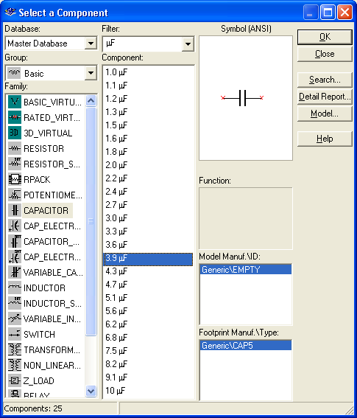
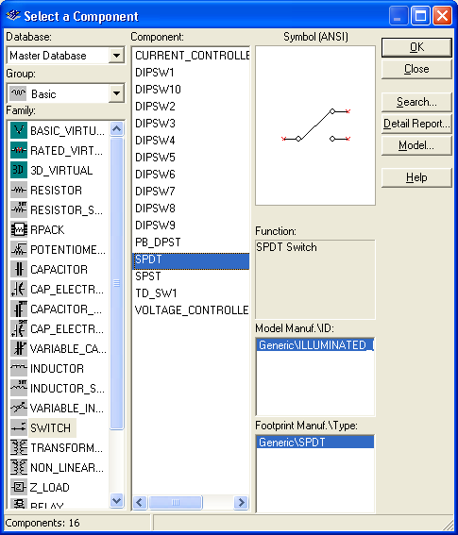
Open up the oscilloscope (right click) so that the display shows. Activate the simulation and flip the switch so that the capacitor is charging. Then when the capacitor is almost fully charged flip the switch so that it discharges. Let it (almost) fully discharge and stop the simulation. Expand the oscilloscope and adjust the time base and number of volts per division so that most of the charging curve can be seen as shown below. Adjust the cyan (1) and yellow (2) cursors such that the cyan cursor is at the edge of where the charging begins and the yellow cursor is at 63% percent of the saturation voltage (the saturation voltage is 5V in this case). Recall that the time constant is the time for the charge to reach about 63% of its saturation value. Vary the resistance and collect data to fill in the tables that follow.
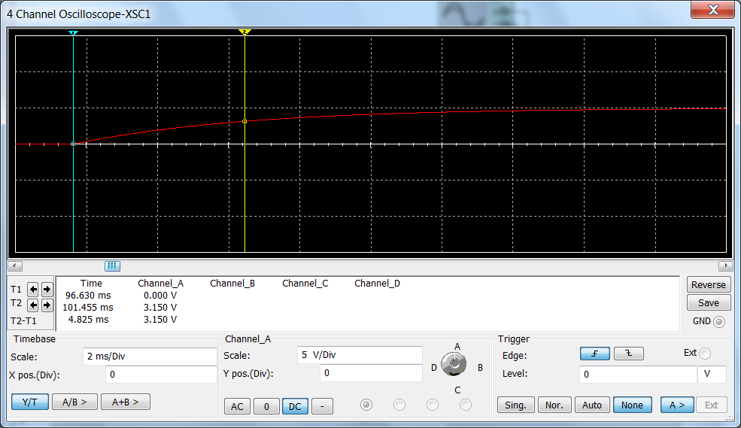

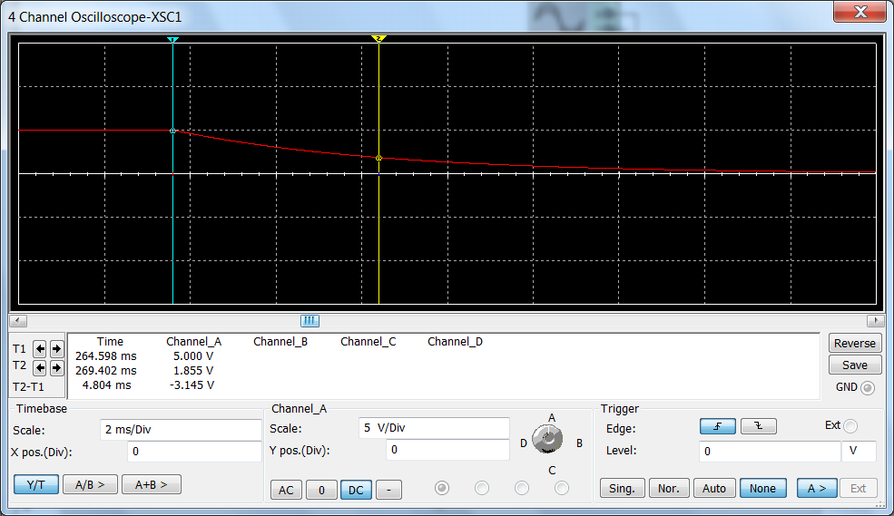

R=1.24 kΩ C=3.9μF
Voltage  applied (V) | 63% of Voltage (V) | Time to charge to 63% (s) | 37% of Voltage (V) | Time to discharge to 37% (s)
5
10
15
20

Are the charging times and discharging times equal?

Are the times the same for different applied voltages?

