Name:_______________________

PHYSICS 201
LAB 11-A

Part 1. Building RAM.

Finish wiring the circuit provide in ram.ms8. Add a decoder (either one you made or one of Electronic Workbench’s) and attach it to the left-hand side. Attach a printout of your finished circuit to your lab.

Provide a set of instructions for writing a particular value to a particular location.

Provide a set of instructions for reading a particular value to a particular location.

Paste a copy of the circuit reading a 6 at location 2.

Paste a copy of the circuit reading a 7 at location 3.

- Stack Vocabulary.

When one jumps to a subroutine, one has to store the address of the Program Counter so that when it comes time to return from the subroutine, one knows where to return. One subroutine may call another, so a whole series of return addresses may be needed. To handle multiple calls, one uses a stack. Give definitions of the following stack terminology.

Stack

LIFO

Pop

Push

Stack Pointer

- Microinstructions for a subroutine call.

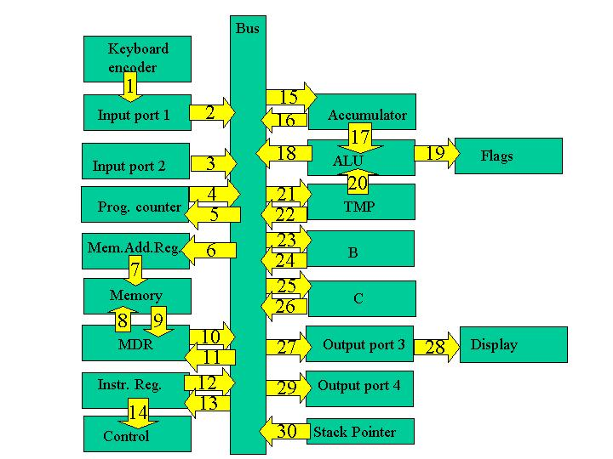

The execution cycle of a subroutine call involves

4. Assume the Stack Pointer holds the last location of the stack (a designated portion of memory) that was written to. In order to place a new value onto the stack, the stack pointer must be incremented.
5. Next place the stack pointer’s (SP) value into the memory address register (MAR) so we are now accessing the next available spot in the stack.
6. Push the value of the program counter (PC) onto the stack (memory location currently pointed to).
7. Take the address of the subroutine which is part of the instruction (in the instruction register) and place it in the PC.

Determine for the timing states of the subroutine call instruction described below
- Which parts of the circuit are active? (Hint: the Controller/Sequencer is active whenever anything is happening and the Instruction Register is active during the execute cycle.)
- “Who’s driving the bus?”
- And who’s reading from the bus?

Subroutine Call
Step | Active | Driving Bus | Reading bus
1
2
3
4
5
6
7

Note that the arrows are numbered. Fill in the table with the number of the arrows along which information is flowing for each of the timing steps.

Subroutine Call
Step | Arrows along which information flows
1
2
3
4
5
6
7

4. Microinstructions for a return from a subroutine.

Repeat the exercise for a return from the subroutine which pops a value off the stack and places it in the program counter.

- Put the SP’s value (which is pointing to the last thing written in the stack) into the MAR.
- Take the last value of the stack (line in memory currently pointed to) and put it into the PC.
- Decrement the SP so that it has the address of the previous item of data put on the stack.

Subroutine Return
Step | Active | Driving Bus | Reading bus
1
2
3
4
5
6

Note that the arrows are numbered. Fill in the table with the number of the arrows along which information is flowing for each of the timing steps.

Subroutine return
Step | Arrows along which information flows
1
2
3
4
5
6

5. LR Circuits

Simulate the circuit below. It is known as an LR circuit. L is the symbol for an inductor and R the symbol for a resistor. The mathematics used to describe this circuit is similar to that for the RC circuits we studied earlier. The voltage across an inductor is proportional to the change in current. When the switch is in the position shown at the start there is no current. Then when the switch is flipped, the battery starts to push current through the circuit, thus changing the current. All of the voltage must be used up in the circuit. There is little if any current initially (so not much voltage is dropped across the resistor), but it is changing rapidly (so most of the voltage is dropped across the inductor). As the current builds up, less voltage is dropped across the inductor and more is dropped across the resistor. The circuit heads toward a steady state in which the current does not change at all, and all of the voltage is dropped across the resistor.
The voltage across the resistor saturates according to the equation

When t=τ, we have

or in other words after a time equal to the time constant τ has gone by, the voltage across the resistor is equal to about 63% of its saturation value.

Shown below is a capture of the oscilloscope output.

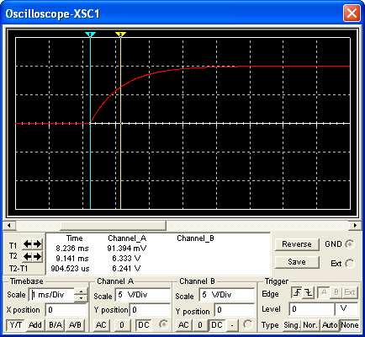

Note that one can also use the falling part of the circuit to determine the time constant. In this case one finds the time it takes for the voltage to fall to approximately 37% of its starting value.
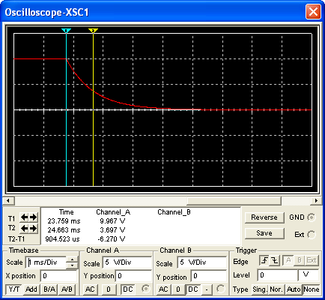

Vary the resistance in your circuit below and determine the time constant. Enter them into the table below.
Inductance L = 910 mH
Resistance  (kΩ) | Time Constant from oscilloscope  (UNIT!!!!) | Theoretical Time Constant (L/R)  (UNIT!!)

Next vary the inductance in your circuit below and determine the time constant. Enter them into the table below.

Resistance R= 1 kΩ
Inductance  (mH) | Time Constant  from oscilloscope  (UNIT!!!) | Theoretical Time Constant (L/R)  (UNIT!!)

6. LC Circuits

Simulate the circuit shown below. Start with the switch set such that the capacitor is connected to the inductor, the oscilloscope reading should be flat. Flip the switch to place the capacitor in the circuit with the battery and the resistor. The capacitor will charge. Recall that the voltage in an RC is

where τ=RC.

Flip the switch again to connect the now charged capacitor to the inductor. This should result in an oscillator behavior.

In the oscilloscope reading shown below, the first line indicates where the switch was flipped the first time and the second line where the switch was flipped the second time. That solid mass is oscillatory behavior, which can be found by changing the oscilloscope’s time base, as seen in the second oscilloscope capture. Oscillatory behavior is characterized by a period (the time for one cycle) or alternatively the frequency (the number of cycles in a second).

Vary the capacitance and determine the period and enter them into the table provided.

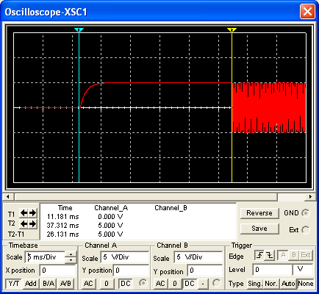

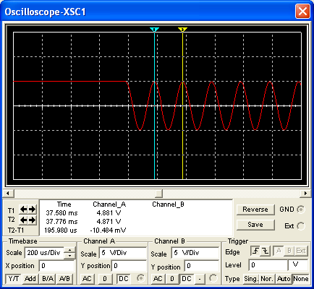

Inductance L = 1 mH
Capacitance ( ) | Period from oscilloscope  ( ) | Frequency  1/Period  ( ) | Theoretical Frequency  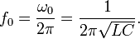

Next vary the Inductance, determine the period and frequency.

Capacitance C = 1 μF
Inductance ( ) | Period from oscilloscope  ( ) | Frequency  1/Period  ( ) | Theoretical Frequency

What is resonance and what does it have to do with using an LC circuit as a tuner?

What is meant by the term low-pass filter?

What is meant by the term high-pass filter?

