Name:

PHYSICS 201
LAB 8

Part 1. Float conversions.

Express the following decimal number as a float. Use 1 bit for the sign, 23 bits for the significand (mantissa), 8 bits for the exponent. Do not use two’s complement. The exponent uses “biasing” – we will use 128.

-890.043

Start by expressing 890.043 as a “pseudo-fixed point number” using as many digits as necessary to represent the whole number 890 and represent the fractional part using the rest of the 23 places.

Next imagine moving the dot that separates whole number and fraction above to the very beginning. That will be our mantissa (we are not completely following the IEEE standard – that will prevent you from just finding some website that does the work for you). Take the number of places that you had to move the dot and add 128 (the bias); that result will be the exponent. The sign is simply 0 for a positive number or 1 for a negative number.

Sign
Mantissa
Exponent

Express the following float as a decimal number.
Sign
0
Mantissa
1 | 0 | 0 | 1 | 1 | 0 | 0 | 1 | 1 | 0 | 0 | 1 | 1 | 0 | 0 | 1 | 1 | 0 | 0 | 1 | 1 | 0 | 0
Exponent
1 | 0 | 1 | 0 | 1 | 0 | 1 | 0

Convert the mantissa to a decimal and divide by 2²³. That should yield a fraction that is more than a half and less than one.

Convert the exponent to decimal and subtract 128 (unbias) to obtain the power of 2.

(Sign) * (Mantissa Result) * 2^(Exponent Result)
Evaluate the above in a calculator.

Part 2. Ripple Counter from JK Flip Flops

Build the Ripple Counter shown below. Replace my version with yours and have a three showing (turn off the simulation when the counter reaches three).

Why is it called a ripple counter? And what problem could occur with it? (Hint look back at the ripple adder.)

What does the counter below count up to?

What does the switch above do?

Make the addition shown below.

What change in behavior results from this addition?

Part 3. The RS flip-flop.

Flip-flops serve as the elementary units for memory in digital systems. Two features are needed:
- The circuit must be able to “hold” either state (a high or low output) and not simply reflect the input at any given time.
- But in some circumstances, we must be able to change (to “set” and “reset”) the values.

One way to achieve this result is for flip-flops to have a feed-back feature.

There are two problems we must consider
- The R=1, S=1 input is disallowed.
- The output corresponding to the R=0, S=0 input depends on the initial state, and when first starting a simulation we don’t know what that state is.

Add to your circuit a battery and ground to establish high and low lines and switches leading from these lines to the R and S inputs as shown below.
Fill in the states Q and Q’ you find by flipping the switches in the order indicated below. Step 0 means that the setting of the switches when the system is first activated. Under type, put “set”, “reset” or “no change”.

R | S | Q | Q’ | Type
0 | 1
0 | 0
0 | 1
0 | 0
1 | 0
0 | 0
1 | 0
0 | 0

What happens if you start the simulation with R=0 and S=0?

What happens to the simulation when R=1 and S=1?

Part 4. Microinstructions.

Source: Digital Computer Electronics (Malvino and Brown)

In this section we will consider the steps involved in performing a simple instruction. We will use as our example the instruction for loading Accumulator A with a value stored at a particular address in the RAM. Recall that the instruction itself is also stored in the RAM. The steps are called timing states. In this example, there are six timing states.

Determine for the timing states of the Load Accumulator A instruction described below
- Which parts of the circuit are active? (Hint: the Controller/Sequencer is active whenever anything is happening and the Instruction Register is active during the execute cycle.)
- “Who’s driving the bus?”
- And who’s reading from the bus?

Load Accumulator A
Step | Active | Driving Bus | Reading bus
1
2
3
4
5
6

Note that the arrows are numbered. Fill in the table with the number of the arrows along which information is flowing for each of the timing steps.

Load Accumulator A
Step | Arrows along which information flows
1
2
3
4
5
6

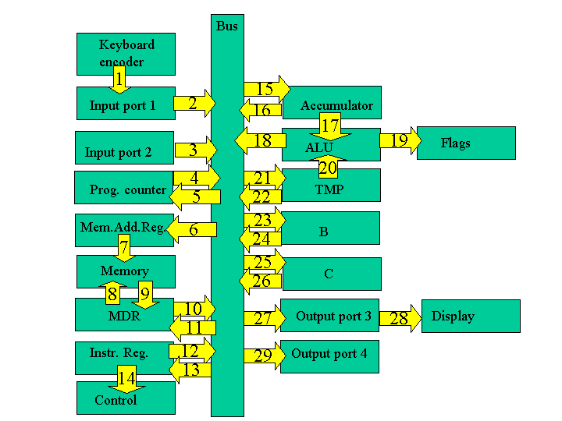

Load Accumulator A

The first few steps are the same for all instructions and are collectively known as the fetch cycle.

Fetch Cycle
- Address State: the value of the program counter (which recall is the address of line of the program to be performed) is put into memory address register.
- Increment State: the program counter is incremented, getting it ready for the next time.
- Memory State: the current line of the program is put into instruction register.

The remaining steps depend on the specific instruction and are collectively known as the execution cycle.

Execution Cycle
- Recall the instruction consisted of a load command and an address. A copy of the address is now taken over to the memory address register.
- The value at that address is loaded into Accumulator A.
- For the load command, there is no activity during the sixth step. It is known as a "no operation" step (a "no op" or "nop").

Part 2. The add command

Let us repeat the above procedure for an add instruction. This instruction adds a value stored at a particular address in the RAM to whatever is in Accumulator A and places that answer back in Accumulator A. Recall that the instruction itself is also stored in the RAM.

The first few steps are the same for all instructions and are collectively known as the fetch cycle.

Fetch Cycle (the first three steps are the same as abovesame as above)

Execution Cycle
- Recall the instruction consists of an add command and the address of the number to be added. A copy of the address is now taken over to the memory address register.
- The value at that address is loaded into TMP.
- The values in Accumulator A and TMP are added and the result is sent to Accumulator A. You may wonder why when the result is placed in the Accumulator A, it is not again added to TMP (producing what is called a "racing accumulator"). The cure for this potential problem is edge clocking. Edge clocking makes it possible to load only during a very short interval of time. It is also possible to activate different processes on different edges.

Add
Step | Active | Driving Bus | Reading bus
1
2
3
4
5
6

Add
Step | Arrows along which information flows
1
2
3
4
5
6
Recall that in lecture we distinguished load, load immediate and load indirect commands. There would similarly be distinctions between add, add immediate and add indirect commands.

