Name:

PHYSICS 201
LAB 8

Part 1. Float conversions.

Express -24511.1897 as a float. Use 1 bit for the sign, 23 bits for the mantissa, and 8 bits for the exponent. Use a bias of 127 for the exponent.

Write an expression for 24511. Ignoring any leading zeros, how many bits does it use?
24511 in binary:
# of bits for whole number:

If we are going to use 24 bits (23 stored & one “implied”), how many are left for the fractional part? Write an expression for the fraction. This time include any leading zeros.
# of bits for fraction:
Binary expression for .1897:

How many shifts are required to move the dot separating whole number and fraction to where there is only one digit (a 1) in the whole number? What is the effect of “biasing” on the number?
Number of shifts:
Effect of biasing

Put the pieces together.

Sign

Exponent

Mantissa

Paste below a screen capture from
https://www.h-schmidt.net/FloatConverter/IEEE754.html
showing the “check” on your answer produces a result close to the original 24511. 1897

Part B. Express -0.002020 as a float. Use 1 bit for the sign, 23 bits for the mantissa, and 8 bits for the exponent. Use a bias of 127 for the exponent.

Multiply the number by 2^24 and convert the whole number portion of the result to binary. How many bits are you short of the desired 24?
Multiply and convert:
How many bits “missing”?

Repeat above but multiply by 2^(24+missing_number).

Use the missing_number and the bias of 127 to determine the exponent.

Put the pieces together.

Sign

Exponent

Mantissa

Paste below a screen capture from
https://www.h-schmidt.net/FloatConverter/IEEE754.html
showing the “check” on your answer produces a result close to the original
-0.002020.

Part C. Express the following float as a decimal number.

Sign
0

Exponent
1 | 0 | 1 | 0 | 0 | 1 | 0 | 1

Mantissa
1 | 1 | 1 | 0 | 0 | 1 | 1 | 1 | 0 | 0 | 1 | 1 | 1 | 0 | 0 | 1 | 1 | 1 | 0 | 0 | 1 | 1 | 1

The decimal number can be expressed as

(-1)^(sign)*(number between 1 and 2 from mantissa)*2^(number from “un-biasing” the exponent)

number between 1 and 2 from mantissa

number from “un-biasing” the exponent

Put the pieces together and calculate

Paste below a screen capture from
https://www.h-schmidt.net/FloatConverter/IEEE754.html
showing the “check” on your answer.

Part 2. IV curve of a diode using Electronics Workbench.

Using Electronics Workbench Multisim, construct the circuit below.

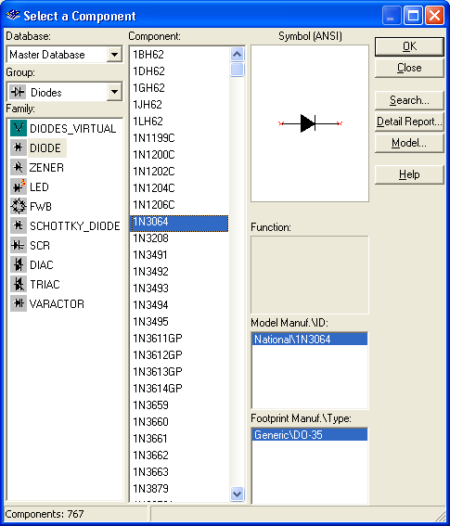

Note that a diode (found under the diode button, next to the basic (resistor) button) is represented as an arrow and a vertical line. Choose the 1N3064 diode. The arrow is on the anode side, and the cathode is on the vertical line side. Set the internal voltmeter resistance to 1000 MΩ and the internal resistance of the ammeter to 1 nΩ, so that the meters are very nearly ideal. Vary the battery voltage from 0.0 t0 1.0V, and record the voltage across the diode and the current through the diode

Voltage across battery | Voltage across diode  (in V) | Current through diode  (in mA) | Resistance across diode  ( Supply Units!)
0.0
0.1
0.2
0.3
0.4
0.5
0.6
0.7
0.8
0.9
1.0

Be sure that you convert all voltages to volts and all currents to milliamps. Next fill in the resistance column. Recall that the resistance is the ratio of Voltage to Current. Compare this to the result you found in Lab 1, Part 1, Number 13. Did the resistance across the resistor (in Lab 1) depend on voltage? Does the resistance of the diode (in this lab) depend on the voltage? Which is Ohmic? And which is non-Ohmic?

Part 3. Rectification
The current coming out of the wall socket is AC (alternating current), and a number of devices (including a computer) require DC current. A rectifier changes AC into DC. The circuit below is called a half-wave rectifier.
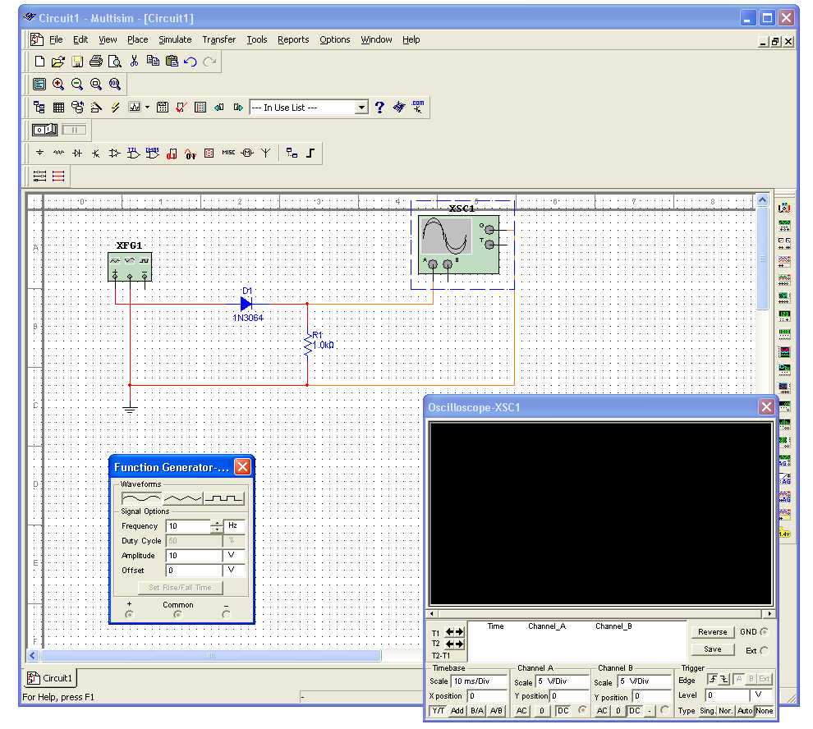
The box on the left is a function generator (found on the right, second from the top). Set its frequency to 10Hz. It will serve as an alternating voltage supply. The box with the sine wave is an oscilloscope (found on the right, fourth from the top). Think of the oscilloscope as a time-dependent voltmeter.

First build the circuit above without the diode. Run a simulation and place a copy of the expanded oscilloscope screen below. Then insert the diode into the circuit and repeat.

Finally build the circuit below, simulate it, and place a copy of its oscilloscope screen below. This circuit is known as a full-wave bridge rectifier. Explain the path taken by the current when the voltage is positive and when it is negative. (Draw a picture twice, indicate on the first the path taken by the current when the voltage at + is positive; indicate on the second the path taken by the current when the voltage at + is negative.)

Part 4. Diode clamps.

Simulate the circuit shown below. Set the amplitude on the signal generator to 5 V and examine the output on the oscilloscope. Then raise the amplitude on the signal generator to 10 V and repeat. What is the effect? Change to the triangular and square waves. Is the effect similar? Paste the resulting oscilloscope screens in your report.

Explain what is happening in this circuit. You may wish to construct a DC version of the circuit shown below and vary the battery that replaced the signal generator from volatges below 5 V to voltages over 5 V.
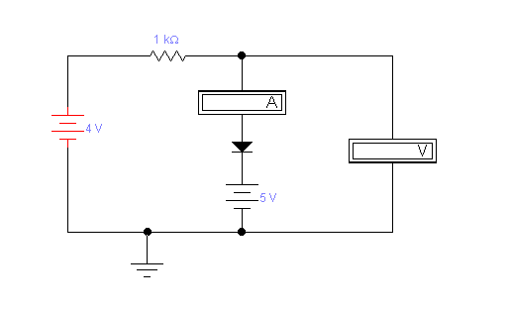
When is the diode conducting current and when is it not? And what was the effect on the “waveform” you put in?

Part 5. Laser printing

Describe the stages of laser printing. What is the role of the laser? Where do the photoconductors come in? Why is the paper warm when it comes out? Sometimes when there’s a paper jam, the print out is very easily smudged; explain what happens in such a case. (Do not simply paste a long explanation that does not specifically address the questions.)

