Name(s):

Physics 202

Part I. (Capacitors in parallel)
Geometry (size and shape) is a factor in determining capacitance. We will be working with three different sized capacitors, and hence three different capacitances: C₁, C₂ and C₃. Let us call the largest one C₁, the middle one C₂ and the smallest C₃. We would have to know the voltage V and the charge Q to determine C. We can use a voltmeter to measure V, but we cannot directly measure Q. Therefore, we will instead determine the ratios C₂/C₁ and C₃/C₁ from our measurements.
- Insert the power Amplifier plug into Analog Channel A in the Pasco Signal Interface. (The Power Amplifier should also be plugged in and turned on.)
- Open Data Studio.
- Click on the Analog Channel icon into the Channel A icon and choose Power Amplifier.
- A Signal Generator window should appear. Choose DC and click on the number under DC Voltage and enter 5.
- Connect C₁ to the Power supply as shown
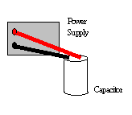
This is drawn diagrammatically as:
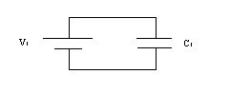

- Apply a voltage of 5 volts across C₁ and disconnect it (while the voltage source, the signal generator is still on). You can use a DC voltmeter to check that you have charged up the capacitor. (It should read close to 5 volts.) To use a multimeter set up as a DC voltmeter, make sure the V button is pressed and that the DC button is pressed (the buttons may have wavy lines for AC and straight lines for DC). The multimeter may have three holes with two leads (wires) coming out. If so make sure the upper lead is plugged into the hole that indicates V (not A). Put one needle into each side of the capacitor as shown below.
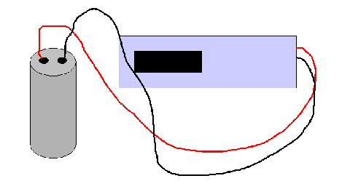
If the voltage reading is negative, switch the leads.
- Next connect C₁ to C₂ as shown. You should make sure C₂ has no charge to start with. How?
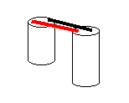
When capacitors are in such an arrangement, they are said to be in parallel. Things in parallel should have the same voltage.
- Disconnect them and measure the voltages across each, V₁' and V₂' (they should be very close). The primes here indicate the voltages after the two capacitors have been placed in parallel.
Capacitors C₁ and C₂ in parallel
 | Voltages (V)  Trial 1 | Voltages (V)  Trial 2
V₁
V₁'
V₂'

- We have three equations:
  - V₁ = Q₁/C₁
  - V₁' = (Q₁-q)/C₁
  - V₂' = q/C₂.
where Q₁ is the charge on C₁ before C₂ is added and q is the charge that goes over to C₂.
- We need to eliminate Q₁ and q. Solve the first equation for Q₁ and the third equation for q.
- Substitute both of these results into the middle equation. The resulting equation has V's which we know and the ratio C₂/C₁ which we want.
- Repeat the above measurements making sure you obtain consistent results. The most common mistake is to forget to discharge the capacitors before starting. If your results are not consistent, repeat again.
- Repeat the measurements and calculations to determine C₃/C₁.

Capacitors C₁ and C₃ in parallel
 | Voltages (V)  Trial 1 | Voltages (V)  Trial 2
V₁
V₁'
V₃'

Ratios from Parallel arrangement
 | Trial 1 | Trial 2
C₂/C₁
C₃/C₁

Part II. (Capacitors in series)
Another way to determine the ratio C₂/C₁ is to put C₁ and C₂ in series, as shown below.
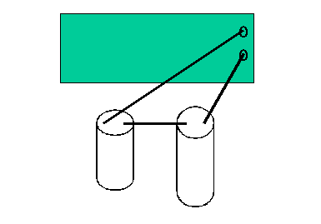

- Set the signal generator to 5 Volts DC.
- First make sure to discharge your capacitors before starting.
- After charging up the capacitors in series, disconnect them from the circuit and each other and measure the voltages across each. (The two voltages should add up to close to 5 V.)
Capacitors C₁ and C₂ in series
 | Voltages (V)  Trial 1 | Voltages (V)  Trial 2
V₁
V₂

- In the series arrangement, the charge on the second capacitor comes from the first and thus they are equal. Hence we have the following set of equations
  - V₁ = Q₁/C₁
  - V₂ = Q₂/C₂
  - Q₁ = Q₂.

- We can again solve for the ratio.
- Compare it to your result from Part 1.
- Repeat the measurements and calculations to obtain C₃/C₁ as well.
Capacitors C₁ and C₃ in series
 | Voltages (V)  Trial 1 | Voltages (V)  Trial 2
V₁
V₃

Ratios from Series arrangement
 | Trial 1 | Trial 2
C₂/C₁
C₃/C₁

Part III: Charging an RC Circuit:
- Connect your interface to a power amplifier and set it up as a DC voltage source.
- Connect a voltage sensor (shown below) to analog channel B.
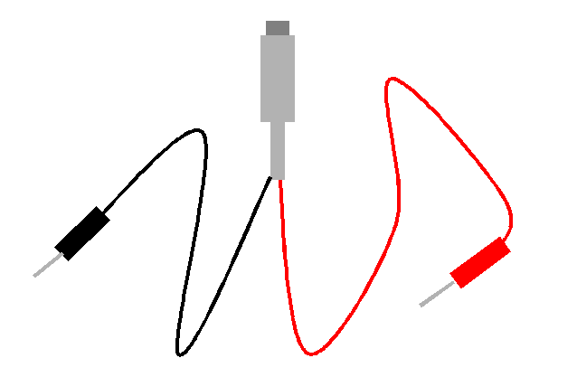

- Then in Data Studio click on the analog plug icon into the analog channel B icon and choose "voltage sensor." Drag a graph into analog channel B so we can see the data as it comes in.
- Set the voltage to 5.00 V.
- Make a circuit with resistor R_{A} and a capacitor in series (have the power amplifier "off"). Your capacitor should be discharged. Diagrammatically this circuit is represented by
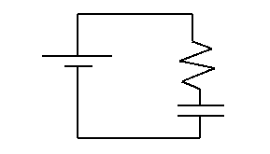

- Put the leads of the voltage sensor across the capacitor. Your circuit will look something like the following
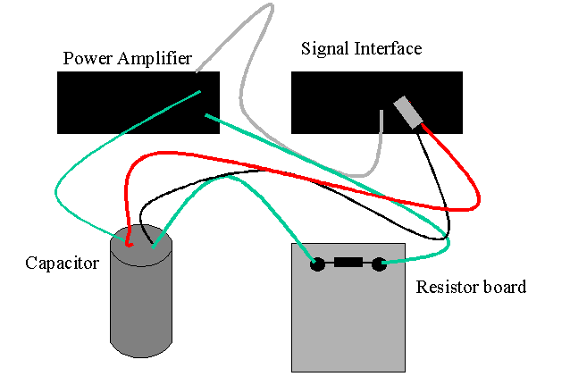
The green wire represents the RC circuit (resistor and capacitor in series), while the black and red wires represent the voltage probe.
- Click Start to turn on the voltage and start recording data.
- You should see the voltage increase and "saturate" at 5.00 V. When it is very close to 5.00 V, stop recording, disconnect the capacitor and then turn off the signal generator. You must disconnect first so that the capacitor will have a charge left on it!
- The charging capacitor data should be described by the equation
V(t) = V_{S} [1 - exp( - t / τ ) ],
where V_{S} is the saturation voltage, τ is a characteristic time, and where it is assumed that t=0 is when we switched on the voltage supply.
- Plot Voltage vs Time
- At this stage follow the instructions at http://www.lasalle.edu/~blum/c152wks/rcfit01.htm for fitting the data.
Charging R_{A}
V_{S} ( )
τ ( )

Discharging:
- With the voltage sensor across the now charged capacitor, begin recording a new set of data.
- Connect the capacitor to resistor R_{A} (no power supply).
- The voltage should start close to 5.00 V and decay to zero. Diagrammatically the circuit looks like the following
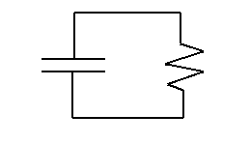

- Copy and paste the data (times and voltages) into Excel. Plot the data. For this case you can use the exponential option in Add trendline. Compare the τ's.
Discharging R_{A}
V₀ ( )
τ ( )

Part IV
- Repeat the charging part of the above measurements with resistor R_{B}.
- Then repeat the discharging part of the above measurements with the combination of R_{A} and R_{B} in series.
- Do the plotting as above and compare τ's.
- Does the result agree with theory?
Charging R_{B}
V_{S} ( )
τ ( )

Discharging R_{A} and R_{B}
V₀ ( )
τ ( )
Theory τ( )
Percent Error

Part V
- Get the measurements of the resistances R_{A} and R_{B} using the multi-meter as an ohm-meter.
- Use your results to extract the capacitance. Note this is the first time we have a capacitance as opposed to a ratio of capacitances.
R_{A} ( )
R_{B} ( )
C ( )
Include in your report:
- What is your best estimate of the time constant if the resistors in the part-II discharging had been in parallel?
- What would happen to the time constant (increase or decrease) if we replaced the single capacitor with the combination of it and a second capacitor in series? Why?
- What would happen to the time constant (increase or decrease) if we replaced the single capacitor with the combination of it and a second capacitor in parallel? Why?

