PHYSICS 202  LAB 2 | SPRING 06

Ohm’s law, combinations of resistors, and multi-meters

Part 1. Ohm’s law and an Introduction to Electronics Workbench.

- Start up Electronics Workbench (Start/All Programs/Electronics Workbench/Multisim8 or double click the multisim.exe file found at c:\Program Files\Electronics Workbench\EWB8 ).

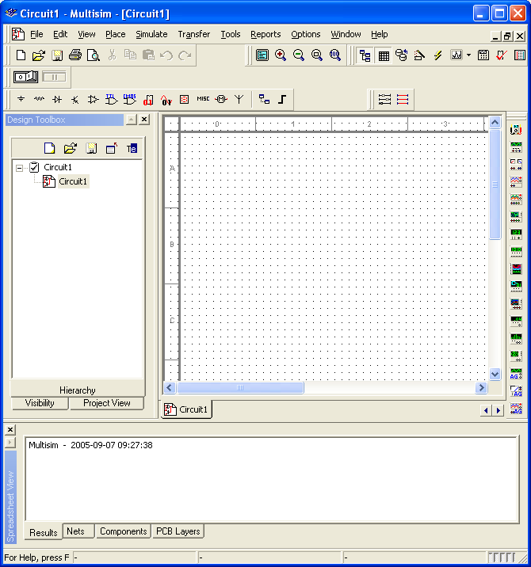

- Click on the Source button (see above). Select a DC source from the list and click OK.
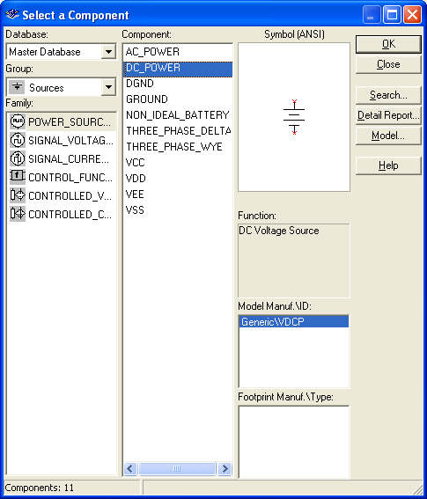

- The cursor now includes a DC Power Source (a battery) icon, click on the location of the workspace where you want to place the battery.
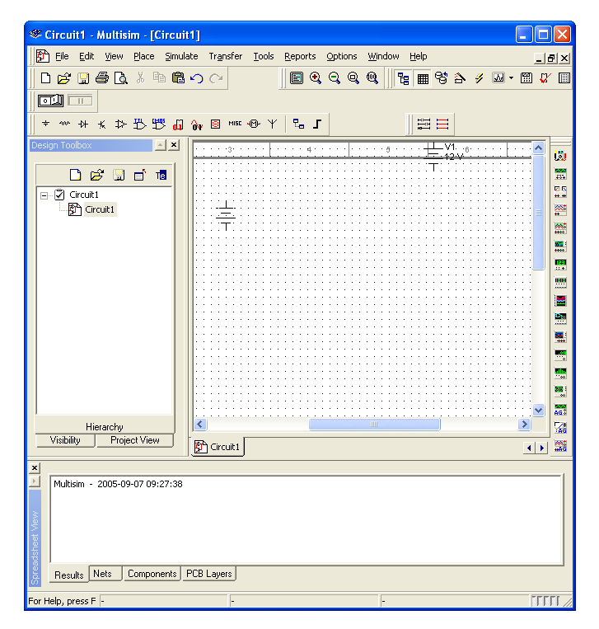
- Right click on the battery and choose Properties. Change the Voltage to 5 V and click OK.
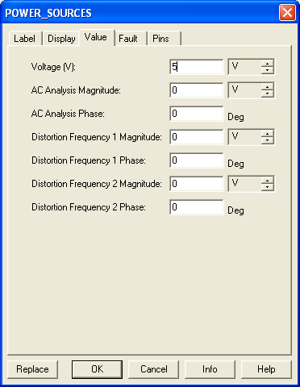
- Click on the Place Basic button, choose Resistor from the list on the left, then choose 1.3kΩ on the resulting list on the right, click OK. Place that resistor on the workspace.

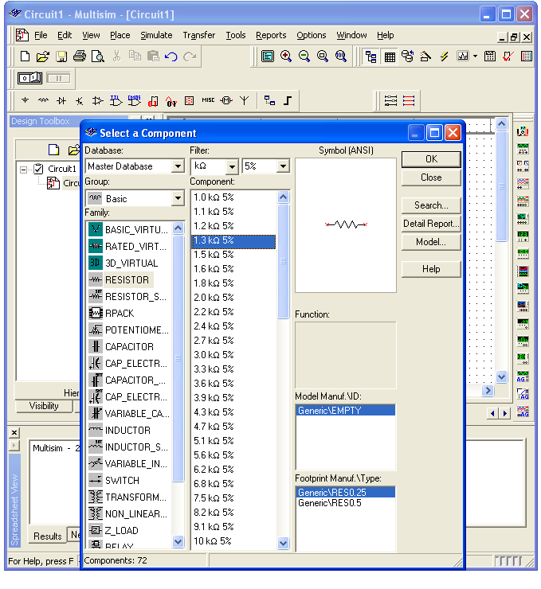
- Add a second resistor (this time 2.7kΩ) onto the workspace. Right click on the second resistor and rotate it.

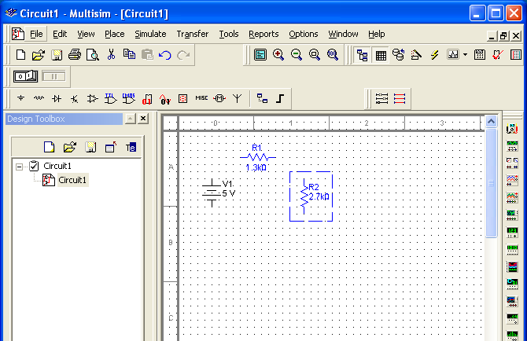
- Connect the battery and resistors in series as shown below. Click at the end of R₁ (a dot will appear) and move it making a line over to the beginning of R₂ click again to end the line. This is the simulation’s equivalent of connecting the two resistors by a wire.
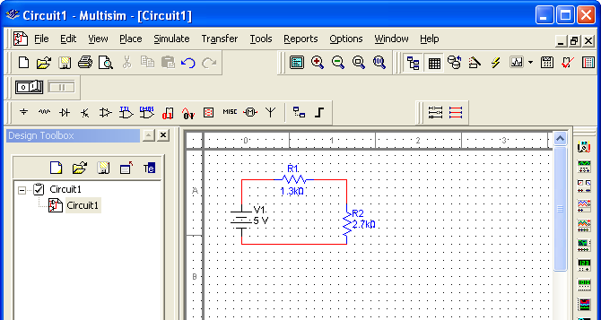
- Add a “ground” to the circuit between R₂ and the battery. Click on the Sources button, choose Ground and OK. Place a Ground onto the workspace. Connect the ground to the circuit.
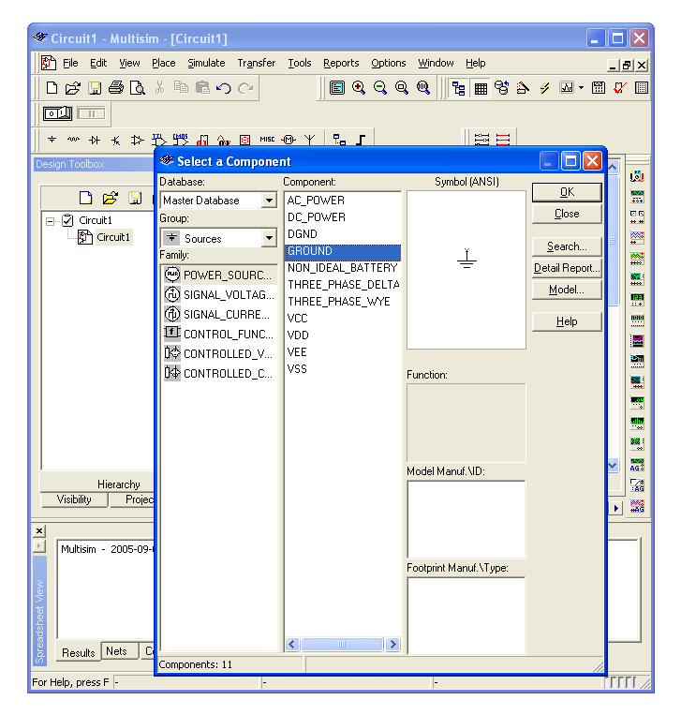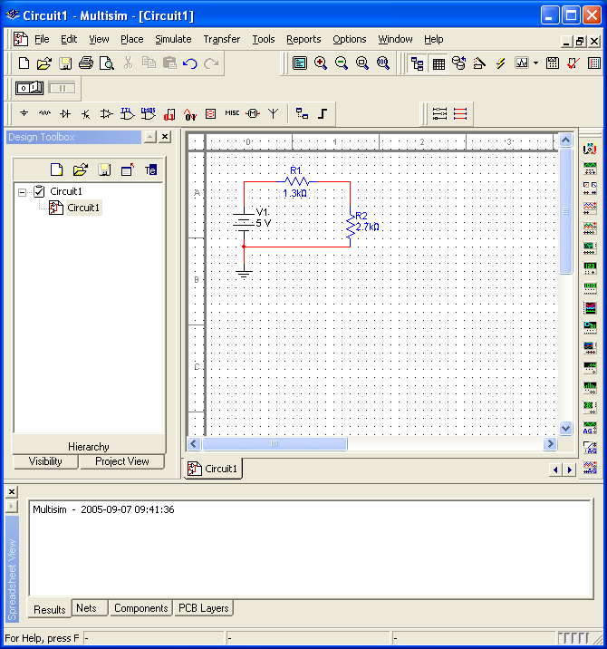

- Hook a voltmeter across (in parallel with) R₁. Click on Place Indicators. Choose Voltmeter, click OK, place a voltmeter onto the workspace. Connect the positive terminal to the beginning of R₁ and the negative terminal to the end of R₁. (I had to highlight the existing circuit and move it lower to make room.)
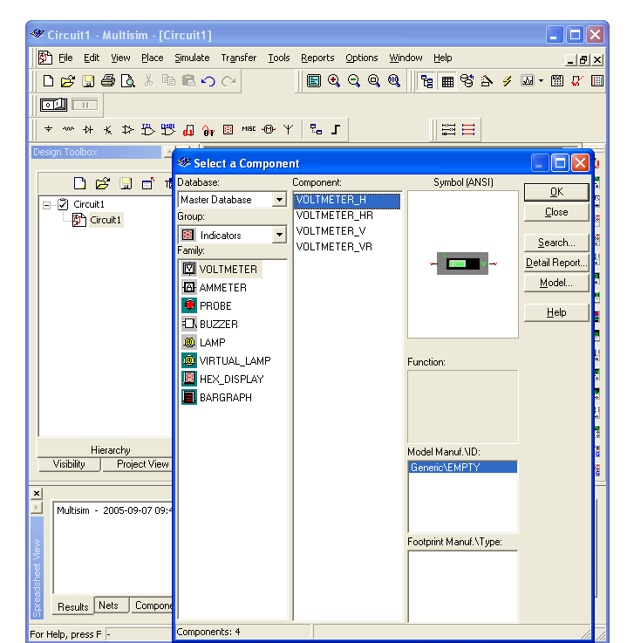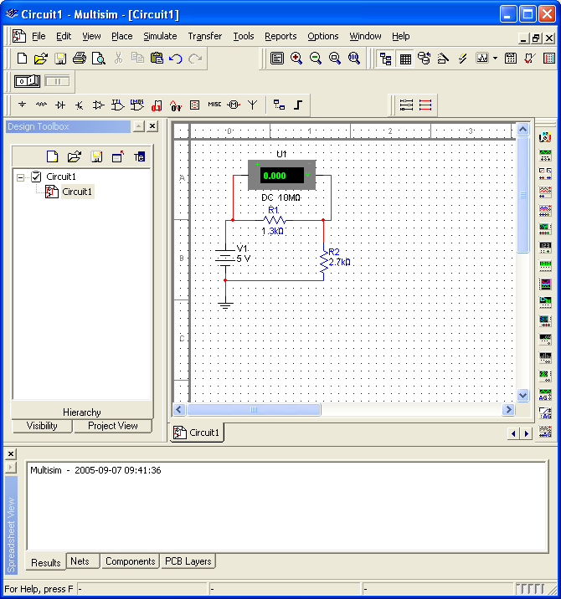
- Right click on the voltmeter. Choose Properties. Make sure the voltmeter is in DC mode.
- Click the Activate simulation button which is often on the upper right, but is on the left in the picture below because the tools wrapped around. Read the voltage across R₁ off of the voltmeter. Enter it into the table below.
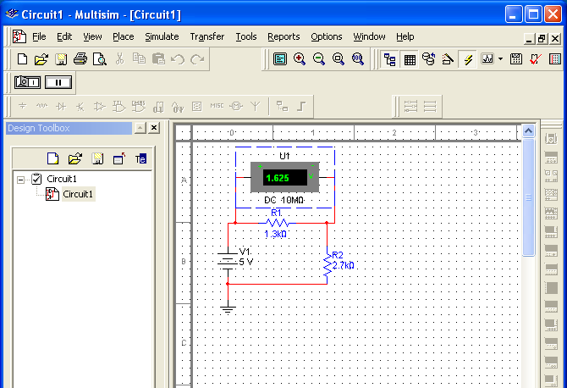
- Save your circuit file. Next place the voltmeter across (in parallel with) R₂. Repeat the measurements and enter them below.
- Bring a copy of your circuit over from Electronics Workbench and paste it into your Word document: Drag from the upper left to lower right of your circuit, then go to Edit/Copy on the Workbench menu. Paste the resulting picture into a Word document.
- Change the resistor values to R₁ = 1.6 kΩ and R₂ = 3.3 kΩ and repeat.

Resistance 1 | Resistance 2 | Voltage across R₁ | Voltage across R₂ | Sum of voltages
R₁ = 1.3 kΩ | R₂ = 2.7 kΩ
R₁ = 1.6 kΩ | R₂ = 3.3 kΩ

Part 2. Determining some resistances.

The circuits we want to simulate have resistors with the following color schemes. Determine their stated resistances.

 | Stripe  Color 1 | Stripe  Color 2 | Stripe  Color 3 | Tolerance Color | Average Resistance
R₁ | Red | Yellow | Orange | Gold
R₂ | Brown | Green | Orange | Gold
R₃ | Blue | Violet | Red | Gold

Part 3. Current through parallel resistors.

Create a circuit with a battery, two resistors in parallel (use values as close as possible to the R₁ and R₂ values from above). Include a ground as well. Place the ammeter in the following four places:
- Between the battery and the resistors before the wires “split.”
- In the branch with R₁ (in series with R₁).
- In the branch with R₂ (in series with R₂).
- After the branches have rejoined.
You can introduce a junction – a place where current might split off by going to Place/Junction (symbolically this act places a dot on the simulation area to which you can attach wires). Place a copy of each configuration into this Word document. Record the current for the voltages found in the table below.

Voltage  (V) | Current “Before” | Current  With R₁ | Current  With R₂ | Current  “After”
1.0
2.0
3.0
4.0
5.0

What is the relationship among these currents?

Part 4. Voltmeter

Simulate a circuit with R₁ and R₃ (use the values from above) in series and that combination in parallel with R₂. Connect that entire combination to a battery and include a ground.

Place a voltmeter (under Indicators) across R₁ and record the voltmeter reading for the battery voltages found in the table below. Make sure your voltmeter is in DC mode.

Place the voltmeter across R₂ and repeat.
- Place the voltmeter across R₃ and repeat.
- Place a copy of one of the above configurations over to this Word document.

Voltage  Supplied (V) | Voltage  across R₁ | Voltage  across R₂ | Voltage  across R₃
1.0
2.0
3.0
4.0
5.0

What is the relationship between these voltages?

Part 5. Equivalent resistance.

Using simulation or theory determine the equivalent resistance R_{eq} of the combinations shown below, that is, what single resistor would draw the same current as these combinations if the combination were connected to battery at points A and B? How did you arrive at your answer?

Resistance of first combination =
How?

Resistance of second combination =
How?

Part 6. A non-ideal ammeter.

Recall that to measure the current passing through a given resistor, you place an ammeter in series with it. The resistance of the ammeter should be small so that it does not change significantly the current through the resistor (and hence the voltage drop across the resistor).

Create a circuit consisting of a battery (10 V), a resistor (10 kΩ), an ammeter (in series with the resistor) and a ground. Right click on the ammeter and choose Properties. On the Values tab, there is a resistance. This is the “internal” resistance of the ammeter. The default value is quite small which makes the ammeter “ideal.” Increase the resistance until your ammeter reading changes by approximately 0.1% from the ideal reading (from 1.000 mA to 0.999 mA). Repeat for changes of 1% and 10%. Place the value of the internal resistance of the ammeter in the table below. Place a copy of your circuit below.

Percentage of current change from the ideal | Ammeter’s internal resistance
0.1%
1.0%
10%

Part 7. A non-ideal voltmeter.

Recall that to measure the voltage drop across a given resistor, you place a voltmeter in parallel with it. The resistance of the voltmeter should be large so that it does not change significantly the current through the resistor (and in turn the voltage drop across the resistor).

Create a circuit consisting of a battery (10 V), two resistors (5.1 kΩ each) in series, a voltmeter (across one resistor) and a ground. Note that under the voltmeter’s Properties (under the Values tab) there is a resistance that you can change. This is the “internal” resistance of the voltmeter. The default value is quite large which makes the voltmeter nearly “ideal.” Change the resistance (if need be) until your voltmeter reading changes by approximately 0.1% from the ideal reading (from 5 V to 4.995V). Repeat for changes of 1% and 10%. Place the value of the internal resistance of the voltmeter in the table below. Place a copy of your circuit below.

Percentage of voltage change from the ideal | Voltmeter’s internal resistance
0.1%
1.0%
10%

Part 8. Combination of resistors

For the circuit below use theory (equations/formula) to find the current passing through as well as the voltage drop across the 2.05-kΩ and 3.40-kΩ resistors. Also determine the power dissipated by them. Then simulate the circuit in Electronics Workbench and verify your results. Print out a copy of the circuit with a meter reading out at least one of the desired results to include in your report.

 | Current through ( ) | Voltage across ( ) | Power dissipated ( )
2.05-kΩ
3.40-kΩ

Part 9. Some questions.

Search the web and find some information on surge protectors. Print out a page listing some of the specifications.

Search the web and find some information on UPSs. Print out a page listing some of the specifications.

