PHYSICS 202  LAB 2 | SPRING

Ohm’s law, combinations of resistors,

Part 1. Ohm’s law and an Introduction to Electronics Workbench.

- Start up Electronics Workbench (Start/All Programs/Electronics Workbench/Multisim8 or double click the multisim.exe file found at c:\Program Files\Electronics Workbench\EWB8 ).

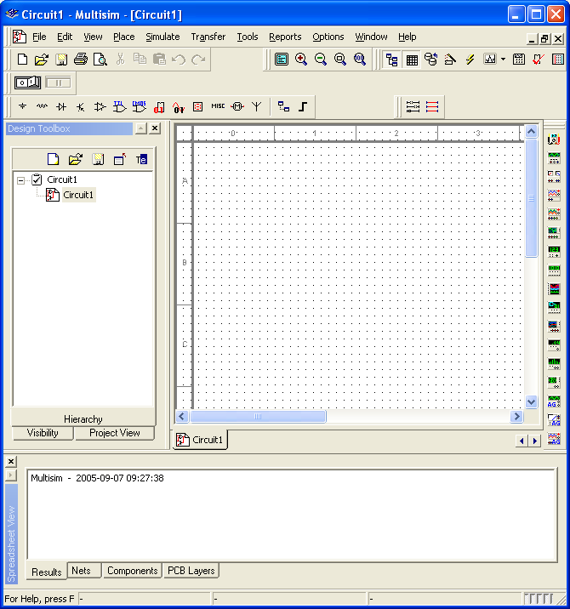

- Click on the Source button (see above). Select a DC source from the list and click OK.
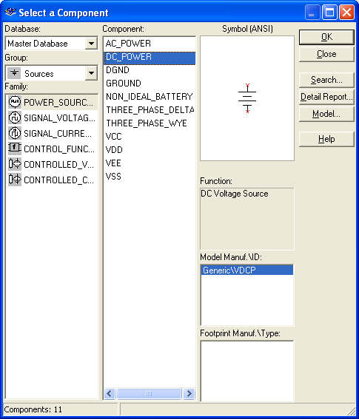

- The cursor now includes a DC Power Source (a battery) icon, click on the location of the workspace where you want to place the battery.
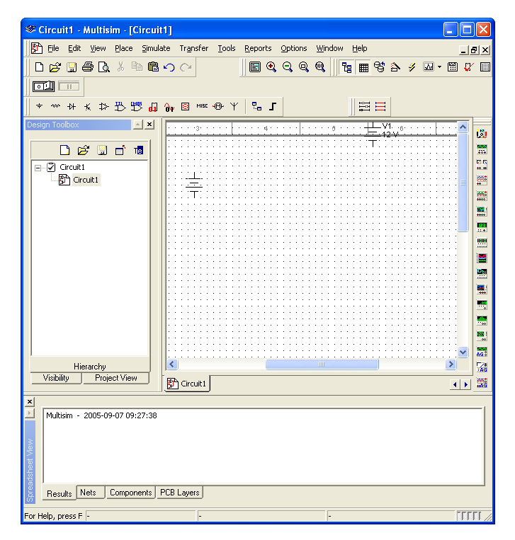
- Right click on the battery and choose Properties. Change the Voltage to 5 V and click OK.
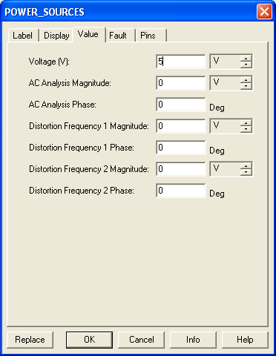
- Click on the Place Basic button, choose Resistor from the list on the left, then choose 1.3kΩ on the resulting list on the right, click OK. Place that resistor on the workspace.

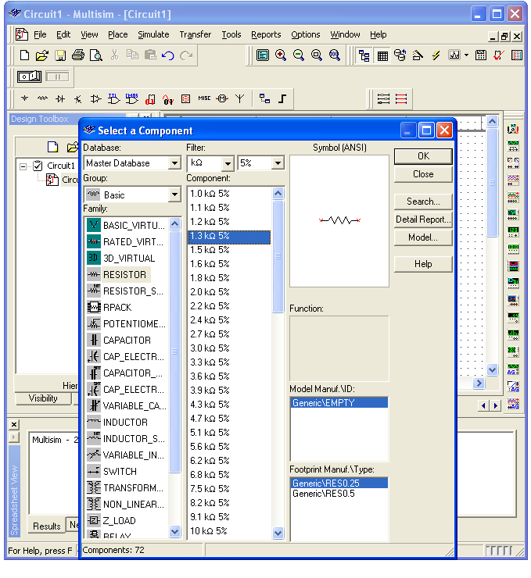
- Add a second resistor (this time 2.7kΩ) onto the workspace. Right click on the second resistor and rotate it.

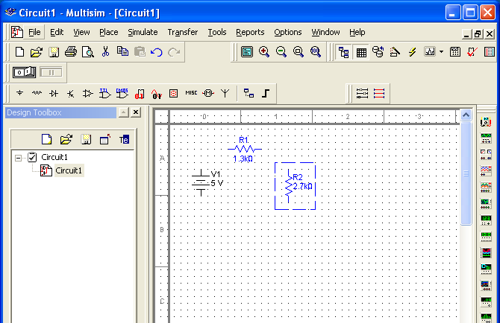
- Connect the battery and resistors in series as shown below. Click at the end of R₁ (a dot will appear) and move it making a line over to the beginning of R₂ click again to end the line. This is the simulation’s equivalent of connecting the two resistors by a wire.
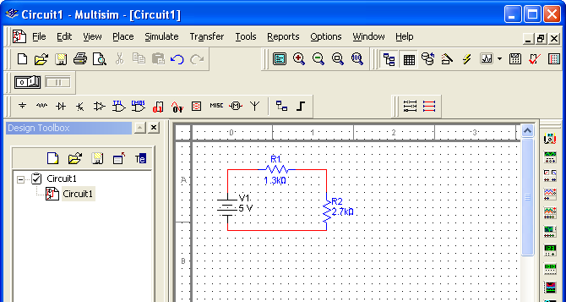
- Add a “ground” to the circuit between R₂ and the battery. Click on the Sources button, choose Ground and OK. Place a Ground onto the workspace. Connect the ground to the circuit.
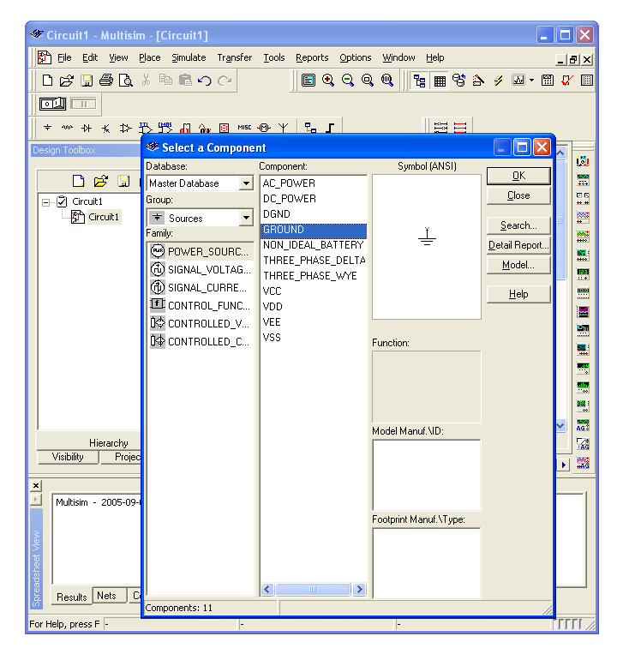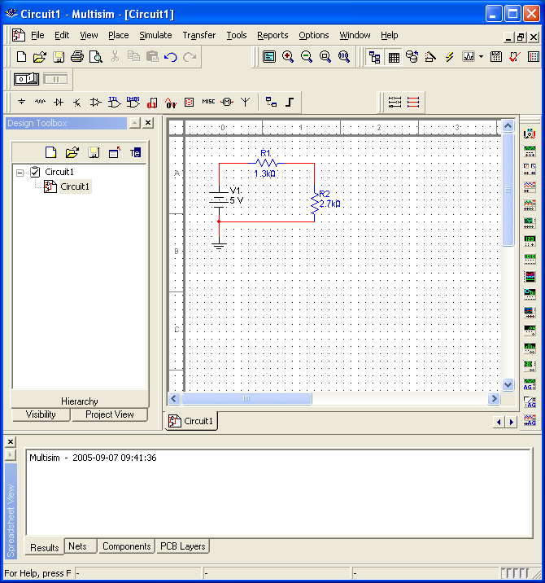

- Hook a voltmeter across (in parallel with) R₁. Click on Place Indicators. Choose Voltmeter, click OK, place a voltmeter onto the workspace. Connect the positive terminal to the beginning of R₁ and the negative terminal to the end of R₁. (I had to highlight the existing circuit and move it lower to make room.)
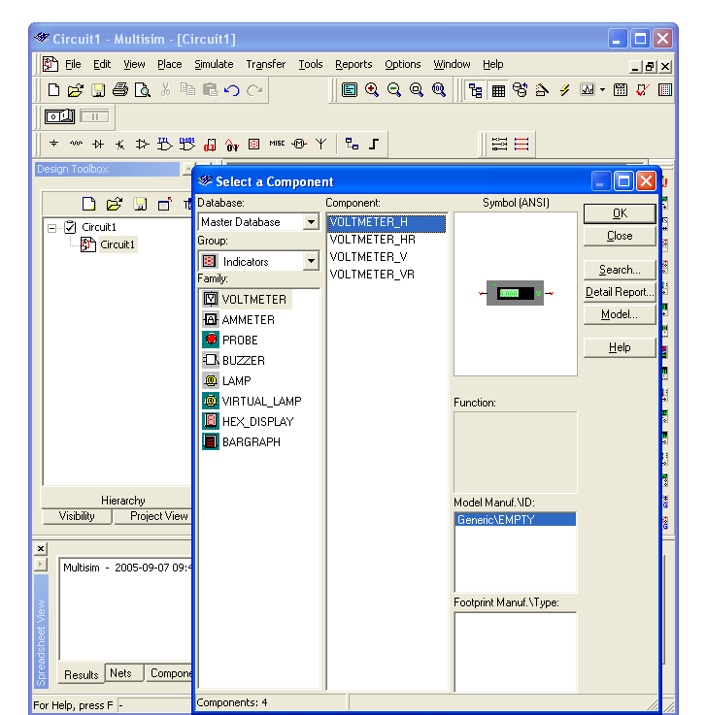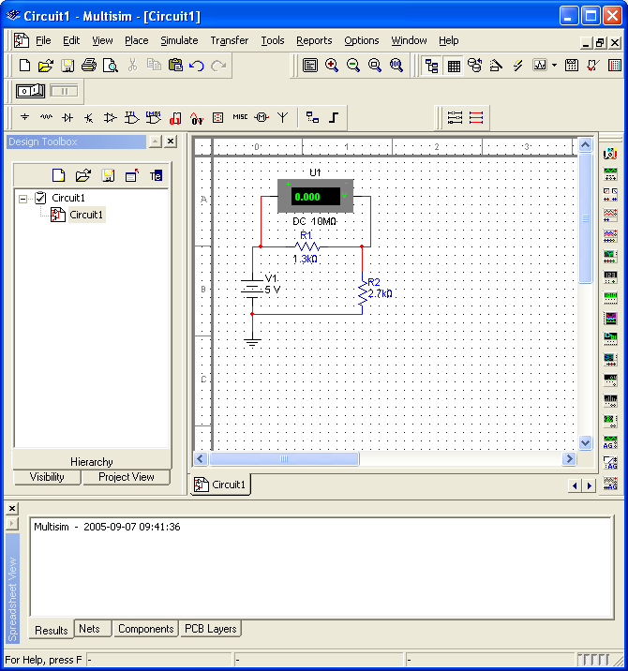
- Right click on the voltmeter. Choose Properties. Make sure the voltmeter is in DC mode.
- Click the Activate simulation button which is often on the upper right, but is on the left in the picture below because the tools wrapped around. Read the voltage across R₁ off of the voltmeter. Enter it into the table below.
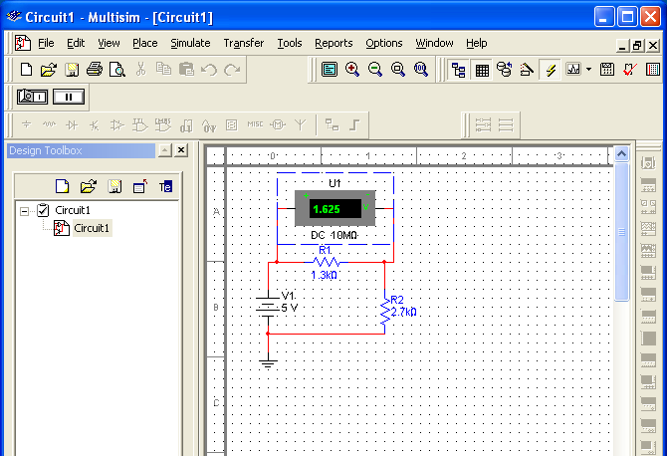
- Save your circuit file. Next place the voltmeter across (in parallel with) R₂. Repeat the measurements and enter them below.
- Bring a copy of your circuit over from Electronics Workbench and paste it into your Word document: Drag from the upper left to lower right of your circuit, then go to Edit/Copy on the Workbench menu. Paste the resulting picture into a Word document.

Resistance 1 | Resistance 2 | Voltage across R₁ | Voltage across R₂ | Sum of voltages
R₁ = 1.3 kΩ | R₂ = 2.7 kΩ

Part 2. Combination of resistors

For the circuit below you should use theory (equations/formulas) to find the current passing through the 2.05-kΩ and 3.40-kΩ resistors as well as the voltage drop across them. Show your equations or explain your logic (you can attach sheets if you don’t want to type out algebra). Then simulate the circuit in Electronics Workbench with voltmeter(s)/ammeter(s) in the appropriate places and verify your results. Paste into your report document a copy of the circuit with a meter reading out at least one of the desired. (Or print it.)
 | Current through ( ) | Voltage across ( )
2.05-kΩ
3.40-kΩ

Part 3. Combination of resistors and Kirchhoff’s Rules

Note: Remember to look for simple series and parallel combinations to simplify your circuit before beginning the more complicated procedure required for more complex circuits.

Using theory (equations), find the current passing through each resistor below in the circuits below. Then simulate the circuit in Electronics Workbench and verify your results. The solving equations part of your report can be hand written. If you use Kirchhoff’s rules, draw the circuit, explicitly assign currents on your circuit, draw the loops you use in applying Kirchhoff’s rules, write down the resulting equations, show the algebra (or Excel spreadsheet), etc. Print out a copy of the circuit with a meter reading out at least one of the desired results to include in your report.

Resistor (kΩ) | Current through resistor ( )
2.2
1.1
4.3
3.3
1.6

Resistor (kΩ) | Current through resistor
2.2
1.3
1.6
3.3
1.8

