Physics 202 | Name:

1. Power

The power dissipated by a device is given by the formula

P=VI

that is, the voltage dropped across the device multiplied by the current through the device. The unit for power is watts — which is another name for joules per second and which correspond to volts times amperes (thus volts times milliamps would be milliwatts mW; the m must be small as capital MW would stand for megawatts).

Simulate the circuit below in Electronics Workbench and use it to fill in the table below.

 | Current through ( ) | Voltage across ( ) | Power dissipated ( )
2.2-kΩ
3.6-kΩ

2. Simulation of RC Circuits

Build the circuit shown below. The capacitor can be found next to the resistors under the Basic button. The switch can be found under the Basic button as well. The oscilloscope can be found on the far right.

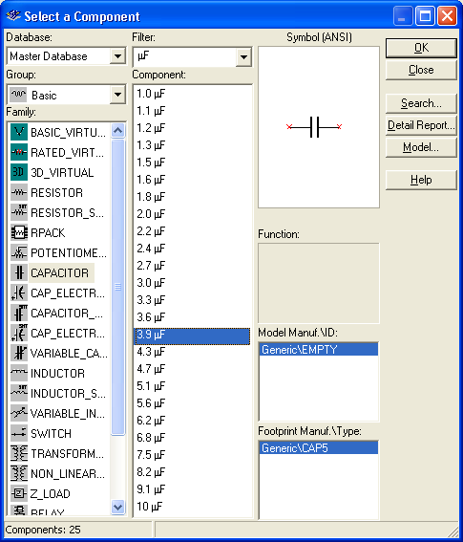
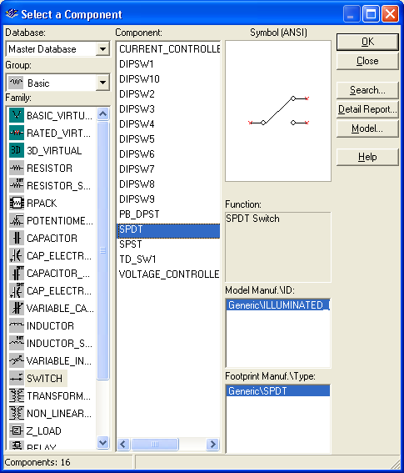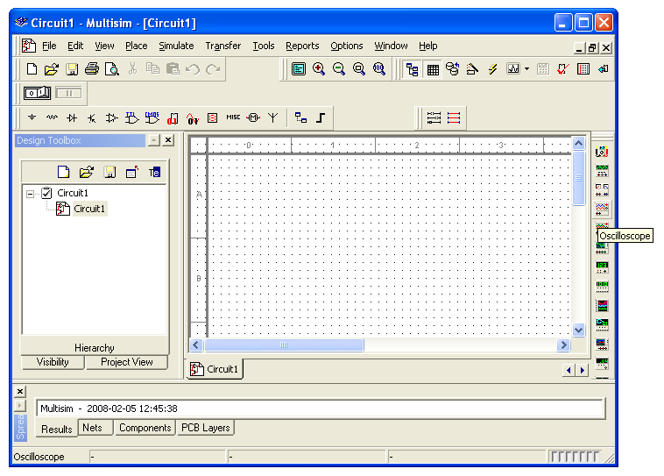

Open up the oscilloscope (right click) so that the display shows. Think of the oscilloscope as a time-dependent voltmeter. Activate the simulation and flip the switch so that the capacitor is charging. Then when the capacitor is almost fully charged flip the switch so that it discharges. Let it (almost) fully discharge and stop the simulation. Expand the oscilloscope and adjust the time base and number of volts per division so that most of the charging curve can be seen as shown below. Adjust the cyan (1) and yellow (2) cursors such that the cyan cursor is at the edge of where the charging begins and the yellow cursor is at 63% percent of the saturation voltage (the saturation voltage is 5V in this case). Recall that the time constant is the time for the charge (or voltage) to reach about 63% of its saturation value. The T2-T1 reading tells you the amount of time that elapsed between the two cursors. Do the same for the dischharging circuit – this time the voltage should fall to 37% of its initial value.

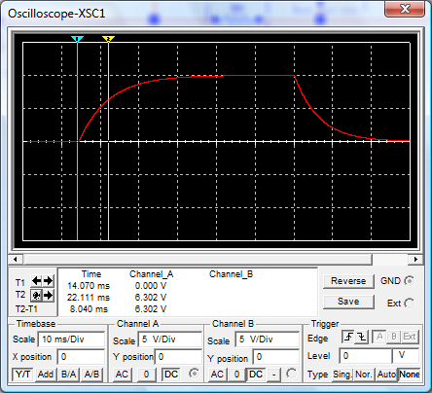

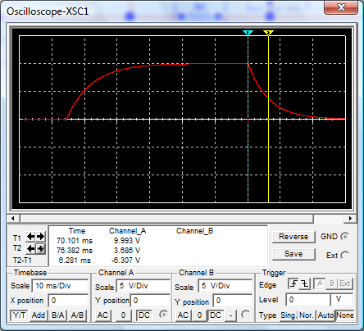

Use theory to predict the charging and discharging time constants of the circuit shown above. You must give your reasoning in detail. Then replace my oscilloscope pictures (both charging and discharging) with yours and take measurements to verify your prediction. Paste a screen capture showing the oscilloscope read out (with numbers) for both the charging and discharging scenarios.

Reasoning:

 | Charging Time ( ) | Discharging Time ( )
Prediction
Simulation

3. IV curve of a diode using Electronics Workbench.

Using Electronics Workbench Multisim, construct the circuit below.

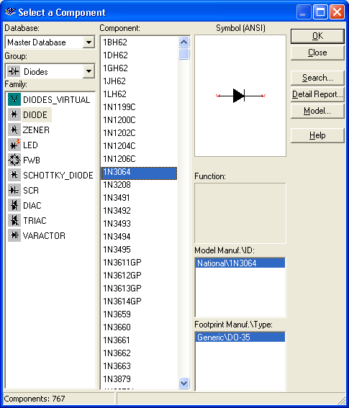

Note that a diode (found under the diode button, next to the basic (resistor) button) is represented as an arrow and a vertical line. Choose the 1N3064 diode. The arrow is on the anode side, and the cathode is on the vertical line side. Set the internal voltmeter resistance to 1000 MΩ (right click Properties, Value tab) and the internal resistance of the ammeter to 1 nΩ, so that the meters are very nearly ideal. Vary the battery voltage from 0.0 to 1.0V, and record the voltage across the diode and the current through the diode. Then use Excel to plot the current through the diode versus the voltage across the diode. Paste it into your report.

Voltage across battery | Voltage across diode  (in V) | Current through diode  (in mA)
0.0
0.1
0.2
0.3
0.4
0.5
0.6
0.7
0.8
0.9
1.0

Be sure that you convert all voltages to volts and all currents to milliamps. Recall that the resistance is the ratio of Voltage to Current. If the graph of Current versus Voltage is a straight line (as it was for the resistor), then the ratio (resistance) is constant. Such a device is said to be linear or Ohmic. The graph of Current versus Voltage for the diode is not a straight line, and thus we say that the diode is a nonlinear or “non-Ohmic” device.

Make a plot of resistance versus voltage. Paste it into your report. (You have to exclude voltages for which the current is zero and perhaps even the first couple voltages with non-zero currents.) Calculate the resistance for a low voltage and a high voltage.

 | Voltage used  ( ) | Resistance  ( )
Low
High

4. Rectification

The current coming out of the wall socket is AC (alternating current), and a number of devices (including a computer) require DC current. A rectifier changes AC into DC. The circuit below is called a half-wave rectifier.

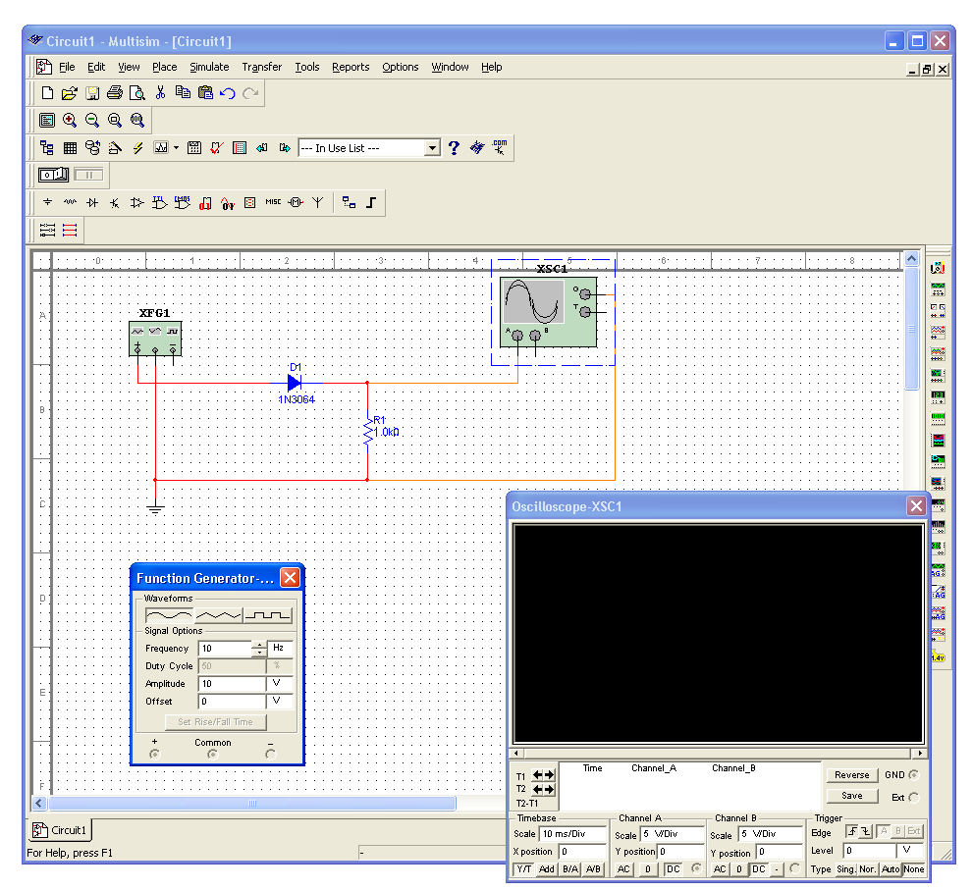

The box on the left is a function generator (found on the right, second from the top). Set its frequency to 10Hz. It will serve as an alternating voltage supply. The box with the sine wave is an oscilloscope (found on the right, fourth from the top).

First build the circuit above without the diode. Run a simulation and place a copy of the expanded oscilloscope screen below.

Oscillospcope output without diode:

Then insert the diode into the circuit and repeat.

Oscillospcope output with diode:

Finally build the circuit below, simulate it, and place a copy of its oscilloscope screen below. This circuit is known as a full-wave bridge rectifier. Explain the path taken by the current when the voltage is positive and when it is negative. (Draw a picture twice, indicate on the first the path taken by the current when the voltage at + is positive; indicate on the second the path taken by the current when the voltage at + is negative.)

5. Diode clamps.

Simulate the circuit shown below. Set the amplitude on the signal generator to 5 V and examine the output on the oscilloscope. Then raise the amplitude on the signal generator to 10 V and repeat. What is the effect? Change to the triangular and square waves. Is the effect similar? Paste the resulting oscilloscope screens in your report.

Explain what is happening in this circuit (in particular when is the diode conducting and when is it not conducting). You may wish to construct a DC version of the circuit shown below and vary the battery that replaced the signal generator from volatges below 5 V to voltages over 5 V.
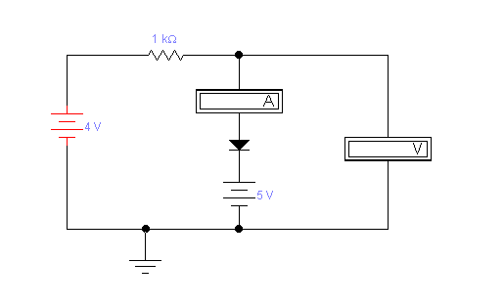
Such a circuit element is called a “diode clamp”; it can be added to a signal that is entering an integrated circuit (digital circuit). What role might a diode clamp play in a computer?

