PHYSICS 202
SPRING 06
LAB 6

Transformers and AC to DC conversion

Part 1. AC Peak and RMS.

Transferring energy over large distances is best done using alternating current (AC) at high voltages. But most of the devices we will be interested in need direct current (DC) at relatively small voltages. One first reduces the voltage by using a transformer. A transformer changes the voltage and the current in such a way that the power is not significantly diminished.

First let us build the circuit below which uses directly the voltage supplied by function generator. The voltmeter and ammeter must be put on their AC settings (right click, choose Properties). Note the Frequency is set to 60 Hz.
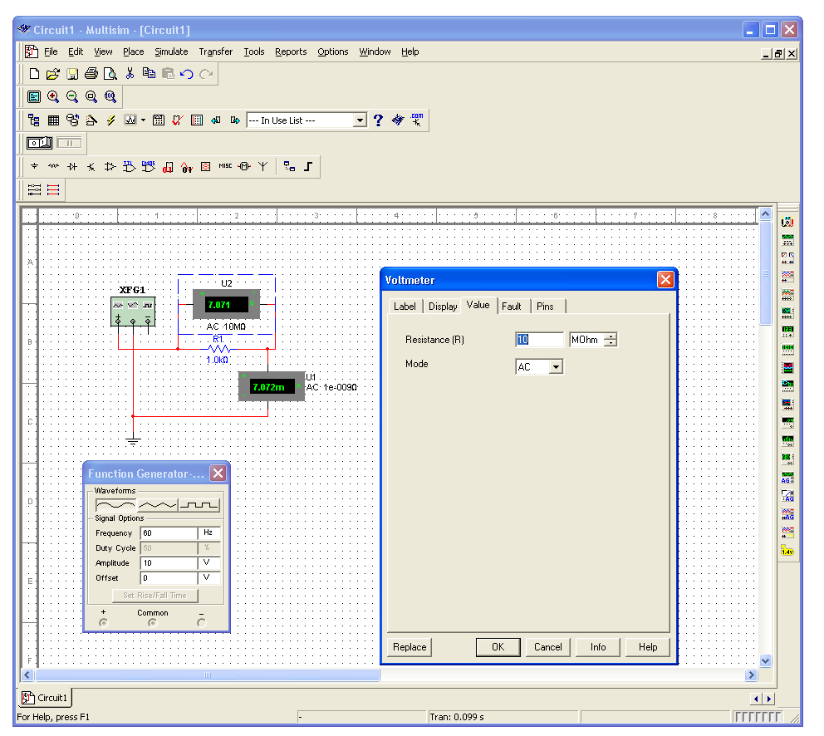

The voltage and current reading are not 10 V and 10 mA, respectively, because the 10 in the amplitude box represents the maximum value and the 7.07’s represent the root-mean-square (RMS) values, which are averaged over time. They differ from the maximum values by a factor 2^{-1/2}. What are the meter readings for the above circuit if we choose the triangular wave instead of the sine wave?

What are the meter readings for the above circuit if we choose the square wave instead of the sine wave?

A slight revision of the circuit above is shown below. The AC_Power course (shown as a circle with the + sign and sine wave – found under the Sources button, same as a battery) represents the AC supplied by a typical wall socket. Build this circuit. Remember to put the voltmeter and ammeter on their AC settings. Is the 120 V the peak value (like the amplitude above) or the RMS value (like the meters above)?

Part 2. Reducing the voltage.

The transformer lowers (or raises) an AC voltage without significant loss of power. A transformer consists of two separate circuits, the primary and the secondary. The AC in one circuit induces a magnetic field, and that magnetic field in turn induces a current (also alternating) in the second circuit. To enhance the magnetic field produced, the circuits surround an iron core. This is what makes transformers heavy. Whether the voltage is increased or decreased depends on the number of turns around the iron core in each circuit. The relationship is

$$V_{2}=−\frac{N_{2}}{N_{1}}V_{1}$$
where N₁ and N₂ are the numbers of turns in the primary and secondary circuits respectively. (Don’t worry about the minus sign.)

Build the circuit below. That symbol in the middle is the transformer (found under the Basic (resistor) button). Notice that there are two separate circuits. In the example below the turns ratio is 25.

Replace the voltmeter on the right with an oscilloscope and take a reading that shows what the peak voltage is. Paste it into this document. You will probably have to adjust the “time base” (time interval per division) as well as the number of volts in a division. What is the peak voltage? Does this make sense? Explain.

Next connect the ground on the right to the center of the transformer. What is the peak voltage now?

Part 3. Smoothing out a rectified signal.

In Lab 5, we simulated rectification, the first step in converting AC to DC. The output was all positive but it still had periodic highs and lows. A useful DC supply must have a relatively steady output. Adding a capacitor to the rectifier circuit will smooth out the voltage. Return to the full-wave rectifier simulation we did last lab. Add a 10-μF capacitor in parallel with the resistor. Display the output of your oscilloscope for capacitances of 1, 3 and 5 capacitors in parallel. Indicate in the 10-μF output (oscilloscope readout) when the capacitor is charging and when it is discharging.

What is the effect of placing the capacitors in parallel? What “equivalent capacitances” could be used?

Part 4. A type of backup power

Simulate the circuit below. What do the ammeters read for the circuit as shown? Explain why. Give the circuit some time to settle. Also keep track of whether the reading is mA, uA (should be μA), nA, or pA.

What do the ammeters read for the circuit when the switch is flipped? Explain why.

Such a circuit could be used to switch to back-up power. Unfortunately there may be a time delay in such a circuit, so something more sophisticated is needed.

Part 5. Amplitude demodulation

In amplitude modulation (AM) the information is placed on a carrier wave (rapidly oscillating sine wave) by varying its amplitude (peak). The amplitude variations will have a much lower frequency. On the receiver end, one must be able to separate the carrier from the signal.

A very simple version of an amplitude-modulated sine wave is obtained by using the concept of beats. If two sine waves with nearby frequencies are added (superimposed) then the result has a fast variation that is effectively the average of the two frequencies and a slow, amplitude variation, the frequency of which is the difference between the two constituent waves.

1. Build the circuit below with two AC sources added in series. Change one of the frequencies to 58 Hz.

The oscilloscope screen capture looks as follows.

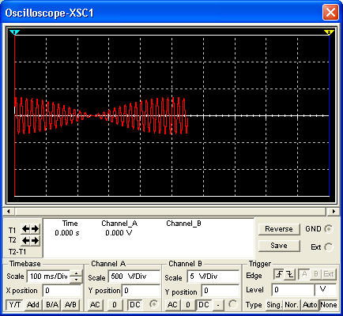

Determine the period and frequency of the fast oscillations as well as those of the slow oscillations.
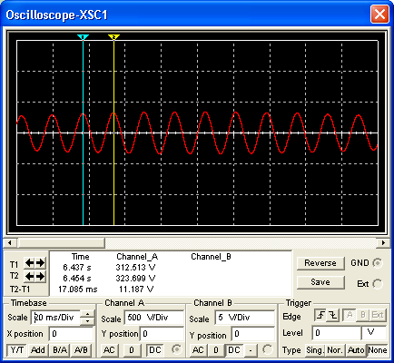
Measuring the fast period

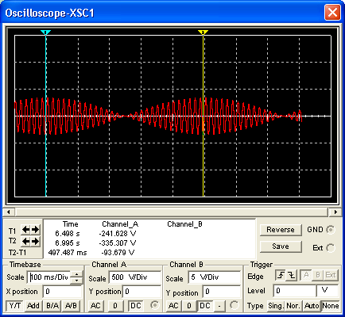
Measuring the slow period

60 Hz and 58 Hz signals added
Fast period (s)
Fast frequency (Hz)
Slow period (s)
Slow frequency (Hz)

Change the frequencies to 60 Hz and 59 Hz and repeat.

60 Hz and 59 Hz signals added
Fast period (s)
Fast frequency (Hz)
Slow period (s)
Slow frequency (Hz)

Change the frequencies to 100 Hz and 98 Hz and repeat.

100 Hz and 98 Hz signals added
Fast period (s)
Fast frequency (Hz)
Slow period (s)
Slow frequency (Hz)

Build a circuit like the one below with two function generators in place of the AC-Power supplies as well as the additional circuitry of the diode (virtual/ideal) and a resistor in parallel with a capacitor.

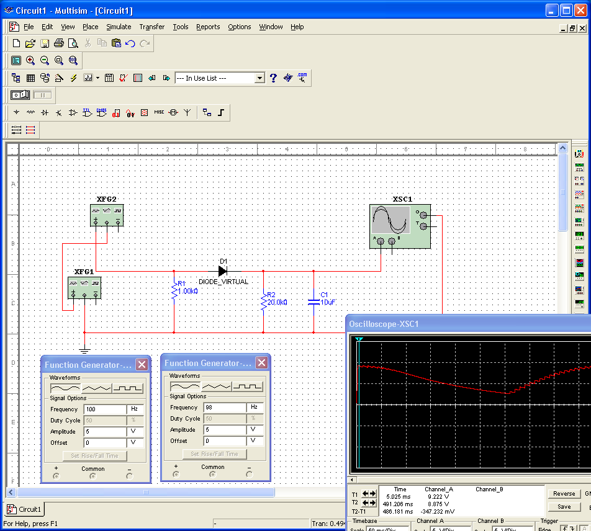

The additional circuitry has a time constant. What is it? (Hint: we added a diode, a resistor and a capacitor. What time constant involves these quantities (or two of them)?)

Time constant:

To filter out the fast behavior but leave the slow behavior intact (i.e. to perform an amplitude demodulation) the filter’s time constant should lie between the characteristic time of the fast behavior and the characteristic time of the slow behavior. Name the carrier frequency of an AM radio station you have listened to?

What is the corresponding characteristic time (period) of the fast part?

If the slow frequency of interest is about 8000Hz (good for human voice, so-so for music), what is the associated time?

What characteristics (resistance, capacitance, etc.) should your filter have to lie between these two times?
R:
C:
?

Part 6. Inductor Circuits

Simulate the circuit below. It is known as an LR circuit. L is the symbol for an inductor and R the symbol for a resistor. The mathematics used to describe this circuit is similar to that for the RC circuits we studied earlier. The voltage across an inductor is proportional to the change in current. When the switch is in the position shown at the start there is no current. Then when the switch is flipped, the battery starts to push current through the circuit, thus changing the current. All of the voltage must be used up in the circuit. There is little if any current initially (so not much voltage is dropped across the resistor), but it is changing rapidly (so most of the voltage is dropped across the inductor). As the current builds up, less voltage is dropped across the inductor and more is dropped across the resistor. The circuit heads toward a steady state in which the current does not change at all, and all of the voltage is dropped across the resistor.

The voltage across the resistor saturates according to the equation

$$V(t)=V_{S}\left(1−e^{{−t}/τ}\right)$$
When t=τ, we have

$$V(t)=V_{S}\left(1−e^{−1}\right)$$

$$V(t)=V_{S}\left(0\text{.}\text{632}\right)$$

or in other words after a time equal to the time constant τ has gone by, the voltage across the resistor is equal to about 63% of its saturation value.

Shown below is a capture of the oscilloscope output.

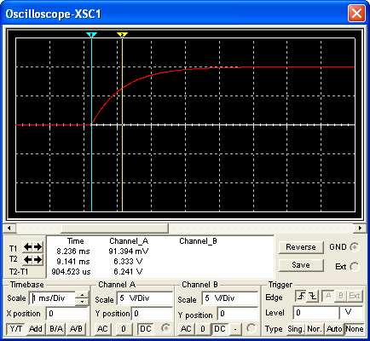

Note that one can also use the falling part of the circuit to determine the time constant. In this case one finds the time it takes for the voltage to fall to approximately 37% of its starting value.
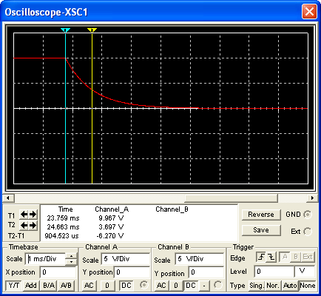

Vary the resistance in your circuit below and determine the time constant. Enter them into the table below.

Inductance L = 910 mH
Resistance  (kΩ) | Time Constant (s)

Plot the time constant versus resistance and fit it (Add a Trendline) to a power law. Paste the graph into your report. What power do you find?

Power:

Next vary the inductance in your circuit below and determine the time constant. Enter them into the table below.

Resistance R= 1 kΩ
Inductance  (mH) | Time Constant (s)

Plot the time constant versus resistance and fit it (Add a Trendline) to a power law. Paste the graph into your report. What power do you find?

Power:

