PHYSICS 202  Lab 7 | Name: ________________________

Inductor Circuits

Simulate the circuit below. It is known as an LR circuit. L is the symbol for an inductor and R the symbol for a resistor. The mathematics used to describe this circuit is similar to that for the RC circuits we studied earlier. The voltage across an inductor is proportional to the change in current. When the switch is in the position shown at the start there is no current. Then when the switch is flipped, the battery starts to push current through the circuit, thus changing the current. All of the voltage must be used up in the circuit. There is little if any current initially (so not much voltage is dropped across the resistor), but it is changing rapidly (so most of the voltage is dropped across the inductor). As the current builds up, less voltage is dropped across the inductor and more is dropped across the resistor. The circuit heads toward a steady state in which the current does not change at all, and all of the voltage is dropped across the resistor.

The voltage across the resistor saturates according to the equation

$$V(t)=V_{S}\left(1−e^{{−t}/τ}\right)$$
When t=τ, we have

$$V(t)=V_{S}\left(1−e^{−1}\right)$$

$$V(t)=V_{S}\left(0\text{.}\text{632}\right)$$

or in other words after a time equal to the time constant τ has gone by, the voltage across the resistor is equal to about 63% of its saturation value.

Shown below is a capture of the oscilloscope output.

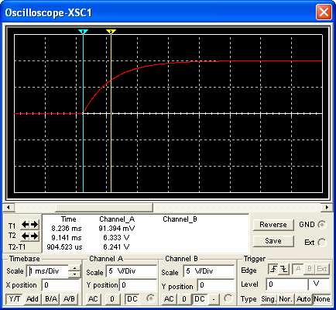

Note that one can also use the falling part of the circuit to determine the time constant. In this case one finds the time it takes for the voltage to fall to approximately 37% of its starting value.
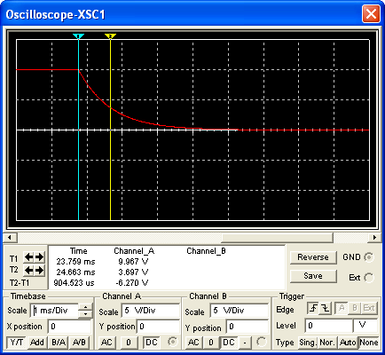

Vary the resistance in your circuit below and determine the time constant. Enter them into the table below.
Inductance L = 910 mH
Resistance  (kΩ) | Time Constant (s)
Plot the time constant versus resistance and fit it (Add a Trendline) to a power law. Paste the graph into your report. What power do you find?

Power:

Next vary the inductance in your circuit below and determine the time constant. Enter them into the table below.

Resistance R= 1 kΩ
Inductance  (mH) | Time Constant (s)

Plot the time constant versus resistance and fit it (Add a Trendline) to a power law. Paste the graph into your report. What power do you find?

Power:

2. Simulate the circuit shown below. Start with the switch set such that the capacitor is connected to the inductor, the oscilloscope reading should be flat. Flip the switch to place the capacitor in the circuit with the battery and the resistor. The capacitor will charge. Recall that the voltage in an RC is

$$V(t)=V_{S}\left(1−e^{{−t}/τ}\right)$$

where τ=RC.

Flip the switch again to connect the now charged capacitor to the inductor. This should result in an oscillator behavior.

In the oscilloscope reading shown below, the first line indicates where the switch was flipped the first time and the second line where the switch was flipped the second time. That solid mass is oscillatory behavior, which can be found by changing the oscilloscope’s time base, as seen in the second oscilloscope capture. Oscillatory behavior is characterized by a period (the time for one cycle) or alternatively the frequency (the number of cycles in a second).

Vary the capacitance and determine the period and enter them into the table provided.

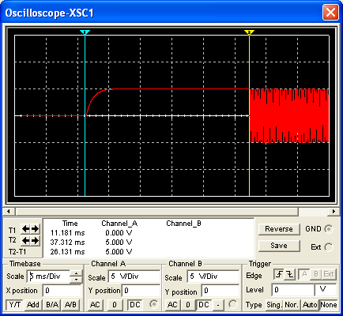

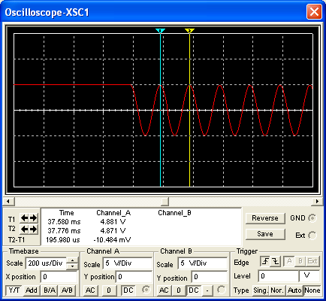

Inductance L = 1 mH
Capacitance ( ) | Period ( ) | Frequency ( )

Plot the period versus capacitance and fit it (Add a Trendline) to a power law. Paste the graph into your report. What power do you find?

Power:

Next vary the Inductance, determine the period and frequency.

Capacitance C = 1 μF
Inductance ( ) | Period ( ) | Frequency ( )

Plot period versus inductance and fit it to a power law. Paste the graph into your report. What power do you find?

Power:

3. We saw from the analysis above that a circuit with an inductor and a capacitor, an LC circuit, displays oscillatory behavior. This frequency is the so-called natural frequency to distinguish it from the driving frequency we are about to introduce into the circuit. In the circuit shown below we introduce a signal generator to the circuit. The signal generator will input an AC voltage, which has its own frequency. The circuit responds at the driving frequency; however, the size of the response depends on the proximity of the driving frequency to the natural frequency. The response grows dramatically in size if the driving frequency is close to the natural frequency. This phenomenon is known as resonance. The usual analogy is to a child on a swing. A child on a swing is a version of a pendulum, which has a natural frequency. If someone is pushing the child on the swing, then there is a driving force. If the driving force has the same frequency as the swing’s natural frequency, then one is always pushing the swing in the direction it is going naturally and the system gains energy, i.e. the child goes higher. If one were pushing at a different frequency, one would sometimes be working with, sometimes working against the child’s motion. The swing would not go very high. Resonance is important for tuning. Signals are placed on carrier waves and one must tune one’s receiver (change its natural frequency) to match the carrier’s frequency in order to receive a detectable signal. One is simultaneously blocking out other signals at other frequencies.

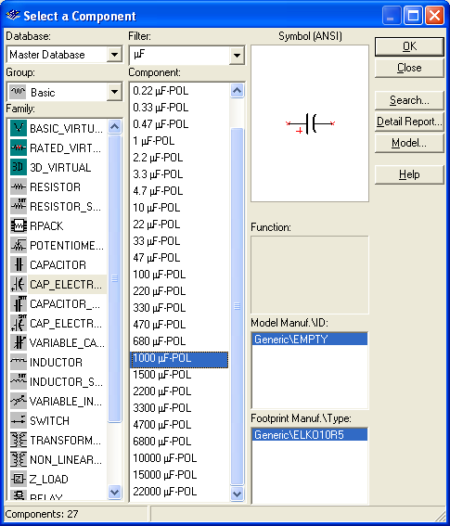
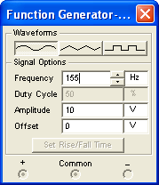

Simulate the circuit above. Allow the output to settle into a sinusoidal form: i.e. measure toward the right in the picture below, not on the left.

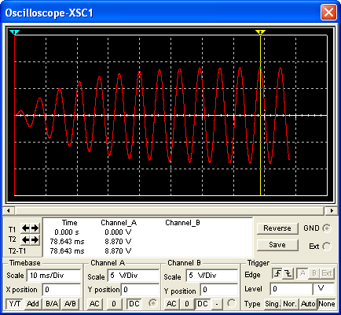

Determine the maximum (peak) voltage of the output signal for various driving frequencies (signal generator). Vary the frequency from 100 Hz to 200 Hz by steps of 5Hz and record the peak voltage seen on the oscilloscope.

Driving Frequency (Hz) | Peak Voltage (V)
100
105
110
115
120
125
130
135
140
145
150
155
160
165
170
175
180
185
190
195
200

Plot peak voltage versus driving frequency. Paste it into your report. Verify that the largest signal is found for a frequency close to the natural frequency for the LC circuit found in the previous section.

4. Build the circuit shown below.
The combination of AC voltage supplies can be thought of as producing two amplitude-modulated signals. What are the carrier (fast) frequencies of those two signals?

Carrier frequency 1:

Carrier frequency 2:

Using the knowledge that the characteristic times of an LC circuit and an RC circuit are given by
$$T=2π\sqrt{\text{LC}}$$
$$τ=\text{RC}$$

respectively, select (tune in) the signal with the higher carrier frequency. Then filter out that carrier frequency leaving just the modulation. Provide your choices for the values C1, L1, R2 and C2 below and your reasoning below.

C1:  L1: | R2:  C2:
Reasoning: | Reasoning:

Paste a copy of your circuit as well as a copy of the oscilloscope output below.

