PHYSICS 202
LAB 9

Part 1. Diode-Transistor Logic

The circuit below is logic gate made from resistors, npn transistors and diodes. Add voltmeters and/or ammeters to determine if the transistors are on or off.

Input A | Input B | Q1  (on or off) | Q2  (on or off) | Output  (in volts) | Output  (high or low)
low | low
low | high
high | low
high | high

What logic gate does this represent?

Part 2. The transistor-transistor logic (TTL) inverter.

The circuit below is a rather complicated version of an inverter. Simulate it and fill in the table. Add voltmeters and/or ammeters to determine if the transistors are on or off.

Input | Q1  (on or off) | Q2  (on or off) | Q3  (on or off) | Q4  (on or off) | Output  (in volts) | Output  (high or low)
Low
High

Part 3. All from NAND

Build a NOT, an AND and an OR from NAND gates. Paste them below.

Part 4. Sum of products

Write the sum of products and product of sums expressions for the following truth table.

A | B | C | Out
0 | 0 | 0 | 1
0 | 0 | 1 | 0
0 | 1 | 0 | 0
0 | 1 | 1 | 1
1 | 0 | 0 | 1
1 | 0 | 1 | 0
1 | 1 | 0 | 0
1 | 1 | 1 | 0

Sum of products:

Build the circuit and paste it below.

Part 5. DRAM Flip-Flop

Build the DRAM circuit shown in the lecture. Set the circuit so that the output is high and then place the circuit into the hold state. Describe what happens and its significance.

Part 6. SRAM Flip-Flop

In the circuit below there is an RS flip-flop made using OR gates. Build something similar but use AND gates. Label the switches A and B. Fill in a table with A and B inputs and the corresponding outputs and identify various states as reset, set or hold.
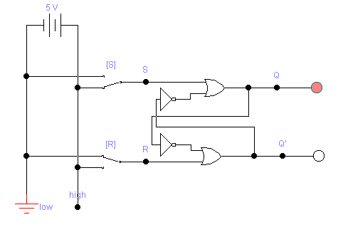
Step | A | B | Q | Q’ | Type
0
1
2
3
4
5
6
7
8

