You have been provided with Album.htm (the main file you should edit), ArrayInitializations.txt (which contains the initializations of three arrays you need for the program) and twelve images (Music0.jpg through Music11.jpg). The only thing on the page provided is the drop-down list (select) element.

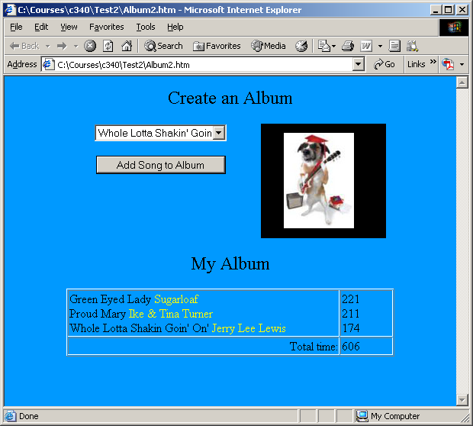

- Design a page that has the main features seen above.
- Add a button below the drop-down list already found in Album.htm. When the button is clicked, place the selected title of the song and the artist who sings it in the first column of the first row of the new table and the length of the song should be added to the second column.
  - The “values” of the drop-down-list items correspond to the indices of the arrays provided in ArrayInitializations.txt.
  - The artist should be styled differently than the title.
  - The second row, second column should keep a running total of the album’s length (the sum of the seconds of the individual songs).
- Have a timer that places a different picture (Music0.jpg through Music11.jpg) in the second column of the original table every 5 seconds.
- There are currently 39 songs. Add another song to the program in all of the appropriate places. The drop-down list is in alphabetical order, your song should be neither the first nor the last in that list. (Of course, you are free to change all of the songs and images if you want.)

