Girl Scout Cookie Survey Page

Wherever appropriate make sure you include both opening and closing HTML tags. Recall that instead of cutting code, you can comment it out so that it might be used for administering partial credit. However, excessive inclusion of extraneous code can result in a loss of points.

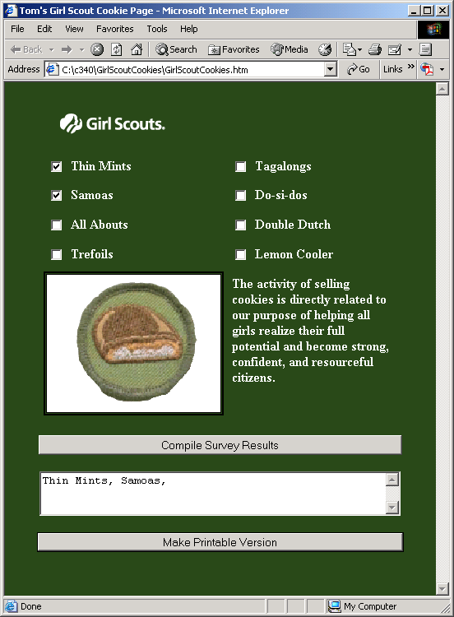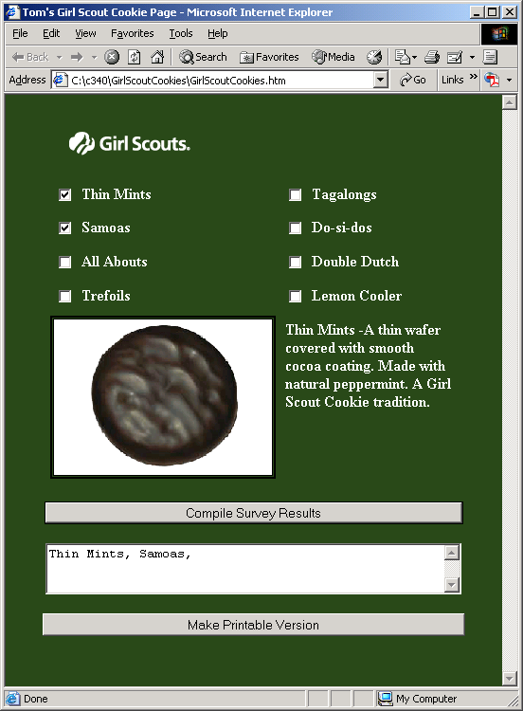

- A start of the HTML page, GirlScoutCookies.htm, is provided. It should have a title such as Joe’s Girl Scout Cookie Page – of course with your name in place of Joe.
- Somewhere in the script portion of the page, you should include a comment with your name.
- Set the background color of the page to a customized color consisting of Red=41, Green=72, and Blue=27.
- The file CookieText.txt provided on the floppy has some array declarations, instantiations and initializations. One array contains the name of cookie image files (ThinMints.gif, etc.). Another array contains text about each cookie.
  - The cookies names are in labels (divs). Have the divs’ mouseover events display a picture of the cookie in place of the badge image and display some text about the cookie in place of the default text (“The activity of ….”) See above.
  - The mouseout events should return the image to the badge and the text to the default text.
  - There should be only one mouseover function and one mouseout function. (You can make 8 of each for reduced credit.)
- Add a button beneath the table, have it say “Compile Survey Results” and center it. Beneath the button, have a Text Area (also centered). Beneath the Text Area, have another centered button that says “Make Printable Version”.
- The customer will use the checkboxes to indicate which kind of cookies he/she likes. The Compile button should clear out any previous results from the TextArea and then loop through checkboxes. If a checkbox is checked, the name of the cookie should added be added to the Text Area.
- The Make Printable button should open a new window and write to it the information found in the Text Area.

